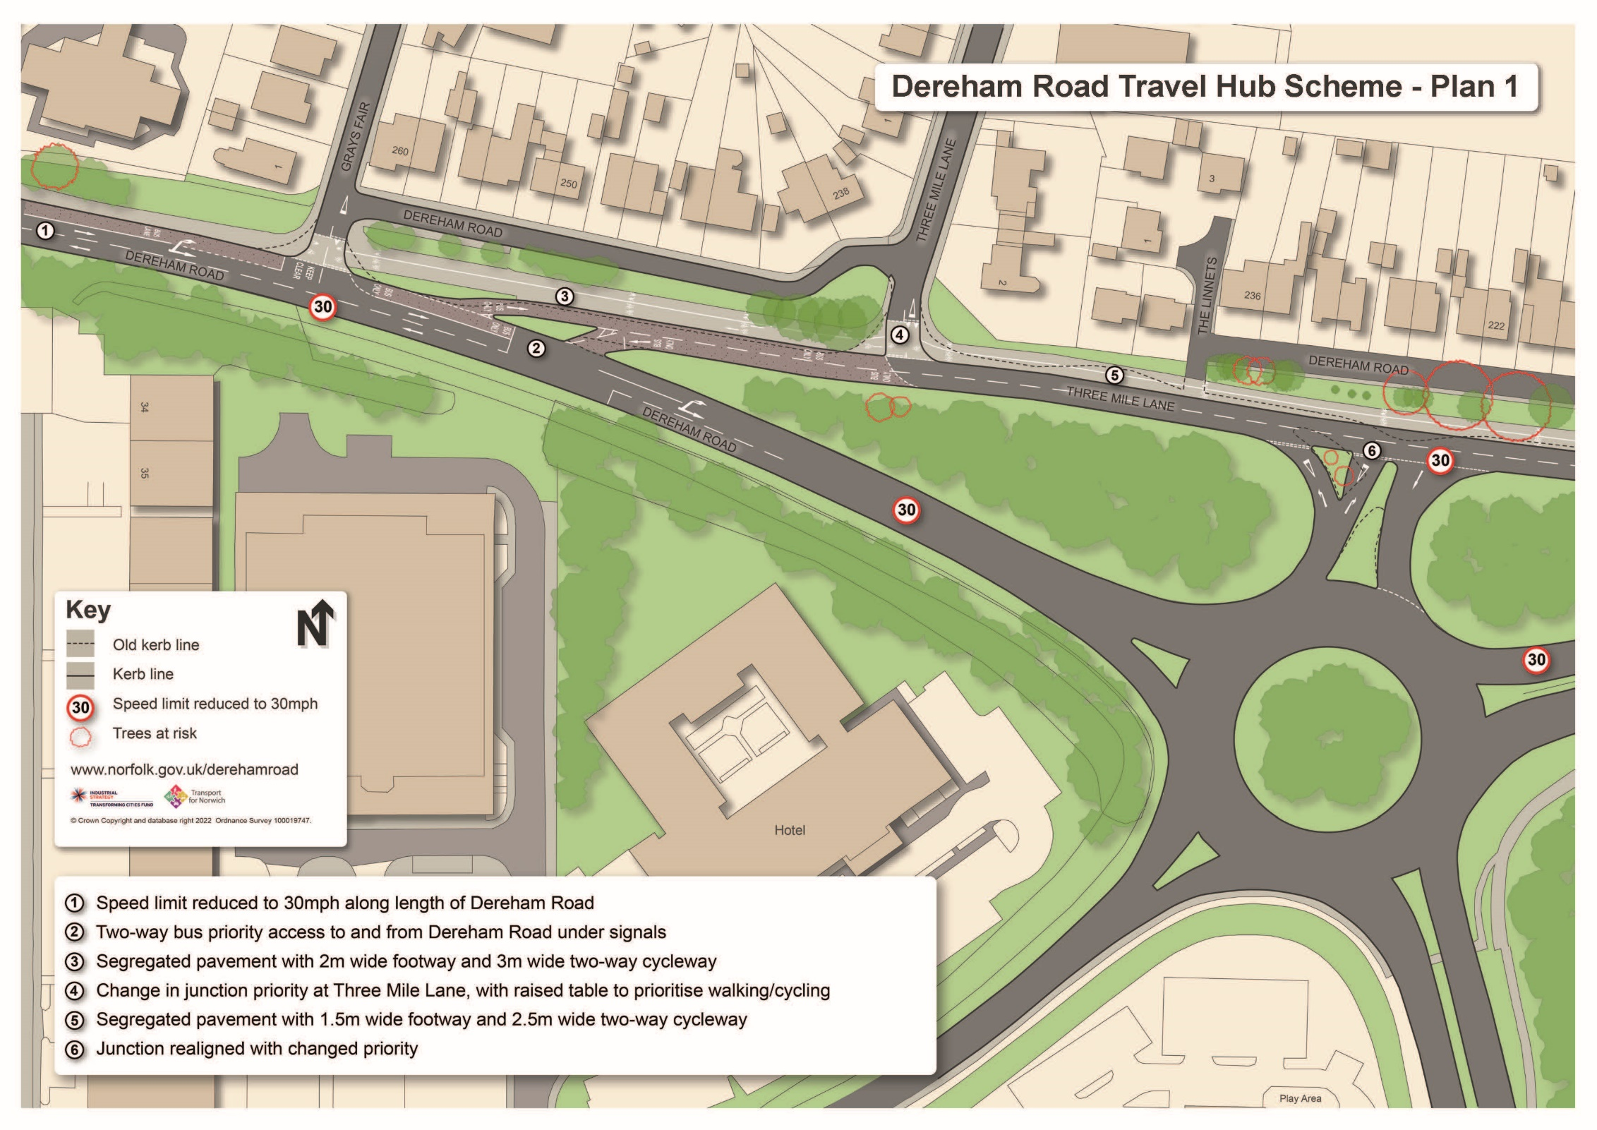

# Dereham Road Travel Hub Scheme – Plan 1