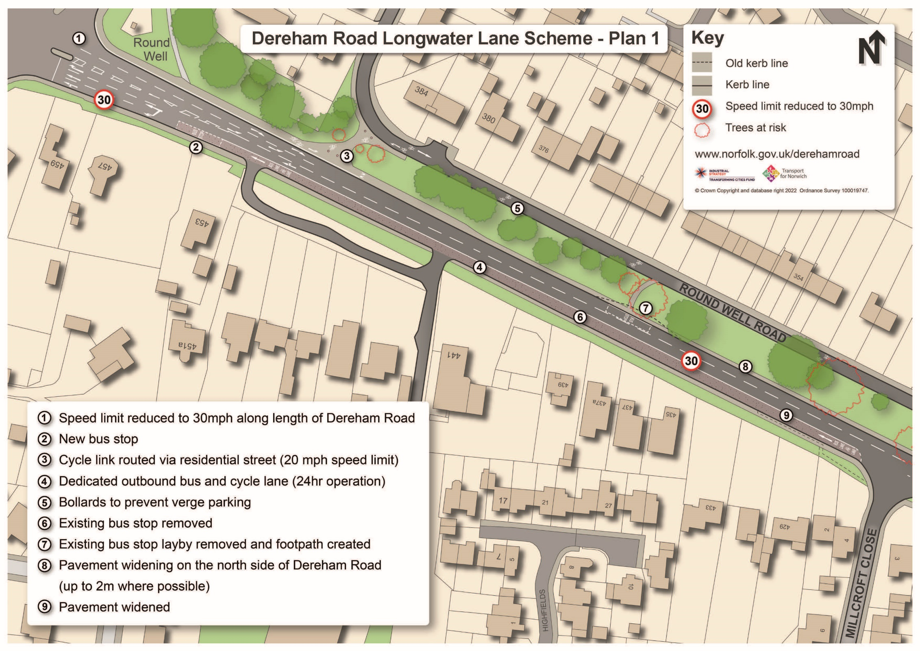

# Dereham Road Longwater Lane Scheme – Plan 1