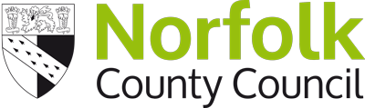

Your views on Norfolk’s railways –
how the stations and train lines
could be better in the future

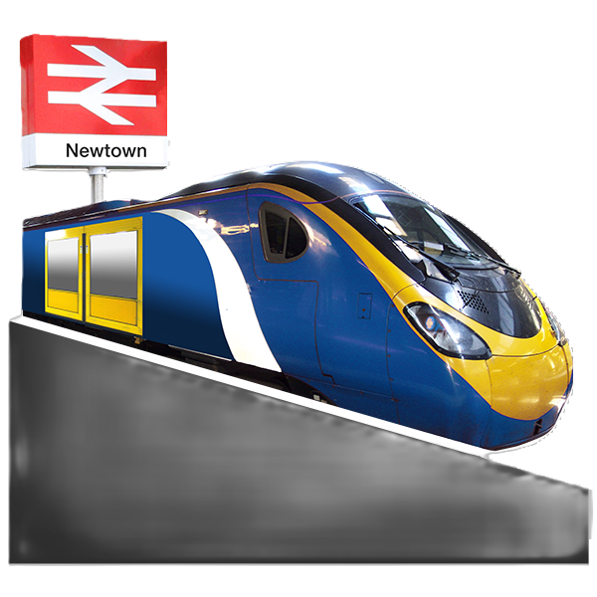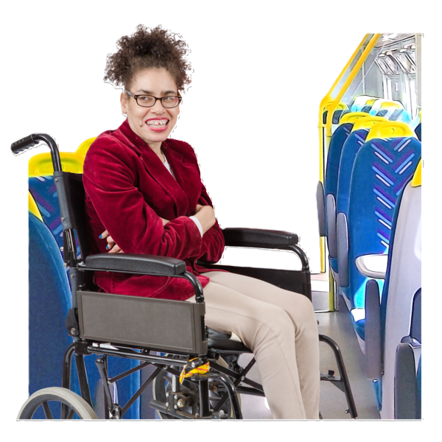



Easy Read

This is an Easy Read version of some information. It may not include all of the information but it will tell you about the important parts.

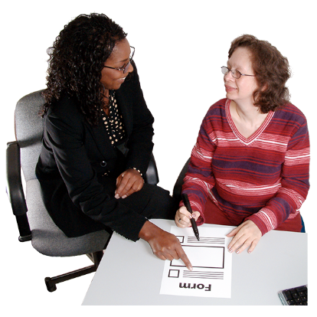
This Easy Read document uses easier words and pictures. Some people may still want help to read it.


Blue and underlined words show links to websites and email addresses. You can click on these links on a computer.

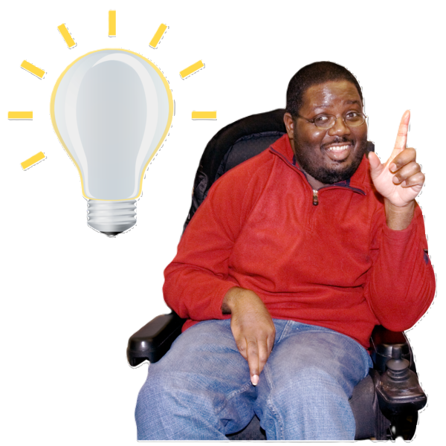

Our ideas
We’ve thought about what improvements we’d like to see made to Norfolk’s railways.

We’d like to know whether you agree with our ideas and what you think would make Norfolk’s railways better in the future.

Putting all the ideas together in one document – called a prospectus – will help tell the government and the people who run the railways what improvements people in Norfolk want.

We will ask questions about our ideas for different parts of the railways including railway lines and stations. You can skip any questions if you do not want to answer them.
Please give us your thoughts by 21 October 2024. (We may not accept your feedback if we receive it after that date).
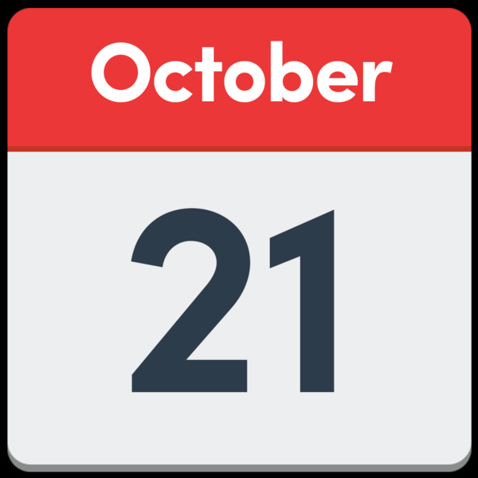

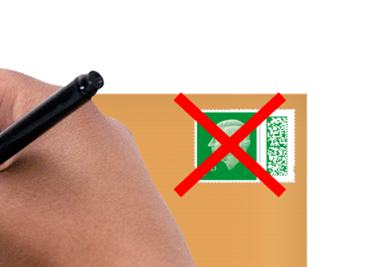
Please send your thoughts back to the address below. You do not have to put a stamp on the envelope.

Norfolk Rail Prospectus survey
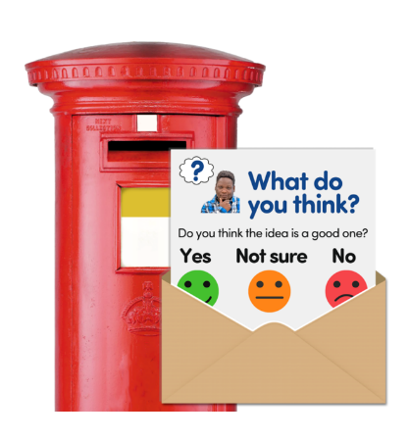
Freepost Plus RTCL-XSTTJZSK,
Norfolk County Council,
Ground Floor - south wing,
County Hall,
Martineau Lane,
Norwich,
Norfolk,
NR1 2DH


You can also tell us what you think on our website: www.norfolk.gov.uk/norfolkrailprospectus


If you need this form in a different format or would like to email your feedback to the council, you can send an email to haveyoursay@norfolk.gov.uk

Or, you can call 0344 800 8020
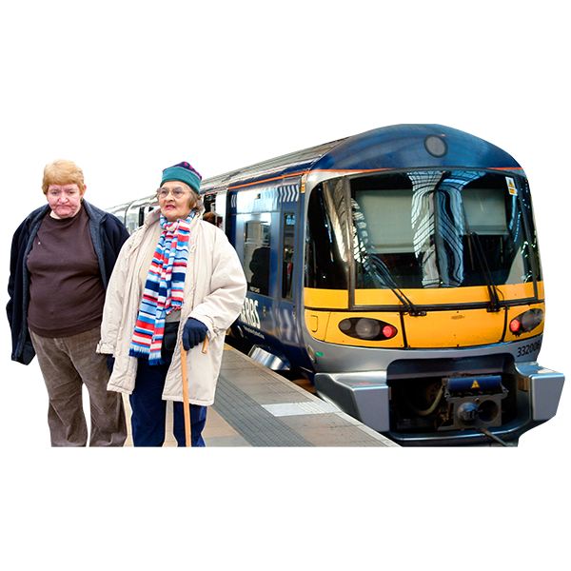
Here are some things we think are most important for railways in Norfolk:
- Faster and more frequent trains
- Railway stations should be accessible for all people
- Simpler prices for train tickets
- More environmentally friendly trains
- Making it easier to get to and from railways stations
- New stations and routes could be needed
- Trains should run earlier in the morning and later in the evening
- Helping run small local rail lines

Do you agree or disagree with the things we think are important? 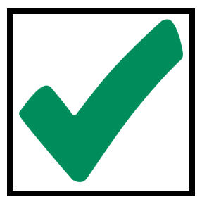 Please tick one box
☐ Strongly agree
☐ Agree
☐ Neither agree or disagree
☐ Disagree
☐ Strongly Disagree
If you have any comments, please let us know here:

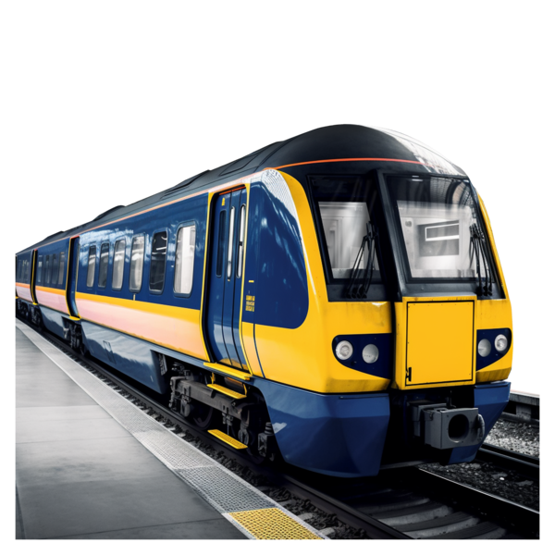
- Lines
This section is about railway lines. For each line we say what our priorities are for the line and the stations along it.
Please let us know what you think of our ideas for each line by answering the questions below.

Norwich to London Liverpool Street line (Great Eastern Mainline)
This is what we think is important to make this line better:
- More trains that go between London and Norwich in only 90 minutes
- Trains leaving every 20 minutes
- Better connections with other train services

Do you agree or disagree with our ideas for the Norwich to London Liverpool Street line (Great Eastern Mainline)? Please tick one box
☐ Strongly agree
☐ Agree
☐ Neither agree or disagree
☐ Disagree
☐ Strongly Disagree
If you have any comments, please let us know here:

King’s Lynn to London King’s Cross line
This is what we think is important to make this line better:
- Trains leaving every half an hour
- Longer trains to carry more passengers

Do you agree or disagree with our ideas for the King’s Lynn to London King’s Cross line? Please tick one box
☐ Strongly agree
☐ Agree
☐ Neither agree or disagree
☐ Disagree
☐ Strongly Disagree
If you have any comments, please let us know here:

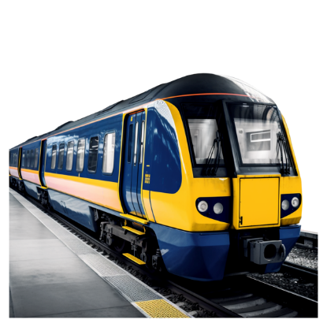

Norwich to Cambridge / Stansted line
This is what we think is important to make this line better:
- More trains on this route
- Faster journeys lasting only 70 minutes between Norwich and Cambridge
- Better connections with other train services
Do you agree or disagree with our ideas for the Norwich to Cambridge / Stansted line?
 Please tick one box
☐ Strongly agree
☐ Agree
☐ Neither agree or disagree
☐ Disagree
☐ Strongly Disagree

If you have any comments, please let us know here:

Norwich to Nottingham / Liverpool Lime Street line
This is what we think is important to make this line better:
- Better connections with other train services
- Faster journeys
- Better trains with wi-fi
- Longer trains to carry more passengers
Do you agree or disagree with our ideas for the Norwich to Nottingham / Liverpool Lime Street line?
Please tick one box
☐ Strongly agree
☐ Agree
☐ Neither agree or disagree
☐ Disagree
☐ Strongly Disagree

If you have any comments, please let us know here:

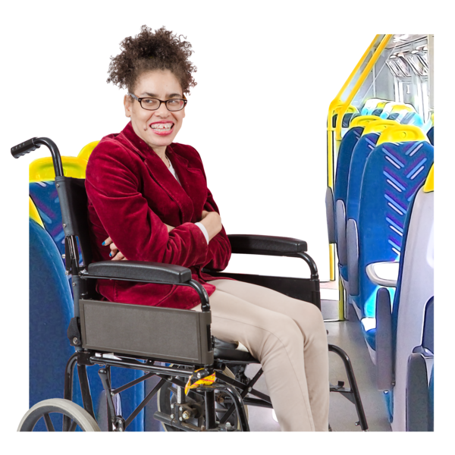

Norwich to Sheringham line (Bittern line)
This is what we think is important to make this line better:
- A new station at Broadland Business Park, Norwich
- More trains leaving every 30 minutes

Do you agree or disagree with our ideas for the Norwich to Sheringham line (Bittern line)?
Please tick one box
☐ Strongly agree
☐ Agree
☐ Neither agree or disagree
☐ Disagree
☐ Strongly Disagree
If you have any comments, please let us know here:

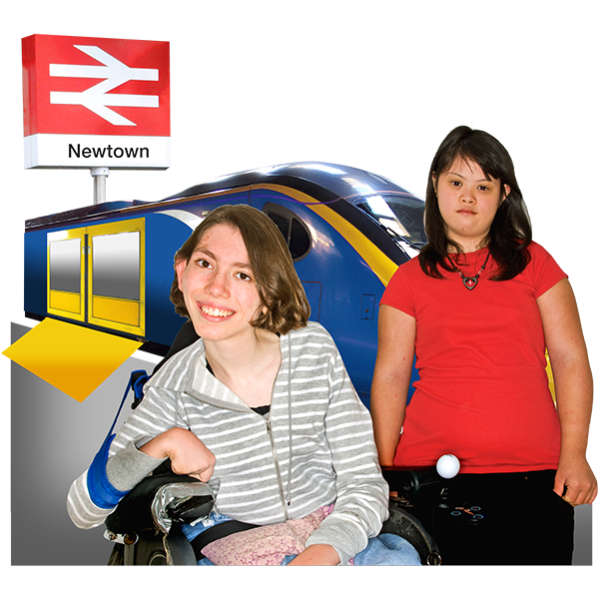

Norwich to Great Yarmouth and Lowestoft (Wherry lines)
This is what we think is important to make this line better:
- Good connections at Norwich
- Improvements to railway stations – particularly the railway stations in and near Great Yarmouth
Do you agree or disagree with our ideas for the Norwich to Great Yarmouth and Lowestoft (Wherry lines)?
Please tick one box
☐ Strongly agree
☐ Agree
☐ Neither agree or disagree
☐ Disagree
☐ Strongly Disagree
If you have any comments, please let us know here:
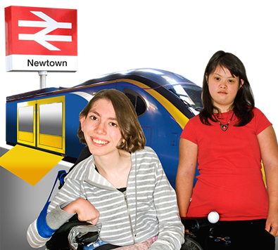

Community Rail and Private Lines – there are some interesting old lines in Norfolk that are open for people to visit or travel on, or where people help to save railway history such as old lines, trains or stations.
We think that Norfolk County Council should continue to help the people who run these lines, especially to help them to find money to run trains and stations.
Do you agree with this?
Please tick one box
☐ Strongly agree
☐ Agree
☐ Neither agree or disagree
☐ Disagree
☐ Strongly Disagree
If you have any comments, please let us know here:

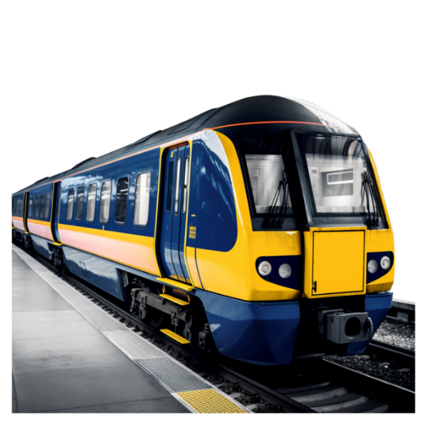

Could Norfolk re-open some old railway lines?
Some people think that we should re-open some old railway lines that were closed many years ago.
These are the lines that they would like to re-open:
- Wymondham to Dereham
- King’s Lynn to Hunstanton
- Great Yarmouth Station to Great Yarmouth Port
- Norfolk Orbital Railway (Wymondham-Dereham-Fakenham-Holt-Sheringham)

Because re-opening a railway line is very expensive, and difficult (as sometimes houses have been built on the old railway line), we think that each idea for a re-opened line needs to be thought about very carefully - and be affordable and value for money.

And we also have an idea that some old railway lines could be used for people to walk and cycle along.

Do agree with the ideas about new or re-opened lines?
Please tick one box
☐ Strongly agree
☐ Agree
☐ Neither agree or disagree
☐ Disagree
☐ Strongly Disagree

If you have any comments, please let us know here:

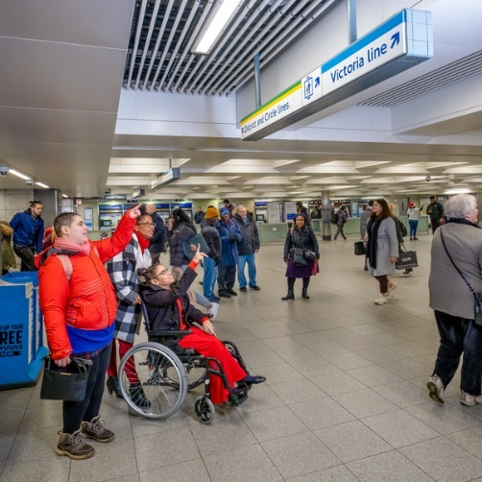
- Stations
This section is about railway stations.
This is what we think is important for Norfolk’s railway stations:
• Keep ticket offices open at the larger stations (Norwich, Thetford, Diss, Great Yarmouth, Downham Market and King’s Lynn)
• Staff at the stations to sell tickets (at medium-sized stations)
• Easy to access buses and taxis outside stations
• Direct and safe walking and cycling paths to and from stations
• Clear signs to railway stations and nearby shops and paths
• Railway stations to have CCTV and safe bicycle parking
• Places to wait at stations that are under cover
• Good bus links to local towns
• Accessible stations and facilities
• Better car parking

Do you agree or disagree with the ideas for Norfolk’s railway stations?
Please tick one box
☐ Strongly agree
☐ Agree
☐ Neither agree or disagree
☐ Disagree
☐ Strongly Disagree

If you have any comments, please let us know here:

Could Norfolk have some new railway stations?
There are several new stations which some people think are needed.

People think new stations are needed at these places:
- Broadland Business Park, Norwich
- Postwick, Norwich
- Rackheath
- North Thetford
- King’s Lynn
- South West Norwich
- Forncett St Mary or Long Stratton
- Wisbech
Because a new station can slow down train travel and is very expensive, we think that each idea for a new station needs to be thought about very carefully - and be affordable and value for money, and also be near where people would want a station and use it most.

Do you agree or disagree with our thoughts on possible new stations?
Please tick one box
☐ Strongly agree
☐ Agree
☐ Neither agree or disagree
☐ Disagree
☐ Strongly Disagree
If you have any comments, please let us know here:

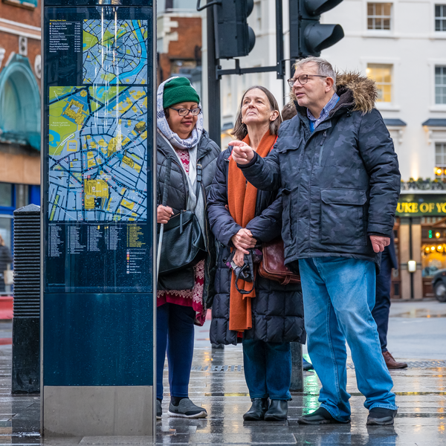

- Network
This section is about the railway network.

This is what we think is important for Norfolk’s railway network:
- Make trains less crowded
- Better connect our trains with other areas of the country
- Make buying tickets easier
- Improve links with buses and taxis
- Make it easier to cycle and walk to a railway station
- Transport more things on trains rather than on lorries
- Make trains more environmentally friendly

Do you agree or disagree with the ideas for Norfolk’s railway network?
Please tick one box
☐ Strongly agree
☐ Agree
☐ Neither agree or disagree
☐ Disagree
☐ Strongly Disagree

If you have any comments, please let us know here:



- Freight
This section is about freight.
We’d like more things to be transported on trains rather than on lorries to make roads less busy, help cut pollution and support local jobs.

Do you agree or disagree with this?
Please tick one box
☐ Strongly agree
☐ Agree
☐ Neither agree or disagree
☐ Disagree
☐ Strongly Disagree
If you have any comments, please let us know here:

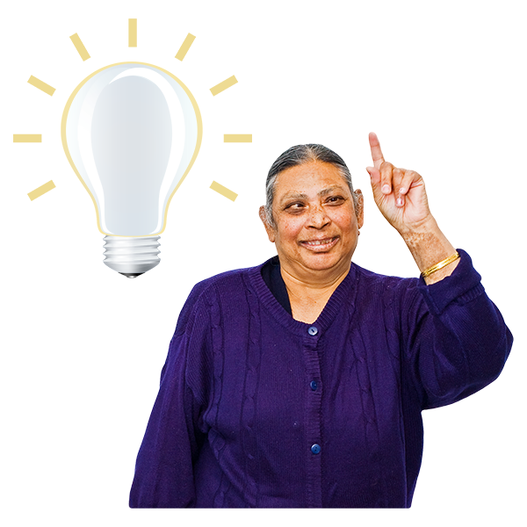

- General Comments
If you have anything else you would like to tell us about train travel or things that would make Norfolk’s railways better, please tell us here.


Questions about you

It would be helpful to know more about you. This helps us to see if different people think our idea is good or bad.

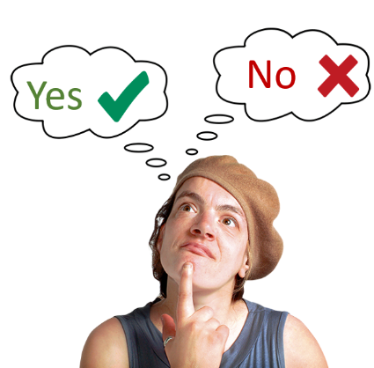

You do not have to answer these questions.


If you answer these questions, we will keep your information safe. We will not share it with anyone.

Question 1
What is your sex?
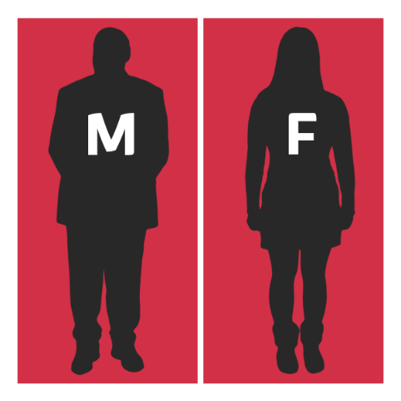
Sex: Your sex is whether you were born as a man or a woman.

☐ Male

☐ Female

Question 2
Is your gender the same as the one you were given at birth?
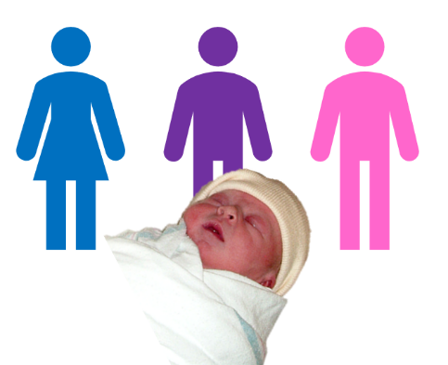
Gender: Gender is whether you like to be known as male, female, or something else.

Please tick one box.

☐ Yes

☐ No

☐ I prefer not to tell you

Question 3
How old are you?

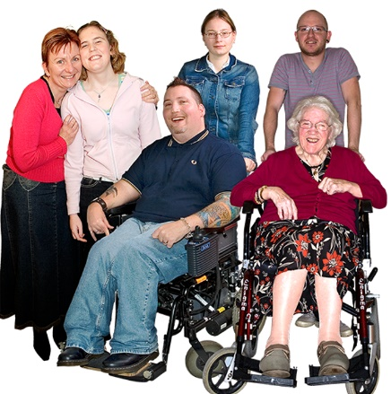
Please write your age in the box below.

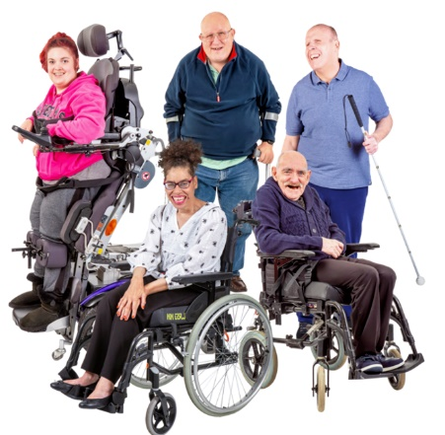
Question 4: Are any of these true for you?

☐ I have a disability

☐ I have had a health condition for a long time

☐ None of these

☐ Prefer not to say
Question 5
Which of these describes your health condition or disability?

☐ Blind or partially sighted

☐ D/deaf or hard of hearing

☐ Limiting health condition – e.g., heart disease, asthma, strokes, osteoarthritis, fibromyalgia etc.

☐ Learning disabilities
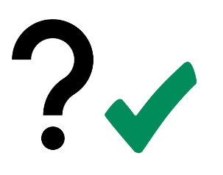
☐ Neurodiversity – e.g., Autism, dyslexia, dyspraxia

☐ Mental health conditions – e.g. depression, schizophrenia, eating disorders, obsessive compulsive disorder

☐ Physical disability – e.g., amputee, wheelchair user, cerebral palsy, motor neurone disease, muscular dystrophy.

☐ Other disability
☐ I prefer not to tell you
☐ None of these

Question 6

What is your ethnicity?

Ethnicity is your race or
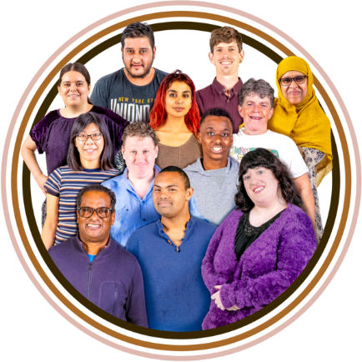
background. For example, Black,
White or Asian.

Please tick one box

Asian or Asian British
☐ Asian British
☐ Indian
☐ Pakistani
☐ Bangladeshi
☐ Chinese
☐ Other Asian background
Black, Black British, Caribbean or African

☐ Black British
☐ Caribbean
☐ African
☐ Other Black, Black British or Caribbean background
Mixed or multiple ethnic groups
☐ White and Black Caribbean
☐ White and Black African
☐ White and Asian
☐ Other mixed or multiple group
White or White British

☐ English, Welsh, Scottish, Northern Irish or British Irish

☐ Gypsy or Irish Traveller
☐ Roma
☐ Other White background

Another ethnic group

☐ Arab

If you’re from another ethnic group, please write in the box:

☐ Prefer not to say

Question 7
What is your first language?

Please tick one box.

☐ English

If another language is your first language, please write the name of it in the box below.

Question 8
Are you a carer?

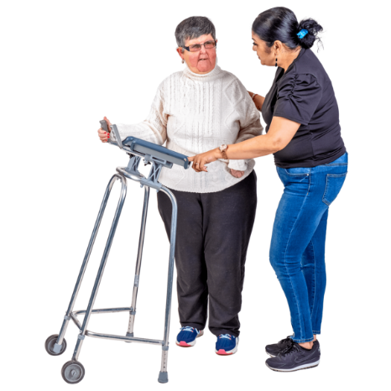
Please tick one box.

☐ Yes

☐ No

☐ I prefer not to tell you

Question 9
Which area of Norfolk do you live in?

Please tick one box only
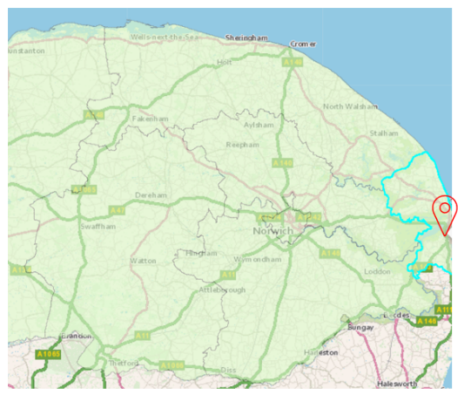
☐ Breckland

☐ Broadland

☐ Great Yarmouth

☐ King’s Lynn and West Norfolk

☐ North Norfolk

☐ Norwich

☐ South Norfolk
Question 10
Are you currently…?
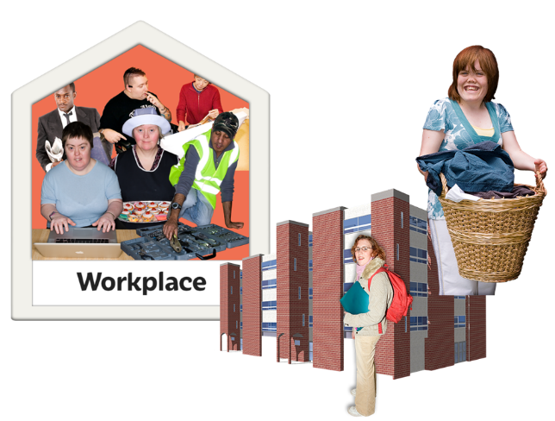
Please tick one box only

☐ Employed – full time

☐ Employed – part time

☐ Self employed

☐ Unemployed

☐ Student

☐ Long term sick

☐ Retired

Question 11
Who are you answering these questions for?

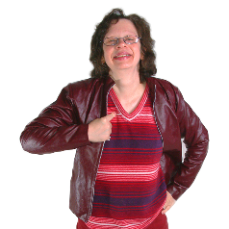
Please tick one box only

☐ Myself

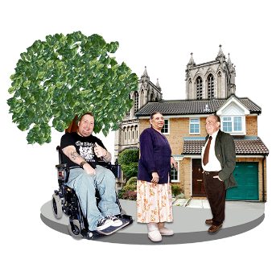

☐ For a voluntary or community group

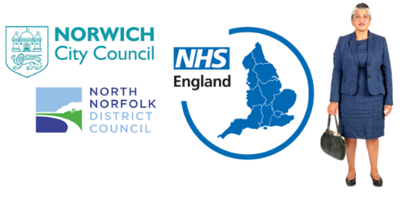
☐ For a statutory organisation

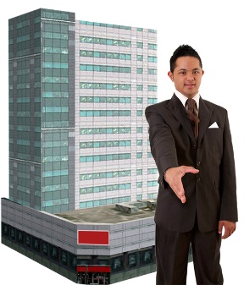
☐ For a business

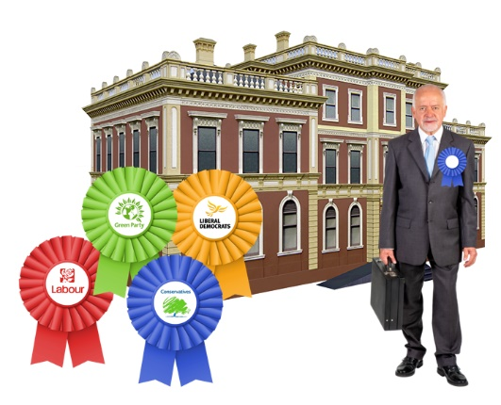
☐ As a Norfolk County councillor

☐ As a district or borough councillor

☐ As a town or parish councillor
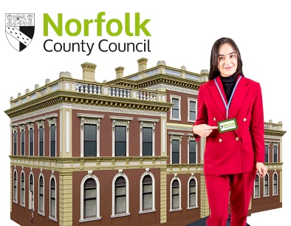

☐ As a Norfolk County Council employee

Question 12:
If you are answering these
questions for an organisation
please tell us the name of the
organisation here, and the email
address.
Organisation:

Email address:

Thank you for taking the time to read this survey and
tell us your views.

Next steps

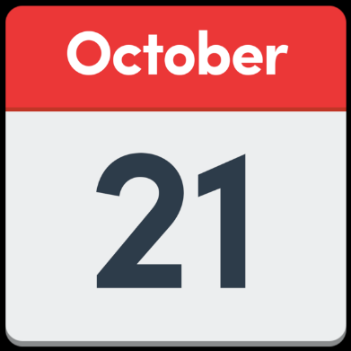
This consultation closes

on 21 October 2024. We
won’t take feedback past
that date.

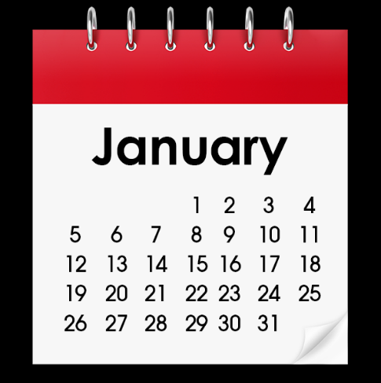
The County Council will think about what people have
told us about these ideas in
January 2025.

