THE NORFOLK COUNTY COUNCIL (BRANCASTER STAITHE, THE CLOSE)
(20 M.P.H. SPEED LIMIT ZONE) ORDER 2024 .

The Norfolk County Council in exercise of its powers under Sections 84(1) and (2) and 122 and parts III and IV of Schedule 9 of the Road Traffic Regulation Act 1984, and of all other enabling powers, and after consultation with the Chief Officer of Police in accordance with Part III of Schedule 9 to the Act, hereby make the following Order:-

1. This Order may be cited as the Norfolk County Council (Brancaster Staithe, The Close) (20 M.P.H. Speed Limit Zone) Order 2024 and shall come into effect on the 22nd day of January 2024.

2. No person shall cause or permit any vehicle to proceed along the length of road set out in the Schedule to this Order at a speed exceeding 20 miles per hour.

3. No speed limit imposed by this Order applies to vehicles falling within regulation 3(4) of the Road Traffic Exemptions (Special Forces) (Variation and Amendment) Regulations 2011 when used in accordance with Regulation 3(5) of those Regulations.

4. The Norfolk County Council (Brancaster Staithe, Various Roads) (20 m.p.h. and 30m.p.h. Speed Limits Order 2018 is amended by the deletion the following wording relating to The Close as set out in Schedule 1 to that Order:-

“U22561 The Close | - | For its entire length including the Turning Head.”

5. Insofar as any provision of this Order conflicts with any provision of any previous Order relating to the length of road specified in the Schedule to this Order, that provision of this Order shall prevail.

SCHEDULE
In the Parish of Brancaster Staithe
20mph Speed Limit Zone

U22561/10 The Close | - | From its junction with A149 Main Road for 182 metres southwards, then eastwards, then northwards, including turning heads
U22561/20 The Close | - | From its junction with U22561/10 The Close for 37 metres southwards
U22561/30 The Close | - | From its junction with U22561/20 The Close for 27 metres westwards

Dated this 16th day of January 2024
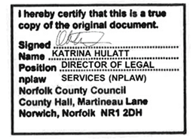
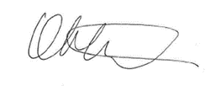

Katrina Hulatt
Director of Legal Services (nplaw)

HKS/143124BrancasterStaithePR3936-20mphZoneOrder)24

