The Norfolk County Council
(North & South Creake, B1355 Church Street/Burnham Road/The Common)
(50 M.P.H. Speed Limit) Order 2023 .

The Norfolk County Council in exercise of its powers under Sections 84(1) and (2) and 122 and parts III and IV of Schedule 9 of the Road Traffic Regulation Act 1984 (hereinafter referred to as "the Act"), and of all other enabling powers, and after consultation with the Chief Officer of Police in accordance with Part III of Schedule 9 to the Act, hereby make the following Order:-

- This Order may be cited as The Norfolk County Council (North & South Creake, B1355 Church Street/Burnham Road/The Common) (50 m.p.h. Speed Limit) Order 2023 and shall come into effect on the 6th day of March 2023.

- No person shall cause or permit any vehicle to proceed at a speed exceeding 50 miles per hour along the length of the B1355 Church Street/Burnham Road, and B1355 The Common as set out in Schedule 1 of this Order.

- No speed limit imposed by this order applies to vehicles falling within regulation 3(4) of the Road Traffic Exemptions (Special Forces) (Variation and Amendment) Regulations 2011 when used in accordance with Regulation 3(5) of those Regulations.

- Insofar as any provision of this Order conflicts with any provision of any previous Order relating to the lengths of road specified in the Schedule to this Order, the provision of this Order shall prevail.

SCHEDULE 1
In the Parishes of North & South Creake
50 m.p.h. Speed Limit

B1355 Church Street & B1355 Burnham Road (North & South Creake) | - | From a point 118 metres north of its junction with the U23571 Church Lane northwards for 1220 metres.
B1355 The Common (South Creake) | - | From the mid-point of its junction with the U22289 Roman Road northwards and westwards for 1385 metres.

Dated this 28th day of February 2023
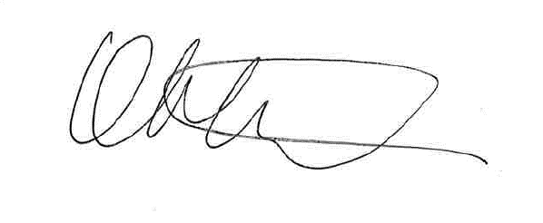

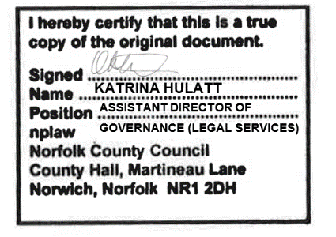
Assistant Director of Governance (Legal Services)

ALW/74232(North&SouthCreakePLA950-50mphSLO)23

