The Norfolk County Council
(South Creake, B1355 Burnham Road)
(30 M.P.H. Speed Limit) Order 2023 .

The Norfolk County Council in exercise of its powers under Sections 84(1) and (2) and 122 and parts III and IV of Schedule 9 of the Road Traffic Regulation Act 1984 (hereinafter referred to as "the Act"), and of all other enabling powers, and after consultation with the Chief Officer of Police in accordance with Part III of Schedule 9 to the Act, hereby make the following Order:-

- This Order may be cited as The Norfolk County Council (South Creake, B1355 Burnham Road) (30 m.p.h. Speed Limit) Amendment Order 2023 and shall come into effect on the 6th day of March 2023.

- The Norfolk County Council (South Creake) (30 m.p.h. & 40 m.p.h. Speed Limit)
Order 1997 (hereinafter referred to as the “1997 Order”) is amended by the deletion of the references to the lengths of road referred to in the Schedule to this Order.

- The Norfolk County Council (South Creake, B1355) (30 m.p.h. Speed Limit) Order 2001 (hereinafter referred to as the “2001 Order”) is hereby revoked.

- No person shall cause or permit any vehicle to proceed at a speed exceeding 30 miles per hour along the lengths of the B1355 Burnham Road/ Front Street/ Fakenham Road as set out in the Schedule to this Order.

- No speed limit imposed by this order applies to vehicles falling within regulation 3(4) of the Road Traffic Exemptions (Special Forces) (Variation and Amendment) Regulations 2011 when used in accordance with Regulation 3(5) of those Regulations.

- Insofar as any provision of this Order conflicts with any provision of any previous Order relating to the lengths of road specified in the Schedule to this Order, the provision of this Order shall prevail.

SCHEDULE 1
In the Parish of South Creake
30 m.p.h. Speed Limit
B1355 Burnham Road | - | From a point 118 metres north of its junction with the U23571 Church Lane southwards for 560 metres.
B1355 Front Street/ Fakenham Road | - | From a point 20 metres north-west of the centreline of its junction with U22185 Back Street south-eastwards for 750 metres.

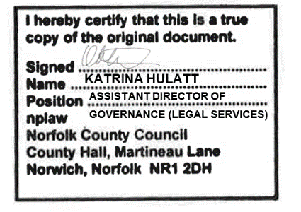
Dated this 28th day of February 2023
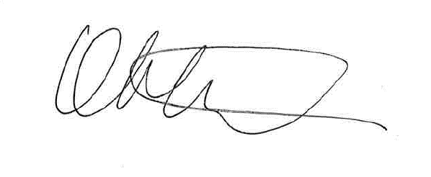

Assistant Director of Governance (Legal Services)

