Community & Environmental Services
County Hall
Martineau Lane
Norwich
NR1 2SG
NCC contact number: 0344 800 8020
Text relay no.: 18001 0344 800 8020

Your Ref: My Ref: PAA005/ID/KP/01
Date: 18 January 2021 Tel No.: 0344 800 8020
Email: transportfornorwich@norfolk.gov.uk

Dear Sir/Madam,

Transport for Norwich: consultation on proposals for Cromer Road/Aylsham Road

Norfolk County Council and the Transport for Norwich (TfN) partnership are asking for feedback on proposals to introduce new sections of bus lane along Cromer Road and Aylsham Road. We’re writing to let you know how to find out more about the project and how to take part in our consultation.

What’s being proposed and why
This table explains what changes we’re proposing and the reasons behind them. The enclosed plan shows what the project would look like on the ground.

Proposal | Reason for proposal
New 24-hour bus/cycle lane, heading towards the city, between Fifers Lane and Mayfield Avenue along Cromer Road. | Cromer Road/Aylsham Road is a key public transport corridor from North Norfolk, Hellesdon and the Airport Park & Ride site. However, bus passengers are currently delayed by congested traffic conditions and there are no facilities for those wanting to cycle in this area. Traffic modelling forecasts that the new bus lanes will reduce bus journey times for all bus services using Aylsham Road and Cromer Road, particularly in the morning peak, by 15 to 20 per cent. The impact for general traffic using roads in the local area is low, with an increase in peak-period journey times of between 5 and 10 per cent.
New 24-hour bus/cycle lane, heading towards the city, between Suckling Avenue and Woodcock Road along Aylsham Road. | As above.
New double yellow lines along the new sections of bus/cycle lane above. | To allow installation of the new bus/cycle lane and free-flow movement of buses and cycles. No designated on-street parking spaces are affected.
Extension of double yellow lines between Losinga Crescent and Suckling Avenue. | Buses and general traffic heading out of the city are currently delayed by parked vehicles along this stretch of road where traffic is effectively reduced to one lane instead of two. Removal of parking will improve the flow of buses and general traffic in this area. No designated on-street parking spaces are affected.

Resurfacing of the road in this area would also be carried out at the same time as this scheme to minimise disruption and improve overall value for money.

How to comment
There are two ways to comment on the consultation:
- Visit www.norfolk.gov.uk/cromerroad where you can complete our online survey to share your thoughts on the proposals.
- Ask for a hard copy of the survey by calling or emailing us using the details at the top of this letter. Large font and other formats are available on request.
Next Steps
The deadline for comments is 10am on Wednesday 10 February 2021. We will carefully consider all responses and report back to the Transforming Cities Fund Joint Committee later in the year. The committee, which is chaired by Norfolk County Council and made up of councillors from TfN partners Norwich City, Broadland District and South Norfolk councils, will then decide how to proceed with the project. The webpage above will be kept up to date with the latest progress and information.

Background
The Department for Transport (DfT) has awarded £32m of funding to TfN from the Transforming Cities Fund to deliver a range of schemes across Greater Norwich. These projects aim to improve access to jobs, training and retail by supporting improvements to sustainable modes of transport, while also responding to issues around air quality.

More information about our application to the DfT and all the proposed schemes can be found at www.norfolk.gov.uk/transformingcities. You can also read more about previous, current and future TfN projects by visiting www.norfolk.gov.uk/tfn.

Yours faithfully,
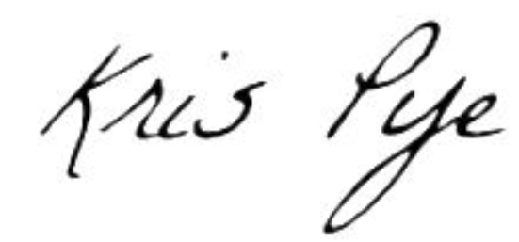
Kris Pye
Technician

