**Your views on our idea to**

**switch off a further 2% of**

**Norfolk County Council**

**maintained streetlights**

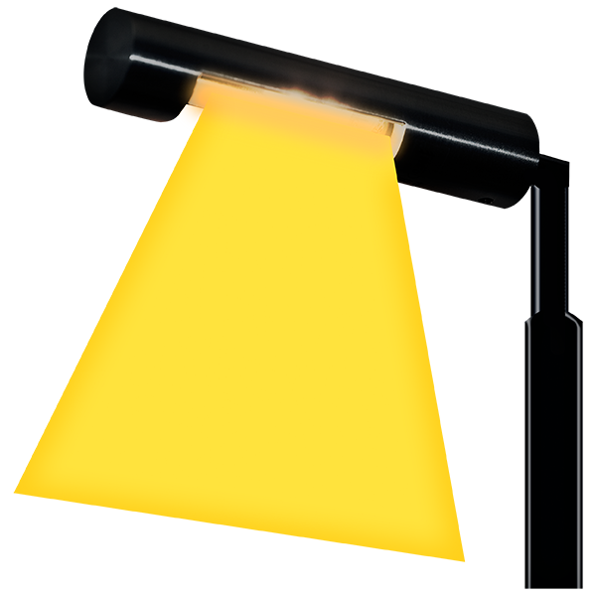

**Some of the things in this paper are not easy to understand.**

**You may need help from someone to read it.**

Norfolk County Council is responsible for a lot of things in Norfolk

Services such as Libraries, the Fire Service and recycling centres (and lots of other things too)!

To do this, we spend over one billion pounds each year.

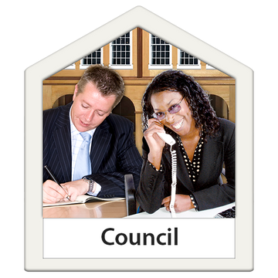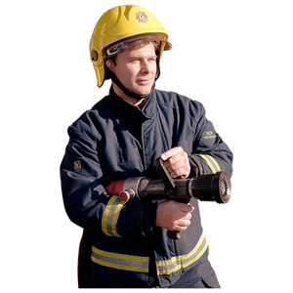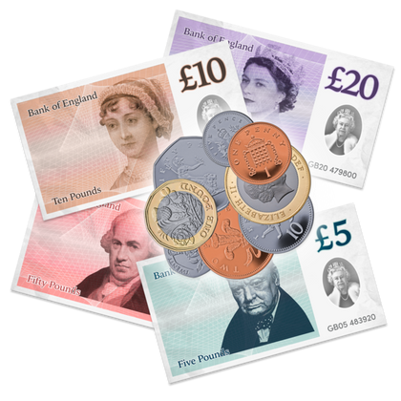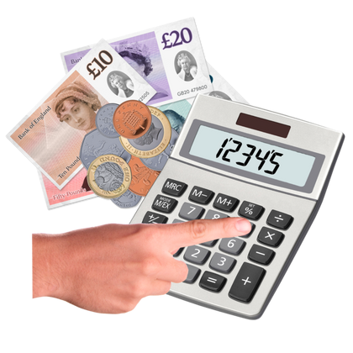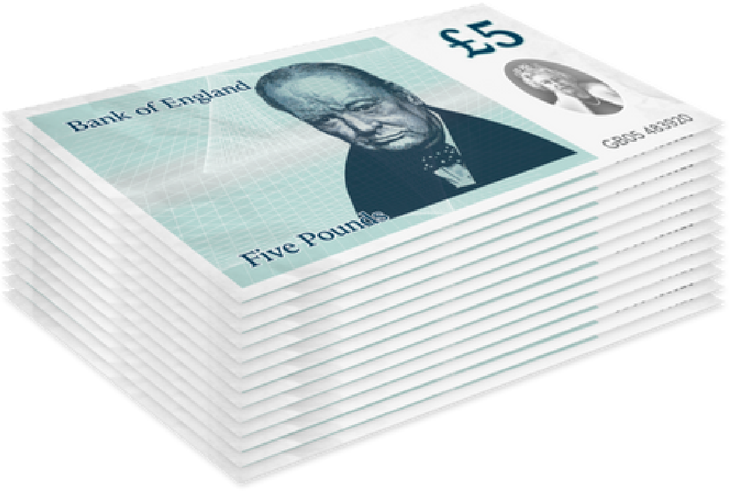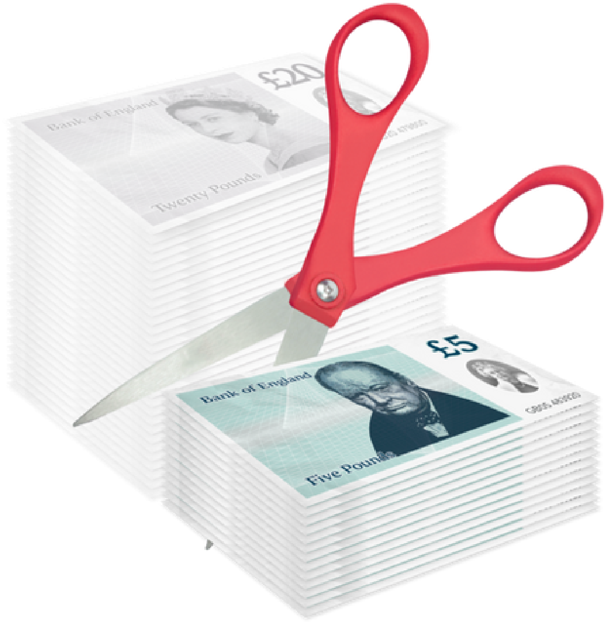

We must be sure the money we spend matches the money we get in. This is hard to do at the moment.

Things are getting more expensive. The money we get isn’t covering what things now cost.

We need to save money by cutting what we spend. We have been saving money between 2011 and 2024. However, we need to save another **£44.722 million** in 2025



We want to hear what you think of one of the ideas we have to save money and reduce our impact on the environment.

Our idea is about streetlights in Norfolk.

Norfolk County Council is responsible for almost 54,000 streetlights across Norfolk.

Because of the energy crisis, the price of electricity has risen, and it now costs the council a lot more to run streetlights.

Last year we had an idea to turn off 2% of our streetlights, and we are now asking what people think about our idea to turn off another 2% more.

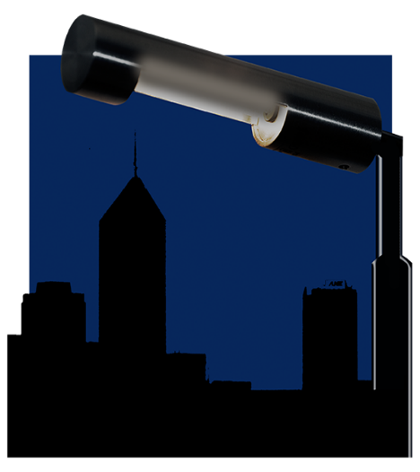

Our target is to turn off 2% of streetlights across Norfolk, this would affect around 1,000 lights.

We have found 132 locations to switch off lights. If we turn off all of the lights in the list that means we would reach our target of 2%.

If this idea is accepted, we will speak with the Network Safety Team and the Police, to make sure all the areas are suitable to be switched off.

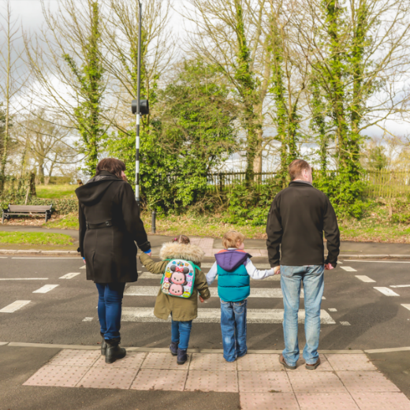People’s safety is our priority so we will only switch off lights in areas where not a lot of people walk, drive or cycle.

If agreed, this idea could save the council approximately £200,000 a year (based on current prices) and help reduce pollution.

On the next x pages you will see a list of the 33 locations that we are currently looking to switch off streetlights.

The list includes the area, road name, and a brief description, to show where we are thinking of switching the lights off.

| **Parish** | **Road Name** | **Description** |
| --- | --- | --- |
| Attleborough | HAVERSCROFT INDUSTRIAL ESTATE | INDUSTRIAL ROAD |
| Attleborough | MAURICE GAYMER ROAD | INDUSTRIAL ROAD |
| Bradwell | EDISON WAY | INDUSTRIAL ROAD |
| Bradwell | FARADAY ROAD | INDUSTRIAL ROAD |
| Bradwell | JAMES WATT CLOSE | INDUSTRIAL ROAD |
| Bradwell | LEFEVRE WAY | INDUSTRIAL ROAD |
| Bradwell | SHUTTLEWORTH CLOSE | INDUSTRIAL ROAD |
| Bradwell | VANGUARD ROAD | INDUSTRIAL ROAD |
| Bradwell | VIKING ROAD | INDUSTRIAL ROAD |
| Bradwell | HEWETT ROAD* | INDUSTRIAL ROAD |
| Dereham | BERTIE WARD WAY | INDUSTRIAL ROAD |
| Dereham | HALL LANE | INDUSTRIAL ROAD |
| Dereham | GREENS ROAD* | INDUSTRIAL ROAD |
| Dereham | RASHS GREEN* | INDUSTRIAL ROAD |
| Diss | OWEN ROAD | INDUSTRIAL ROAD |
| Downham Market | SOVEREIGN WAY | INDUSTRIAL ROAD |
| Fakenham | GARROOD DRIVE | INDUSTRIAL ROAD |
| Fakenham | MILLERS CLOSE | INDUSTRIAL ROAD |
| Fakenham | WYMANS WAY | INDUSTRIAL ROAD |
| Fakenham | ENTERPRISE WAY | INDUSTRIAL ROAD |
| Fakenham | GEORGE EDWARDS ROAD* | INDUSTRIAL ROAD |
| Great Yarmouth North | BEEVOR ROAD | INDUSTRIAL ROAD |
| Great Yarmouth North | BLOOMFIELD ROAD | INDUSTRIAL ROAD |
| Great Yarmouth North | FENNER ROAD | INDUSTRIAL ROAD |
| Great Yarmouth North | FISHWHARF | INDUSTRIAL ROAD |
| Great Yarmouth North | MONUMENT ROAD | INDUSTRIAL ROAD |
| Great Yarmouth North | SALMON ROAD | INDUSTRIAL ROAD |
| Great Yarmouth North | SUFFLING ROAD | INDUSTRIAL ROAD |
| Great Yarmouth North | SWANSTONS ROAD | INDUSTRIAL ROAD |
| Great Yarmouth North | POMMERS LANE | INDUSTRIAL ROAD |
| Great Yarmouth North | BATTERY ROAD | INDUSTRIAL ROAD |
| Great Yarmouth North | MIDDLE ROAD EAST | INDUSTRIAL ROAD |
| Great Yarmouth North | MIDDLE ROAD WEST | INDUSTRIAL ROAD |
| Great Yarmouth North | ADMIRALTY ROAD* | INDUSTRIAL ROAD |
| Great Yarmouth South | BESSEMER WAY | INDUSTRIAL ROAD |
| Great Yarmouth South | BRINELL WAY | INDUSTRIAL ROAD |
| Great Yarmouth South | OWEN ROAD | INDUSTRIAL ROAD |
| Great Yarmouth South | HARFREYS ROAD* | INDUSTRIAL ROAD |
| Great Yarmouth South | BOUNDARY ROAD* | INDUSTRIAL ROAD |
| Harleston | FULLER ROAD | INDUSTRIAL ROAD |
| Harleston | SPEEDWELL WAY | INDUSTRIAL ROAD |
| Harleston | MAYFLOWER WAY | INDUSTRIAL ROAD |
| Hellesdon | ALSTON ROAD | INDUSTRIAL ROAD |
| Hellesdon | HELLESDON PARK ROAD* | INDUSTRIAL ROAD |
| Hingham | IRONSIDE WAY | INDUSTRIAL ROAD |
| King’s Lynn | ACER ROAD | INDUSTRIAL ROAD |
| King’s Lynn | BRYGGEN ROAD | INDUSTRIAL ROAD |
| King’s Lynn | DENNEY ROAD | INDUSTRIAL ROAD |
| King’s Lynn | FRIESIAN WAY | INDUSTRIAL ROAD |
| King’s Lynn | HAMLIN WAY | INDUSTRIAL ROAD |
| King’s Lynn | HEREFORD WAY | INDUSTRIAL ROAD |
| King’s Lynn | HORSLEYS FIELDS | INDUSTRIAL ROAD |
| King’s Lynn | LARCH ROAD | INDUSTRIAL ROAD |
| King’s Lynn | MAPLE ROAD | INDUSTRIAL ROAD |
| King’s Lynn | PAXMAN ROAD | INDUSTRIAL ROAD |
| King’s Lynn | PIPER ROAD | INDUSTRIAL ROAD |
| King’s Lynn | ROLLESBY ROAD | INDUSTRIAL ROAD |
| King’s Lynn | ROWAN ROAD | INDUSTRIAL ROAD |
| King’s Lynn | SIMON SCOTLAND ROAD | INDUSTRIAL ROAD |
| King’s Lynn | HORSELEY CHASE | INDUSTRIAL ROAD |
| King’s Lynn | BERGEN WAY* | INDUSTRIAL ROAD |
| King’s Lynn | BEVERIDGE WAY* | INDUSTRIAL ROAD |
| King’s Lynn | ESTUARY ROAD* | INDUSTRIAL ROAD |
| King’s Lynn | GREENYARD WAY* | INDUSTRIAL ROAD |
| King’s Lynn | HAMBURG WAY* | INDUSTRIAL ROAD |
| King’s Lynn | HANSA ROAD* | INDUSTRIAL ROAD |
| Little Cressingham | THREXTON ROAD INDUSTRIAL ESTATE | INDUSTRIAL ROAD |
| Loddon | LITTLE MONEY ROAD | INDUSTRIAL ROAD |
| North Walsham | CORNISH WAY | INDUSTRIAL ROAD |
| North Walsham | GAYMERS WAY | INDUSTRIAL ROAD |
| North Walsham | STANFORD TUCK ROAD | INDUSTRIAL ROAD |
| North Walsham | FOLGATE ROAD* | INDUSTRIAL ROAD |
| North Walsham | LAUNDRY LOKE* | INDUSTRIAL ROAD |
| Norwich North | AUSTER CLOSE | INDUSTRIAL ROAD |
| Norwich North | BEECH DRIVE | INDUSTRIAL ROAD |
| Norwich North | BURNET ROAD | INDUSTRIAL ROAD |
| Norwich North | BURTON CLOSE | INDUSTRIAL ROAD |
| Norwich North | BURTON ROAD | INDUSTRIAL ROAD |
| Norwich North | CALEY CLOSE | INDUSTRIAL ROAD |
| Norwich North | CONCORDE ROAD | INDUSTRIAL ROAD |
| Norwich North | DELTA CLOSE | INDUSTRIAL ROAD |
| Norwich North | DIAMOND ROAD | INDUSTRIAL ROAD |
| Norwich North | FRENSHAM ROAD | INDUSTRIAL ROAD |
| Norwich North | JAVELIN ROAD | INDUSTRIAL ROAD |
| Norwich North | LIBERATOR ROAD | INDUSTRIAL ROAD |
| Norwich North | METEOR CLOSE | INDUSTRIAL ROAD |
| Norwich North | NAYLOR ROAD | INDUSTRIAL ROAD |
| Norwich North | PAGE ROAD | INDUSTRIAL ROAD |
| Norwich North | SPITFIRE ROAD | INDUSTRIAL ROAD |
| Norwich North | BARROW CLOSE | INDUSTRIAL ROAD |
| Norwich North | BRUNEL WAY | INDUSTRIAL ROAD |
| Norwich North | ALBERTINE CLOSE | INDUSTRIAL ROAD |
| Norwich North | HELLESDON HALL ROAD* | INDUSTRIAL ROAD |
| Norwich North | HURRICANE WAY* | INDUSTRIAL ROAD |
| Norwich North | MASON ROAD* | INDUSTRIAL ROAD |
| Norwich North | SPAR ROAD* | INDUSTRIAL ROAD |
| Norwich North | VULCAN ROAD SOUTH | INDUSTRIAL ROAD |
| Norwich North | WHIFFLER ROAD | INDUSTRIAL ROAD |
| Norwich South | EUROPA WAY | INDUSTRIAL ROAD |
| Norwich South | BESSEMER ROAD* | INDUSTRIAL ROAD |
| Norwich South | WHITING ROAD* | INDUSTRIAL ROAD |
| Norwich West | CHARLES WATLING WAY | INDUSTRIAL ROAD |
| Norwich West | FRANCIS WAY | INDUSTRIAL ROAD |
| Norwich West | JARROLD WAY | INDUSTRIAL ROAD |
| Norwich West | KINGSWAY | INDUSTRIAL ROAD |
| Norwich West | MORGAN WAY | INDUSTRIAL ROAD |
| Norwich West | PADDOCK STREET | INDUSTRIAL ROAD |
| Norwich West | ROBBERDS WAY | INDUSTRIAL ROAD |
| Norwich West | MARRIOTT CLOSE | INDUSTRIAL ROAD |
| Norwich West | BARKER STREET* | INDUSTRIAL ROAD |
| Norwich West | BARNARD ROAD* | INDUSTRIAL ROAD |
| Sprowston | PINETREES ROAD | INDUSTRIAL ROAD |
| Tharston | SALAMANCA ROAD | INDUSTRIAL ROAD |
| Tharston | WELLESLEY ROAD | INDUSTRIAL ROAD |
| Tharston | WELLINGTON ROAD | INDUSTRIAL ROAD |
| Thetford | BAIRD WAY | INDUSTRIAL ROAD |
| Thetford | BRICKFIELDS WAY | INDUSTRIAL ROAD |
| Thetford | BRUNEL WAY | INDUSTRIAL ROAD |
| Thetford | LODGE WAY | INDUSTRIAL ROAD |
| Thetford | ROMAN WAY | INDUSTRIAL ROAD |
| Thetford | RUTHERFORD WAY | INDUSTRIAL ROAD |
| Thetford | ST HELENS WAY | INDUSTRIAL ROAD |
| Thetford | TELFORD WAY | INDUSTRIAL ROAD |
| Thetford | BURRELL WAY* | INDUSTRIAL ROAD |
| Thetford | CAXTON WAY* | INDUSTRIAL ROAD |
| Thetford | FISON WAY* | INDUSTRIAL ROAD |
| Thetford | HOWLETT WAY* | INDUSTRIAL ROAD |
| Thetford | STEPHENSON WAY* | INDUSTRIAL ROAD |
| Thorpe St Andrew | CENTRAL AVENUE | INDUSTRIAL ROAD |
| Thorpe St Andrew | NORTHSIDE* | INDUSTRIAL ROAD |
| Wymondham | VALLEY SIDE | INDUSTRIAL ROAD |
| Wymondham | AYTON ROAD* | INDUSTRIAL ROAD |
| * Whole road to be included in the consultation but will likely be only part of the road which can be de-illuminated | | |

We would like to hear your views on our proposals.

You do not have to answer all of the questions, only the ones you want to.

Please send us your response by **16 December 2024** (we may not accept your response if we receive it after that date).

**Question 1. Do you agree or disagree with our idea to reduce street lighting by 2%?**

Please tick one box 🗹

Strongly agree 🞏

Agree 🞏

Neither agree or disagree 🞏

Disagree 🞏

Strongly disagree 🞏

Don’t know 🞏

**Question 2. Please tell us why you said that – and if you have any further comments about our ideas.**

Please write in the box below.

**Question 3 Please tell us of any other places you think that streetlights could be switched off**.

Please write in the box below.

**About You**

Please tell us about yourself.

This will help us to make our decisions.

We will keep your information safe. We will not share it with anyone.

**Question 7. How did you hear about this consultation?**

Local media (e.g newspaper, radio)

From a social media post (e.g Facebook)

From a friend

From a group I belong to

From my place of work or education

The Norfolk Residents’ Panel

District Council web page

Norfolk County Council web page

My Parish Council

From an email I received

Other, please write here:





**Question 8. How old are you?**

Please write your age in the box below.

**Question 9. Are you?**

Please tick one box 🗹

Yes

No, write in gender identity here:



**Question 10. Is the gender you identify with the same as your sex registered at birth?**

Male

Female



**Question 11. Do you have any long-term illness, disability or health problem that limits what you can do in a day?**



Yes

No

Prefer not to say



**Question 12. How would you describe your ethnic background?**

Please tick one box 🗹

Asian or Asian British

Black, Black British, Caribbean, or African

Mixed or multiple ethnic groups

White or White British

If you’re from another ethnic group, please write in the box below:



**Question 13. Do you have any caring responsibilities?**

Please tick one box 🗹

No

Yes – for children with additional needs

Yes – for older family members

Yes, other. Please write in the box below:



**Question 14. What is your first language?**

Please tick one box 🗹

English



If another language is your first language, please write the name of it in the box below:

If another language is your first language, please write the name of it in the box below:

**Question 15. Which area of Norfolk to you live in?**

Please tick one box 🗹

Breckland

Broadland

Great Yarmouth

King’s Lynn and West Norfolk

North Norfolk

Norwich

South Norfolk



**Question 16. Are you currently?**

Please tick one box 🗹

Employed (full-time)

Employed (part-time)

Self-employed

Unemployed

Student

Looking after the family home

Long-term sick

Retired



**Question 17. Did you answer these questions as?**

Please tick one box 🗹

An individual / member of the public

On behalf of a voluntary or community group

On behalf of a statutory organisation

On behalf of a business

A Norfolk County councillor

A district or borough councillor

A town or parish councillor

A Norfolk County Council employee



**How to have your say**

Fill out this consultation online at **www.norfolk.gov.uk/budget**

You can send this form to the council for free by sending to:

**Budget Consultation**

**Freepost Plus RTCL-XSTT-JZSK**

**Norfolk County Council**

**Ground Floor, South Wing**

**County Hall**

**Martineau Lane**

**Norwich NR1 2DH**

If you need this form in a different format or would like to email your feedback to the council, you can email

**haveyoursay@norfolk.gov.uk**

You can call 0344 800 8020

**Next Steps**

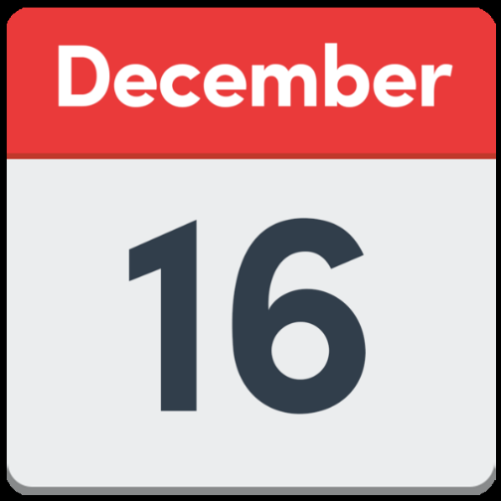

**January**



This consultation closes on **16 December 2024**

The County Council will consider what people have told us about this idea in **January 2025.**

A final decision on the Council’s budget will be made in **February 2025.**