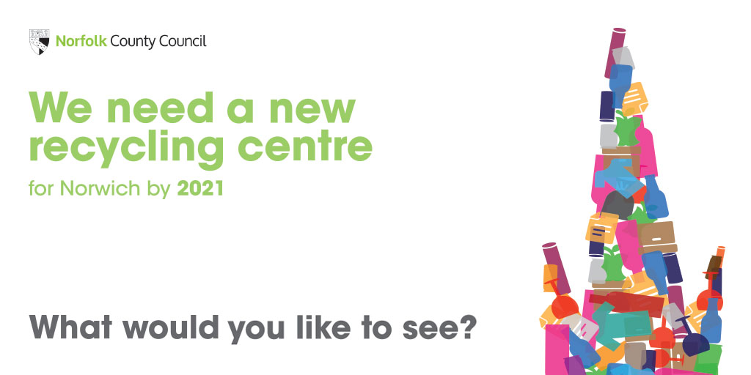

Your views on a new recycling centre for Norwich

Overview
We need a new household waste recycling centre for Norwich by 2021 and want your ideas on the types of services you'd like to see.

Why we are consulting
Our contract expires with Mile Cross Recycling Centre in 2021. As the site is not owned by the County Council we need to find a new recycling centre.
We'd like to see a new site that makes reuse and recycling easy for residents and improves how much waste is reused or recycled in Norfolk.
We'd therefore like your early thoughts and ideas on the services you'd expect to see in a new site to help us shape our design and make decisions about a future site. We'll be carrying out further consultation once we secure a preferred site and start work on the design.

Introduction
Personal information, confidentiality and data protection
We are asking your views to help us shape the design of a new recycling centre for Norwich and make sure that the future site meets people's needs.
We will treat your response in line with the Data Protection Act 2018 and the General Data Protection Regulation (GDPR). This means that Norfolk County Council will hold your personal data and only use it for the purpose for which it was collected, being this consultation. We won't identify individuals when reporting back our findings and under our record management policy we will keep this information for five years. You can read our privacy notice at https://www.norfolk.gov.uk/what-we-do-and-how-we-work/policy-performance-and-partnerships/policies-and-strategies/corporate/data-protection/norfolk-county-council-privacy-notice

Are you happy to take part in our survey? (Required)
Please select only one item
- Yes - I have read the data protection information and I am happy to take part

- No - I do not wish to take part in this survey

Background information
A new recycling centre for Norwich is needed by 2021 as the contract expires at Mile Cross Recycling Centre and because the site is not owned by the County Council.
We gather the views of people who use our household waste recycling centres every year. Those dissatisfied with the current site tell us there are often long queues to access the recycling centre, the site is poorly laid out and that there is a lack of facilities, for example a reuse shop.
We’d like to see a new site that makes reuse and recycling easy for residents and improves how much waste is reused or recycled in Norfolk.
Providing a new site gives an opportunity to have improved facilities. For example, other sites in Norfolk currently offer:
- reuse shops
- trade waste pay-as-you-throw services
- annual hazardous waste events
- sale of compost bins
At this stage we want to hear your thoughts and ideas to help us shape our design and the future site. We’ll be carrying out further consultation once a preferred site is secured and work has started on the design.
Our search for a site
Finding a new site isn’t an easy process because the site needs to meet certain criteria - for example, it needs to be a large site, not too close to residential areas and with good road access.
The County Council policy is to have sites within a 20-minute drive time for residents and so our search for a new site is focused on the greater Norwich area.
In order to develop a site, we will need to get the right land agreements in place as well as planning consent and an environmental permit for the recycling centre.
When we have found a site that meets our criteria we will need to carry out some detailed studies which will look at the potential impacts of any development such as on traffic and the environment. There will be more opportunities to have your say on the detailed planning proposals.
At this stage we need to find out what people want from a new recycling centre for Norwich.
What facilities would you like to see at a new recycling centre

for Norwich?

On the next two pages are a list of features of a recycling centre. How important or unimportant are each of these to you? Please select one answer on each row:

 | Very important | Important | Neither important nor unimportant | Unimportant | Very unimportant
Availability of parking spaces
Please select only one item
Easy vehicle flow through the site
Please select only one item
Low level bins or raised platforms for ease of putting waste in skips
Please select only one item
Covered facilities
Please select only one item
A separate service area so that the site doesn't have to close when the skips are being emptied
Please select only one item
Other, please write in here:

Which of the following services, if any, would you like to see at a new recycling centre for Norwich? Please select all that apply:
Please select all that apply
- A reuse shop - where people can drop off reusable items and/or buy these for a small fee
- A trade waste 'pay as you throw' service to help small businesses
- An annual Hazardous Waste event where people can dispose of paint, garden chemicals etc
- Compost and/or compost bins for sale
- Other - please write in here

What sort of items would you like to be able to take to a new recycling centre for Norwich? Please select all that apply:
Please select all that apply

- Batteries - car
- Batteries - household
- Books
- Bricks and rubble
- Cans and tins
- Cardboard and paper
- Cooking oil
- DIY waste
- Electrical items small (e.g. iron, kettle, toaster)
- Electrical items large (e.g. microwave, vacuum cleaners, TVs, computers, washing machines, freezers)
- Engine oil
- Foil
- Furniture
- Gas bottles (empty)
- General household rubbish (Black bag waste)
- Glass bottles and jars
- Garden waste
- Light bulbs and fluorescent tubes
- Liquid cartons (Tetra Paks)
- Mobile phones
- Paint / hazardous waste (as part of the Household Hazardous Waste Days)
- Plastic
- Plasterboard
- Printer / toner cartridges
- Scrap metal
- Textiles and shoes
- Timber and wood
- Tyres
- Unwanted but good quality household items that could be reused
- Other - please write in here

You and recycling centres

In the last 12 months, how often have you visited a recycling centre? Please select one only:
Please select only one item
- Weekly or more often
- Once every two weeks
- Once a month
- Once every 2 - 3 months
- Once every 4 - 6 months
- Once every 6 months to a year
- I haven't visited in the last 12 months

Have you used the Mile Cross Recycling Centre during this period?
Please select only one item
- Yes
- No
- Don't know

Which is your nearest recycling centre? Please select one from the list below:
Please select only one item

- Ashill
- Bergh Apton
- Caister
- Dereham
- Docking
- Heacham
- Hempton
- Ketteringham
- Kings Lynn
- Mayton Wood
- Mile Cross
- Morningthorpe
- Sheringham
- Snetterton
- Strumpshaw
- Thetford
- Wells
- Wereham
- Worstead
- Wymondham

Is the recycling centre that you use most frequently the one that is closest to your home? Please select one only:
Please select only one item
- Yes
- No

Why do you not use the closest site? Please select all that apply:
Please select all that apply
- Closest site is only open part time
- I find the closest site is too small
- Closest site has traffic issues e.g. queuing / parking
- Closest does not accept my usual recyclable materials
- The site I use the most is closer to my work location or en-route to work/school run/shopping
- The site I use the most is less busy
- I use the nearest site
- None of the above (please add comment below)

What is the main method of transport you use to visit the recycling centre? Please select one only:
Please select only one item
- Car
- 4x4
- Bicycle
- Motorbike
- Walk
- Car or 4x4 with trailer
- Van
- Pick-up truck
- Other - please state

Which route do you generally prefer to follow when visiting a recycling centre? Please select one only:
Please select only one item
- Home - HWRC - Home
- Home - HWRC - Work
- Home - HWRC - Other
- Work - HWRC - Home
- Work - HWRC - Work
- Work - HWRC - Other
- Other - please write in here

About you
Providing this information is optional, however it helps us understand how different groups of people might be affected by our proposed scheme.
What is your email address?
If you enter your email address then we will automatically send you an acknowledgement email when you submit your response. We won't use your email for any other purpose, will always treat your personal details with the utmost respect and will never pass your details on to other organisations.
Email

Are you responding as ...?
Please select all that apply
- A local resident
- On behalf of a local business
- On behalf of a local organisation
- Someone who works in the area
- A visitor to the area
- Someone who travels through the area
- On behalf of a community organisation

Are you...?
Please select only one item
- Male
- Female
- Prefer to self-describe (please specify below)
- Prefer not to say
If you prefer to self-describe please specify here:

How old are you?
Please select only one item
- 0-15
- 16-29
- 30-44
- 45-64
- 65-84
- 85+

Do you have any long-term illness, disability or health problem that limits your daily activities or the work you can do?
Please select only one item
- Yes
- No

How would you describe your ethnic background? Please select one only
Please select only one item

- White British
- White Irish
- White other
- Mixed
- Asian or Asian British
- Black or Black British
- Chinese
- Other ethnic background - please describe below

What is the first part of your postcode? (e.g. NR4)
Please write your answer here:

You can send back a paper feedback form to:

Freepost Plus RTCL-XSTT-JZSK, Norfolk County Council, Ground floor - south wing, County Hall, Martineau Lane, Norwich NR1 2DH.

However, if you want to help the council save money please use a stamp and send to this address: Stakeholder and Consultation Team, Norfolk County Council, Ground floor - south wing, County Hall, Martineau Lane, NR1 2DH.

Your opinions are valuable to us. Thank you for taking the time to read this document and respond.

If you need this document in large print, audio, Braille, alternative format or in a different language please contact HaveYourSay@norfolk.gov.uk or 01603 222844 and we will do our best to help.

