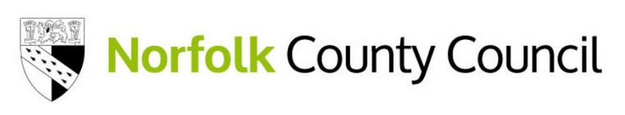

About our idea to reduce the number of hazardous waste disposal events

Tell us what you think
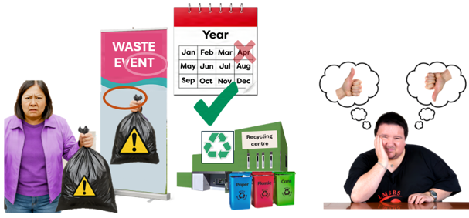


This is an Easy Read survey.



Some of the things in this survey are not easy to understand.
You may need help from someone to read it.

About Norfolk County Council

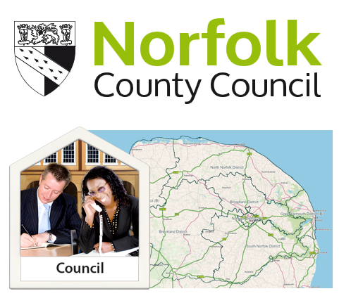

Norfolk County Council runs lots of services in Norfolk.

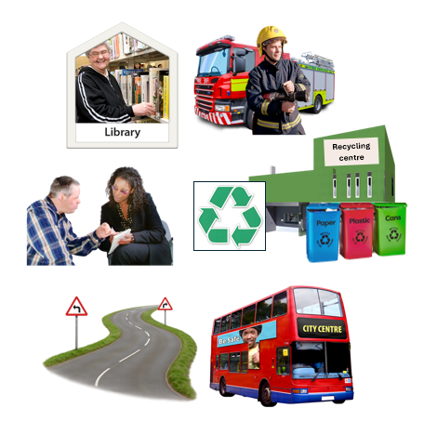

Services such as:

- Libraries
- Fire and Rescue
- Social Care
- Highways and Transport
- Recycling centres.

There are lots of others too.

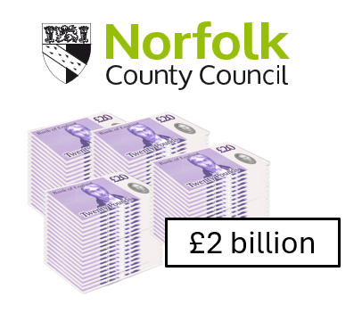

We spend over £2billion each year to run our services.

We need to save money

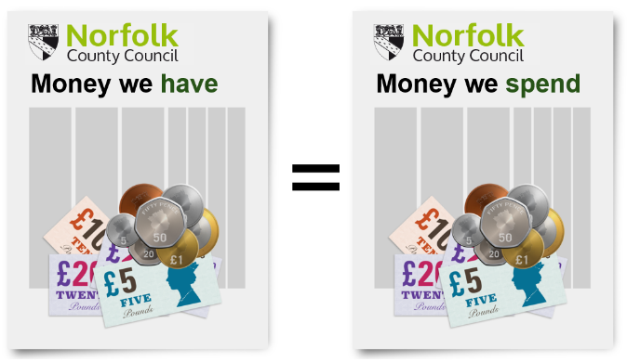
We must make sure that the money we spend matches the money we have.

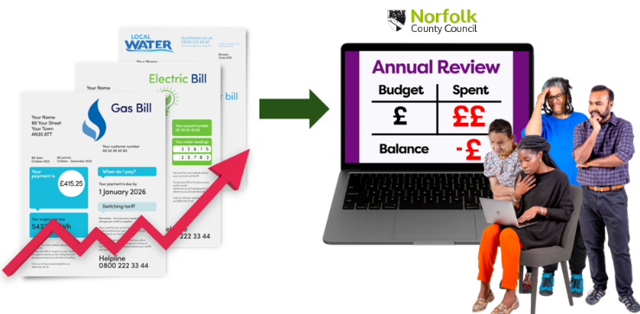
The money we have is not enough to cover what we spend. This is because lots of things are more expensive than they were in the past.

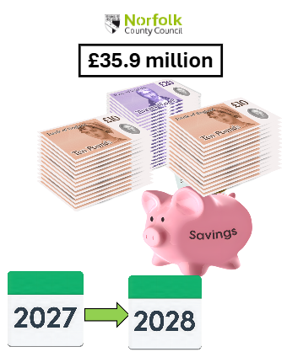

We need to save around
£35.9 million in 2027-2028.

Our idea 1
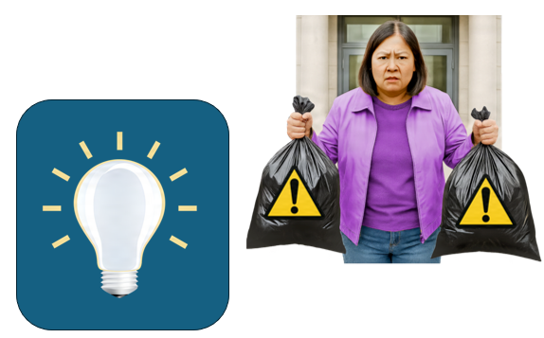
We have an idea that will save money. The idea is to change how we help people to get rid of hazardous waste.

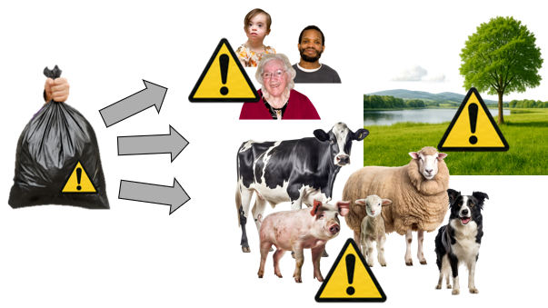
Hazardous waste is rubbish that can harm people, animals or the environment.

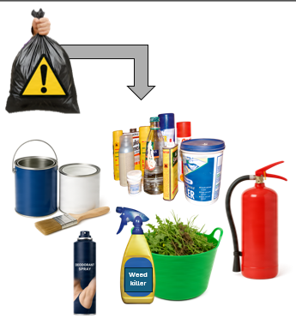
Hazardous waste includes things like:

- Paint
- Household cleaning chemicals
- Weed killers
- Aerosols that are not empty
- Fire extinguishers

Our idea 2
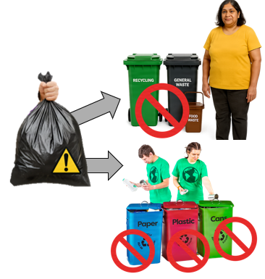

You are not allowed to put hazardous waste in normal bins or normal recycling centres.

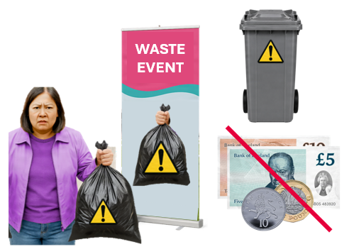
We help people to get rid of hazardous waste by holding Hazardous Waste Disposal Events.

Hazardous waste disposal events are when people in Norfolk can get rid of some hazardous waste free of charge.

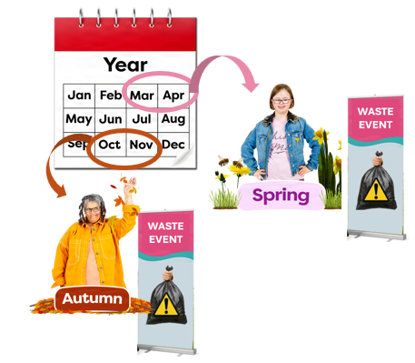

We hold these events 2 times each year. We hold 1 event in Spring and 1 event in Autumn.

Our idea 3
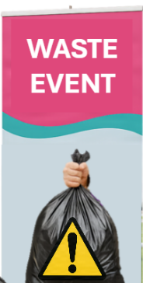
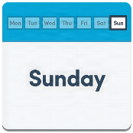
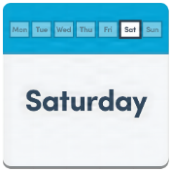
Each event is at a weekend, and lasts for two days.

We hold these events at 7 main recycling centres in:

- Caister
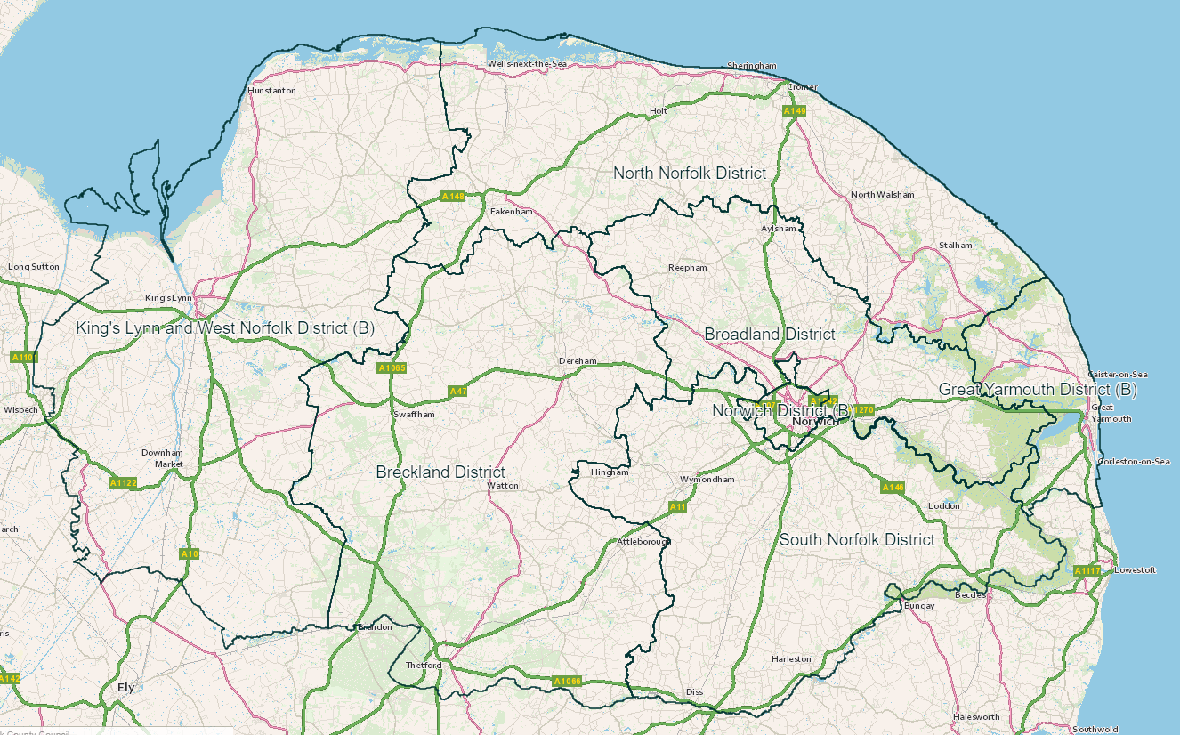
- Dereham

- Hempton
- King’s Lynn
- Norwich North
- Norwich South
- Thetford.

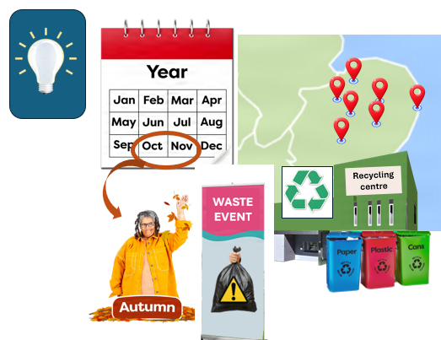
Our idea is to reduce how many hazardous waste disposal events we hold. We want to hold 1 event every year, at each of the 7 recycling centres.

Our idea 4

We think that the events would only take place in the autumn in the future.

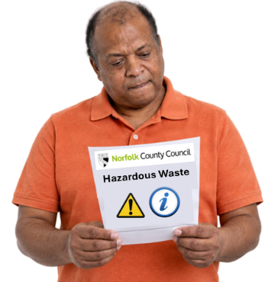
We will also give information to people in Norfolk about what to do with hazardous waste between the events.

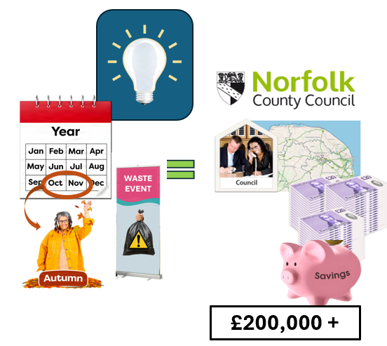
If we reduce the number of hazardous waste disposal events, Norfolk County Council will save money.

This idea will save us about £200,000 each year.


We want to hear what you think of our idea.

Taking part
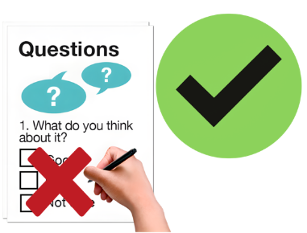
You don’t have to answer all the questions.



You don’t have to tell us your name or anything about you.


We must keep your information safe by law.


We will not share your information with people who don’t work for us.


If you have a question about how we keep your information safe, call us on 0344 800 8020.

Our questions

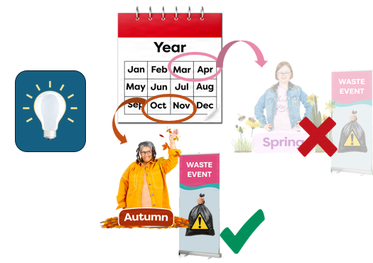
Question 1:

Do you agree or disagree with the idea to reduce how many Hazardous Waste Disposal Events we hold?

- Tick 1 box

😃 ☐ Strongly agree

🙂 ☐ Agree

😐 ☐ Not sure

🙁 ☐ Disagree

☹️ ☐ Strongly disagree

? ☐ Don’t know

Our questions

Please tell us why you gave that answer to Question 1.


Please write your answer in this box:

Questions about you


It is helpful to know more about you. This helps us to see if different people think our ideas are good or bad.

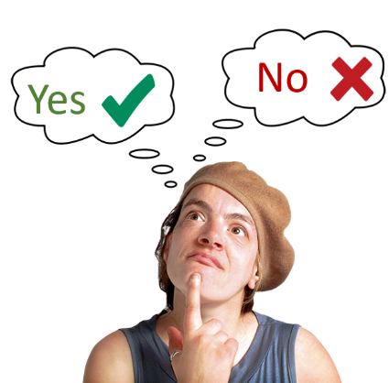

You do not have to answer these questions.



If you answer these questions, we will keep your information safe. We will not share your answers with anyone.

Question 1: Who are you answering these questions for?

- Please tick 1 box
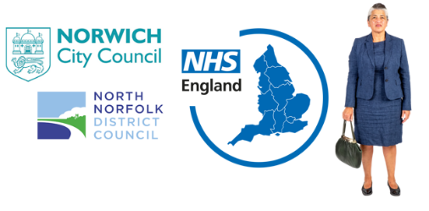

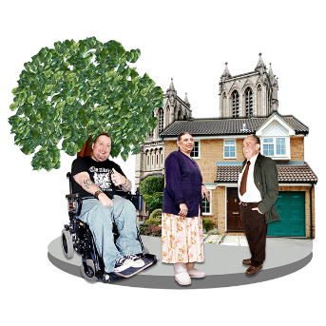

☐ Me

☐ For a voluntary or community group

☐ For a statutory organisation

☐ For a business

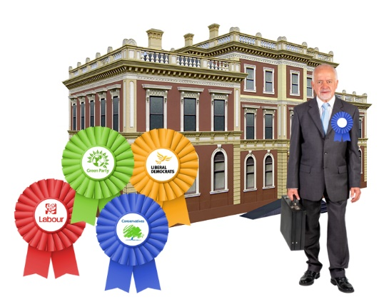
☐ As a Norfolk County Councillor
☐ As a district or borough Councillor
☐ As a town or parish Councillor
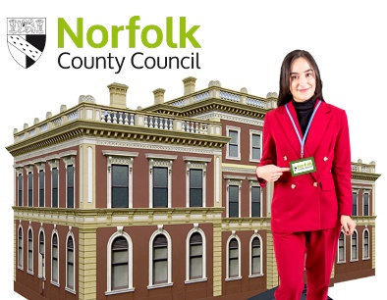
☐ As a Norfolk County Council employee
If you are answering these questions for a group, organisation or business, what is it called?

Please write your answer in this box:


Question 2: How did you find out about this survey?

- Please tick 1 box


☐ Local media
(eg newspaper, radio)


☐ From a social media post
(eg Facebook)


☐ From a friend


☐ From a group I belong to

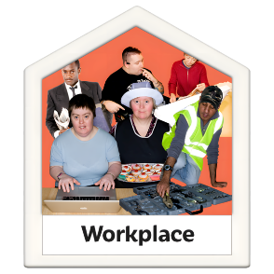

☐ From my place of work or education

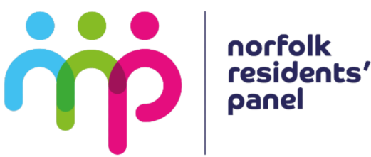

☐ The Norfolk Residents’ Panel


☐ District Council web page

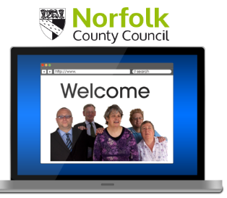

☐ Norfolk County Council web page

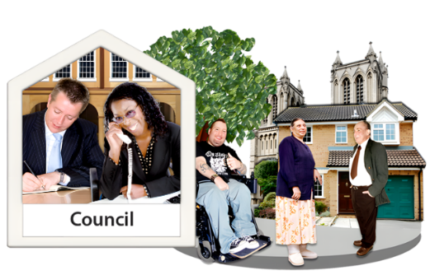

☐ My Parish Council


☐ From an email

If you found out about this survey a different way, please tell us how in this box:

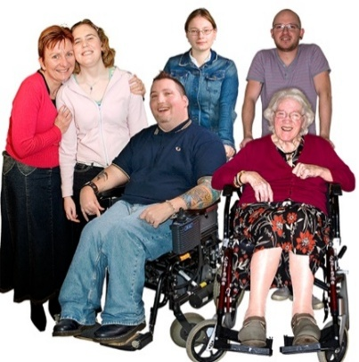
Question 3: How old are you?

Please write your age in this box:

☐ I prefer not to tell you

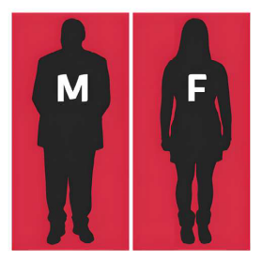
Question 4: What is your sex?

Sex: Your sex is whether you were born as a man or a woman.

- Please tick 1 box

☐ Male
☐ Female

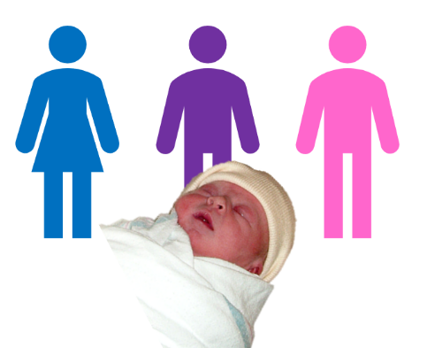
Question 5: Is your gender the same as your sex?

Gender: Gender is whether you like to be known as male, female, or something else.

- Please tick 1 box

☐ Yes
☐ No
☐ I prefer not to tell you

If you would like to, you can tell us your gender identity in this box:


Question 6: Are any of these true for you?

☐ I have a disability

☐ I have had a health condition for a long time

☐ None of these

☐ I prefer not to tell you


Question 7: Which of these describes your health condition or disability?

Please tick all that apply:

☐ Blind or partially sighted

☐ Deaf or hard of hearing

☐ Limiting health condition
e.g. heart disease, asthma, strokes, osteoarthritis, rheumatoid arthritis, fibromyalgia and myalgic encephalomyelitis (ME) etc.
☐ Learning Disabilities

☐ Neurodiversity
e.g. autism, dyslexia, dyspraxia

☐ Mental health conditions
e.g. depression, schizophrenia, bipolar affective disorders, eating disorders, obsessive compulsive disorder

☐ Physical disability
e.g. limb disorder, amputee, wheelchair user, cerebral palsy, motor neurone disease, muscular dystrophy

☐ None of these

If you have another type of disability or health condition, you can tell us in this box:


Question 8: What is your ethnicity?

Ethnicity is your race or
background. For example, you may be Black, White or Asian.

- Please tick 1 box

☐ White or White British

☐ Asian or Asian British

☐ Black, Black British,
Black Caribbean or African

☐ Mixed or multiple ethnic groups

☐ Another ethnic group

☐ I prefer not to tell you

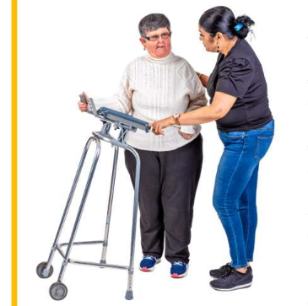
Question 9: Do you help to care for someone else?
- Please tick all that apply

☐ No

☐ Yes – children with a special educational need or disability

☐ Yes – older family members

☐ Yes, other – please write here:

☐ I prefer not to tell you.


Question 10: Which area of Norfolk do you live in?
- Please tick 1 box

☐ Breckland
☐ Broadland
☐ Great Yarmouth
☐ King’s Lynn and West Norfolk
☐ North Norfolk
☐ Norwich
☐ South Norfolk

☐ I prefer not to tell you.

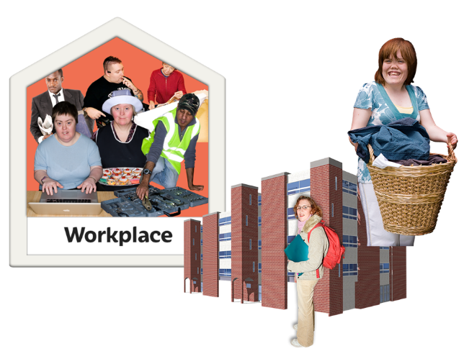
Question 11: Are you currently…?

- Please tick 1 box

☐ Employed - full time
☐ Employed - part time
☐ Self employed
☐ Unemployed
☐ Student
☐ Looking after the family home
☐ Long term sick
☐ Retired

How to send us your answers
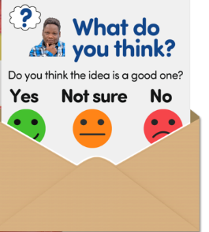
Put the survey in an envelope.

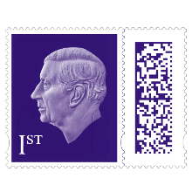

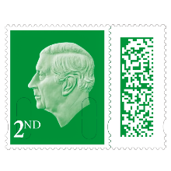
You do not need to put a stamp on the envelope.

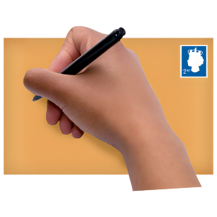
Put this address on the envelope:


BUDGET CONSULTATION 2027-2028
Freepost RTCL-XSTT-JZSK
County Hall
Martineau Lane
Norwich
NR1 2DH
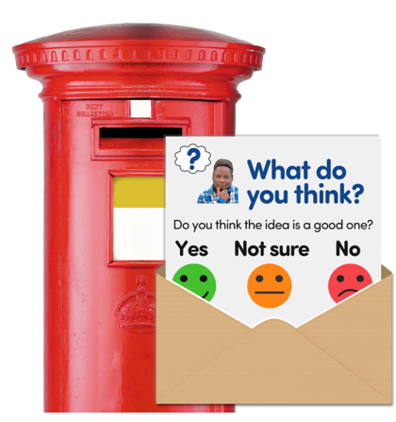
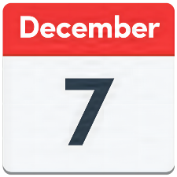
Send this survey back to us by
Monday 7 December

What happens next
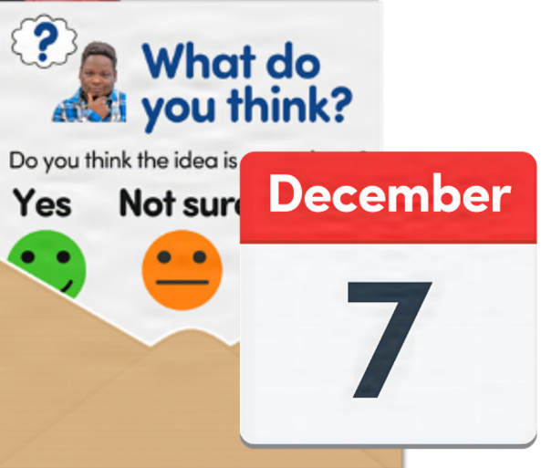

This survey closes on
Monday 7 December

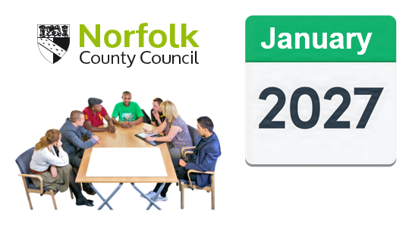
The County Council will think about what people have told us about our idea in January 2027.

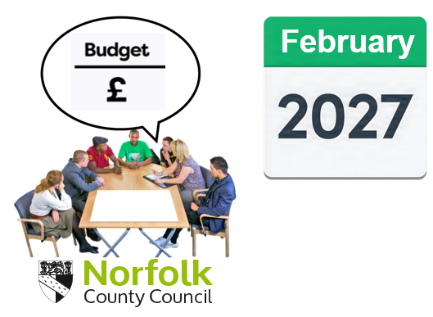
The Council’s budget will be decided in February 2027.

If you have more questions


If you have more questions, you can contact us:



Phone: 0344 800 8020

Email: haveyoursay@norfolk.gov.uk

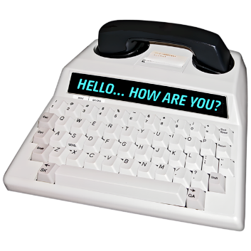
Text Relay:
18001 0344 800 8020


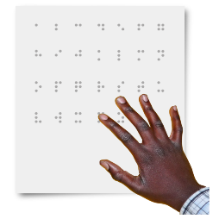
You can ask us for this document in large print, audio, Braille, or a different format.

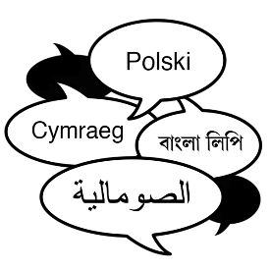
You can ask us for this information in a different language.
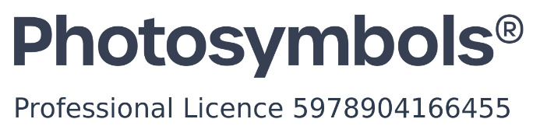

Most images in this document are from the Photosymbols Easy Read photo library.

