

About our idea to change our winter road gritting service

Tell us what you think
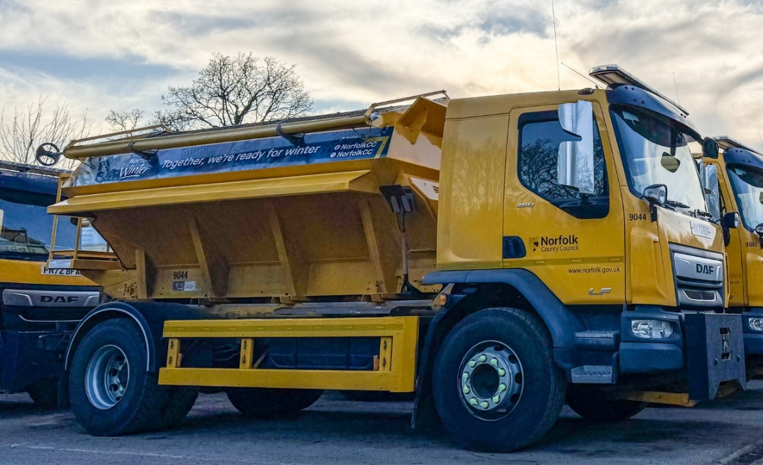


This is an Easy Read survey.

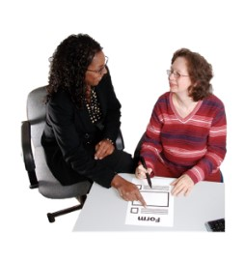
Some of the things in this survey are not easy to understand.
You may need help from someone to read it.

About Norfolk County Council

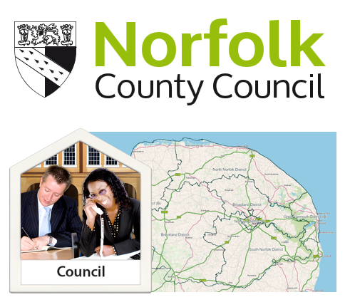

Norfolk County Council runs lots of services in Norfolk.

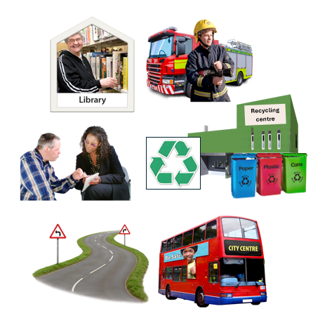

Services such as:

- Libraries
- Fire and Rescue
- Social Care
- Highways and Transport
- Recycling centres.

There are lots of others too.

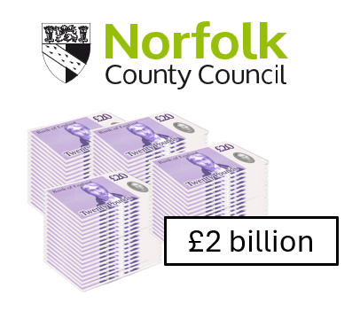

We spend over £2billion each year to run our services.

We need to save money

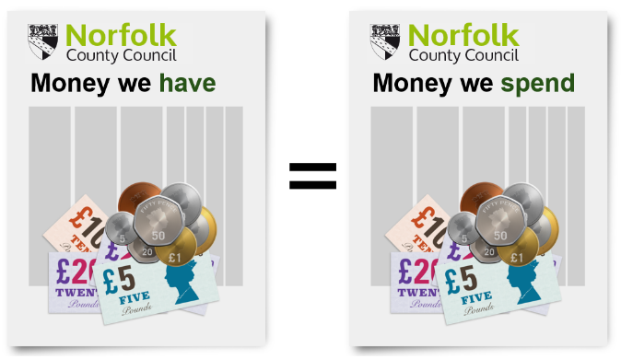
We must make sure that the money we spend matches the money we have.

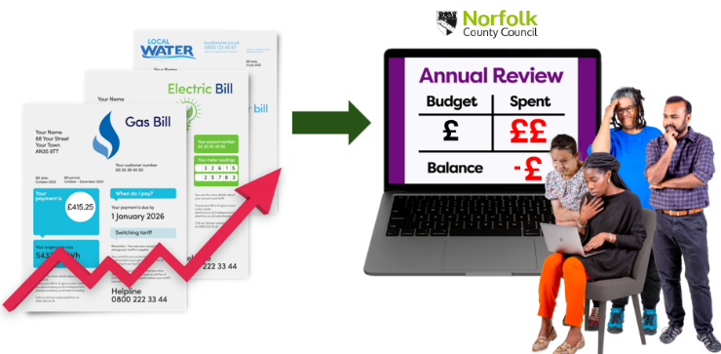
The money we have is not enough to cover what we spend. This is because lots of things are more expensive than they were in the past.

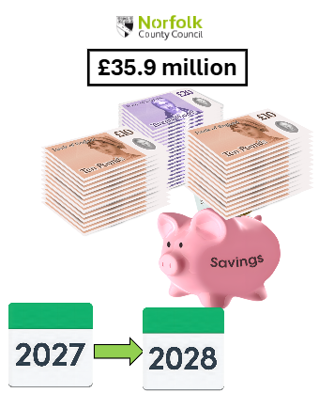

We need to save around
£35.9 million in 2027-2028.

Our idea 1
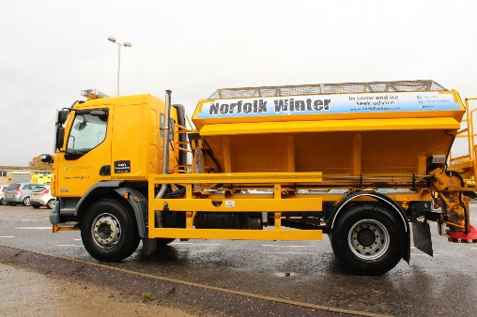


We have an idea that will save money. Our idea is to reduce our winter road gritting service.

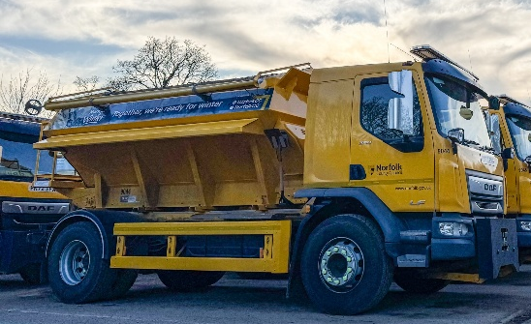
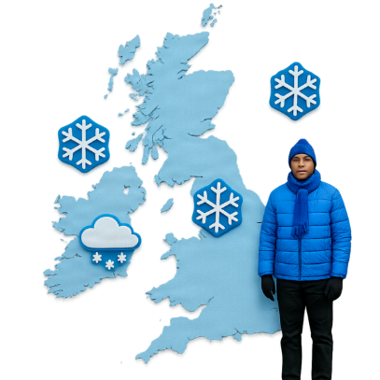
Our winter road gritting service is when we send gritting lorries out if we think the roads are going to get ice on them. This service makes roads safer to use.
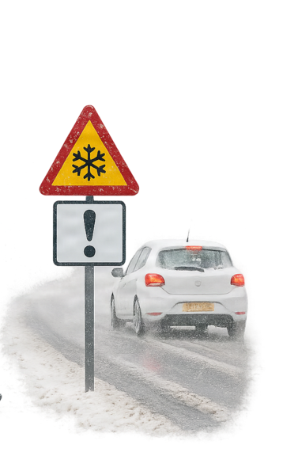

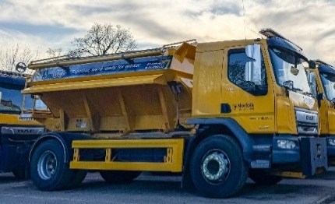
The lorries spread grit on the roads we think are most important first, because lots of people use them. We call these roads our ‘priority gritting network’.

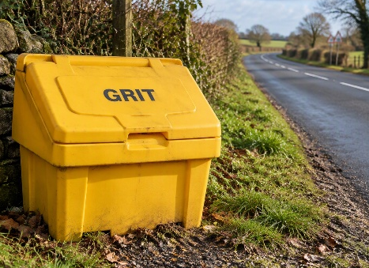
Grit is a mixture of salt and sand that stops roads getting ice on them. When roads are gritted, they are safer to use.

Our idea 2
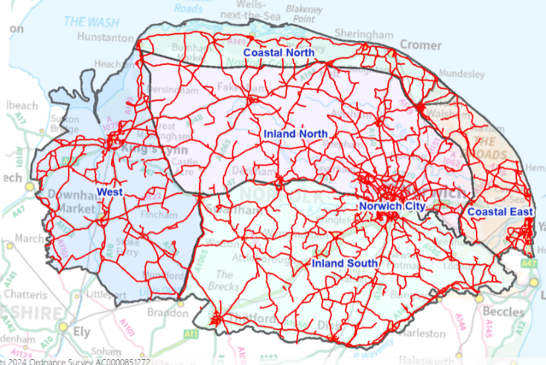

Our priority network is 2,200 miles of road. In total there are 6,000 miles of road in Norfolk.

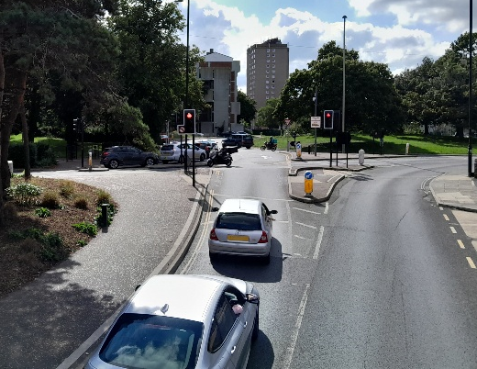
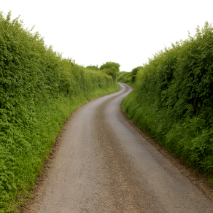
The main roads are gritted before other roads.

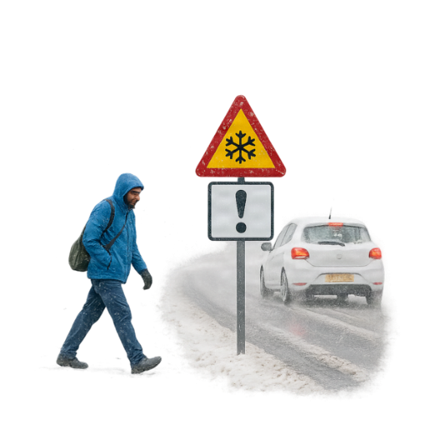

Some paths are also gritted to keep people safe when it is icy weather.

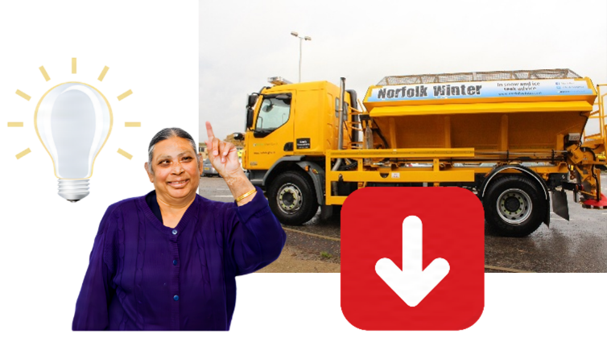
Our idea is to stop gritting some of the roads in icy weather.

Our idea 3
5%

110 miles
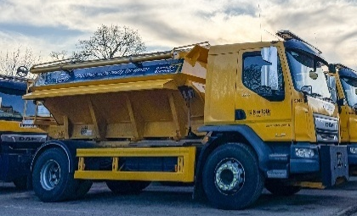

We want to stop gritting about 5% of the roads we send gritting lorries to now. This is about 110 miles of road.

We will only stop gritting roads that are not used by many people.

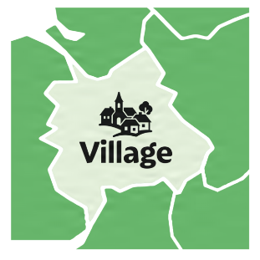
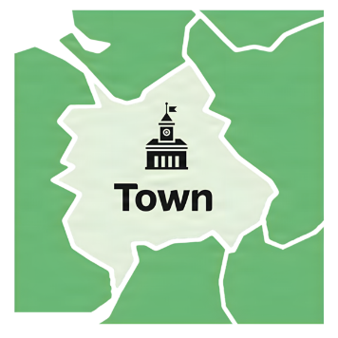

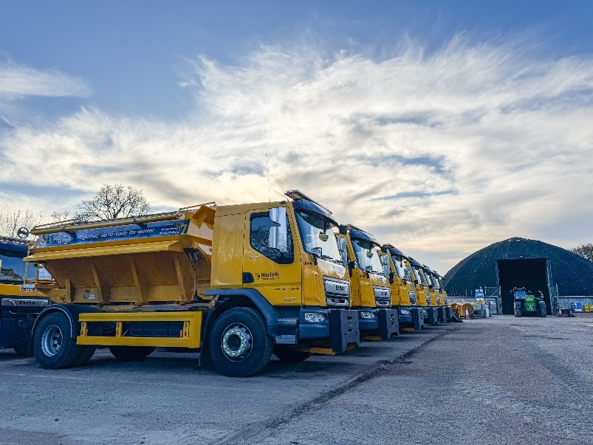

We will try to make sure there will still be a route into towns and villages that has been gritted.





If we want to stop gritting a road, we will make sure we understand how this might affect people and how they use our roads.

Our idea 4

These things might happen if we change our road gritting service in this way:

- We probably could not grit extra roads in the future.

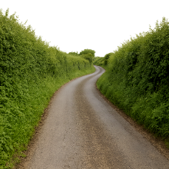
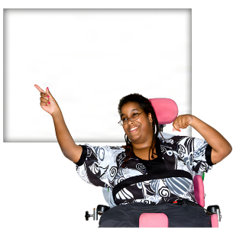
- People may choose to use a different route if we stop gritting a road they use at the moment.

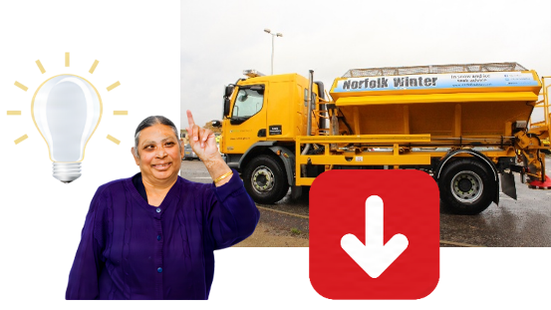

We think our idea would save around £225,000 each year. The money we save will help us to run our services.
£225,000

Our idea 5
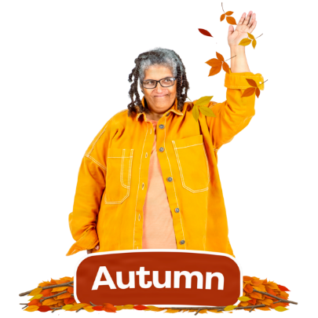
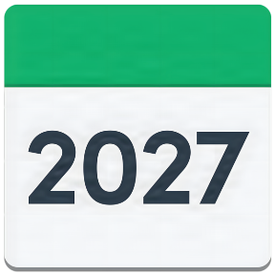
If we decide to change our road gritting service in this way, we will change it from autumn 2027.



We want to hear what you think of our idea.

Taking part

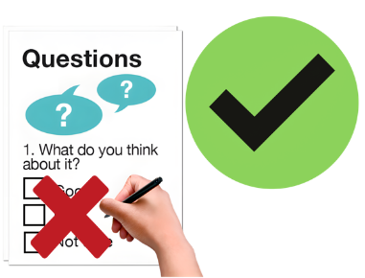
You don’t have to answer all the questions.



You don’t have to tell us your name or anything about you.

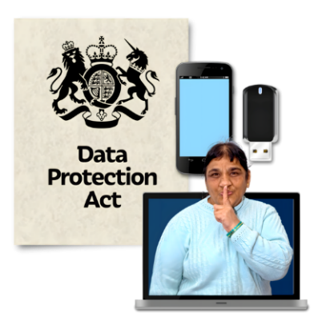
We must keep your information safe by law.

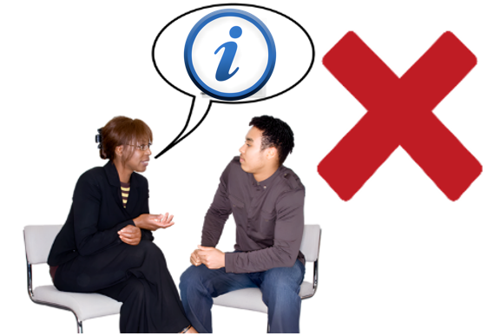
We will not share your information with people who don’t work for us.

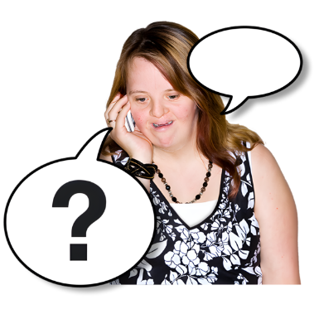
If you have a question about how we keep your information safe, call us on 0344 800 8020.

Our questions

Question 1:

Do you agree or disagree with the idea to reduce our road gritting service by 5%?

- Tick 1 box

😃 ☐ Strongly agree

🙂 ☐ Agree

😐 ☐ Not sure

🙁 ☐ Disagree

☹️ ☐ Strongly disagree

? ☐ Don’t know

Our questions

Please tell us why you gave that answer to Question 1.


Please write your answer in this box:

Questions about you


It is helpful to know more about you. This helps us to see if different people think our ideas are good or bad.

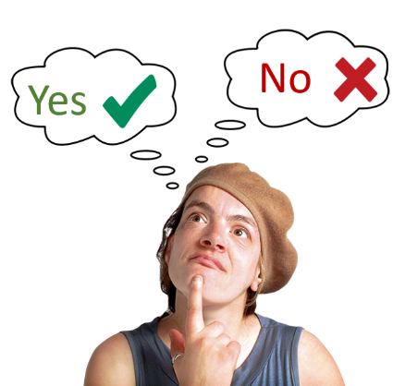

You do not have to answer these questions.



If you answer these questions, we will keep your information safe. We will not share your answers with anyone.

Question 1: Who are you answering these questions for?

- Please tick 1 box
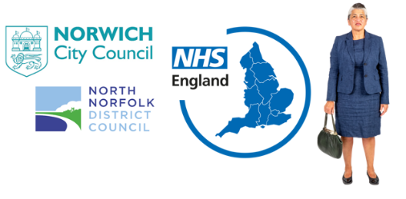

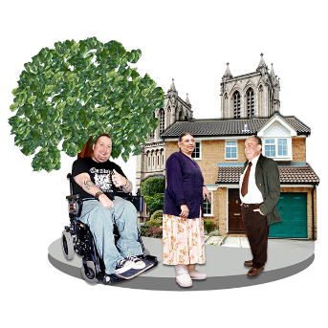
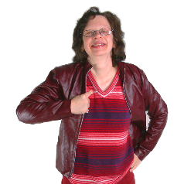
☐ Me

☐ For a voluntary or community group

☐ For a statutory organisation

☐ For a business

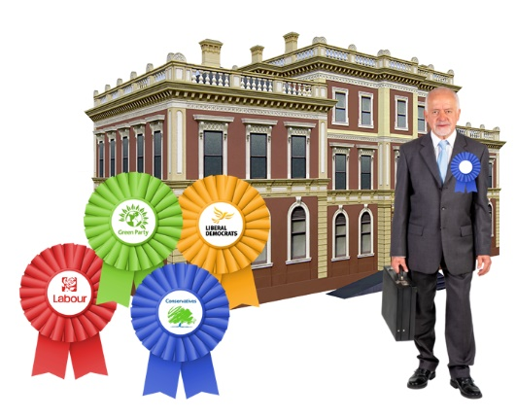
☐ As a Norfolk County Councillor
☐ As a district or borough Councillor
☐ As a town or parish Councillor
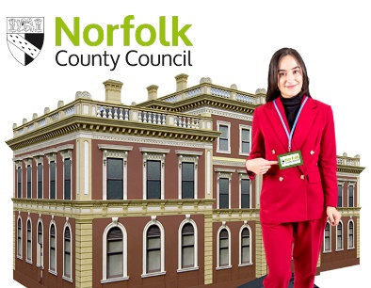
☐ As a Norfolk County Council employee
If you are answering these questions for a group, organisation or business, what is it called?

Please write your answer in this box:


Question 2: How did you find out about this survey?

- Please tick 1 box


☐ Local media
(eg newspaper, radio)


☐ From a social media post
(eg Facebook)
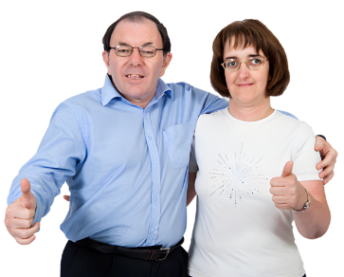

☐ From a friend

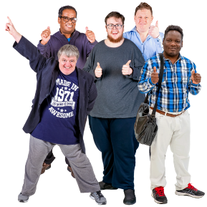
☐ From a group I belong to

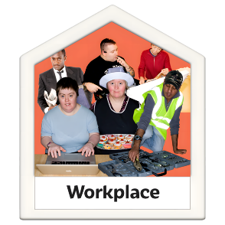
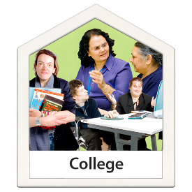
☐ From my place of work or education

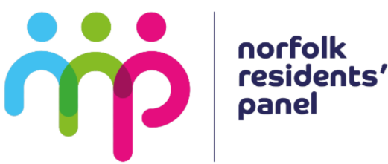

☐ The Norfolk Residents’ Panel


☐ District Council web page

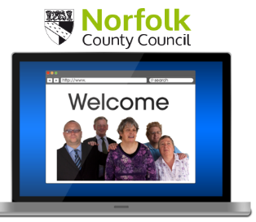

☐ Norfolk County Council web page

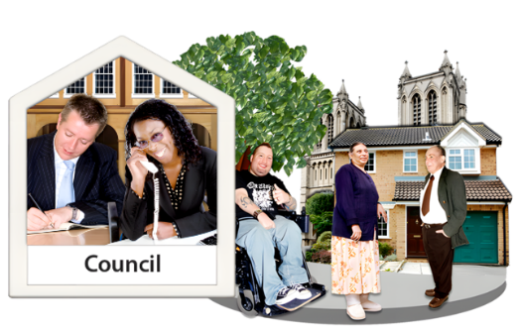

☐ My Parish Council


☐ From an email

If you found out about this survey a different way, please tell us how in this box:

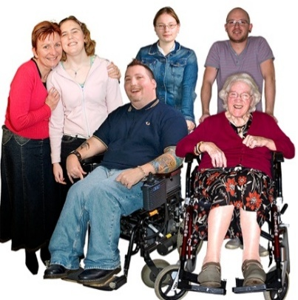
Question 3: How old are you?

Please write your age in this box:

☐ I prefer not to tell you

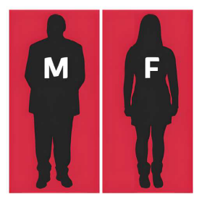
Question 4: What is your sex?

Sex: Your sex is whether you were born as a man or a woman.

- Please tick 1 box

☐ Male
☐ Female

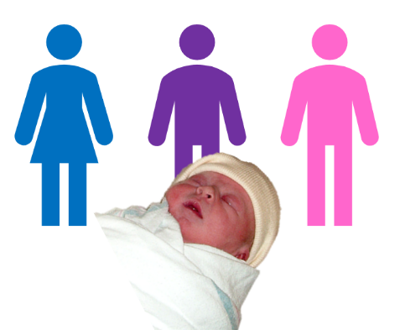
Question 5: Is your gender the same as your sex?

Gender: Gender is whether you like to be known as male, female, or something else.

- Please tick 1 box

☐ Yes
☐ No
☐ I prefer not to tell you

If you would like to, you can tell us your gender identity in this box:

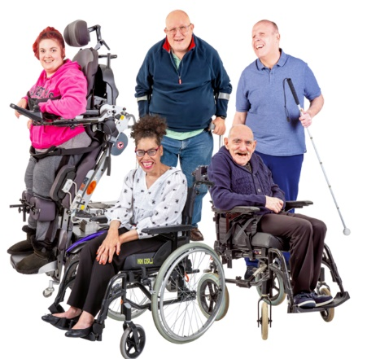
Question 6: Are any of these true for you?

☐ I have a disability

☐ I have had a health condition for a long time

☐ None of these

☐ I prefer not to tell you


Question 7: Which of these describes your health condition or disability?

Please tick all that apply:

☐ Blind or partially sighted

☐ Deaf or hard of hearing

☐ Limiting health condition
e.g. heart disease, asthma, strokes, osteoarthritis, rheumatoid arthritis, fibromyalgia and myalgic encephalomyelitis (ME) etc.
☐ Learning Disabilities

☐ Neurodiversity
e.g. autism, dyslexia, dyspraxia

☐ Mental health conditions
e.g. depression, schizophrenia, bipolar affective disorders, eating disorders, obsessive compulsive disorder

☐ Physical disability
e.g. limb disorder, amputee, wheelchair user, cerebral palsy, motor neurone disease, muscular dystrophy

☐ None of these

If you have another type of disability or health condition, you can tell us in this box:

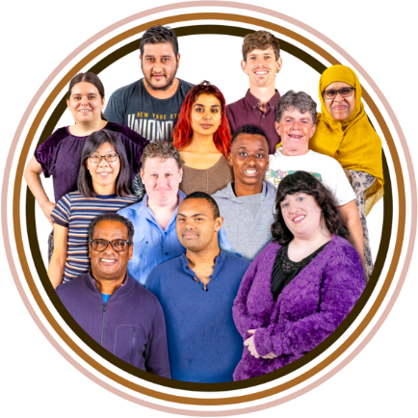
Question 8: What is your ethnicity?

Ethnicity is your race or
background. For example, you may be Black, White or Asian.

- Please tick 1 box

☐ White or White British

☐ Asian or Asian British

☐ Black, Black British,
Black Caribbean or African

☐ Mixed or multiple ethnic groups

☐ Another ethnic group

☐ I prefer not to tell you

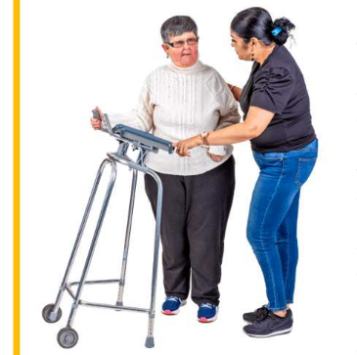
Question 9: Do you help to care for someone else?

- Please tick all that apply

☐ No

☐ Yes – children with a special educational need or disability

☐ Yes – older family members

☐ Yes, other – please write here:

☐ I prefer not to tell you.


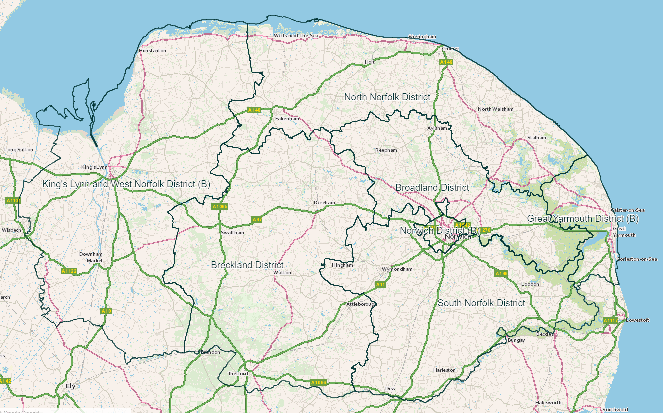
Question 10: Which area of Norfolk do you live in?

- Please tick 1 box

☐ Breckland
☐ Broadland
☐ Great Yarmouth
☐ King’s Lynn and West Norfolk
☐ North Norfolk
☐ Norwich
☐ South Norfolk

☐ I prefer not to tell you.

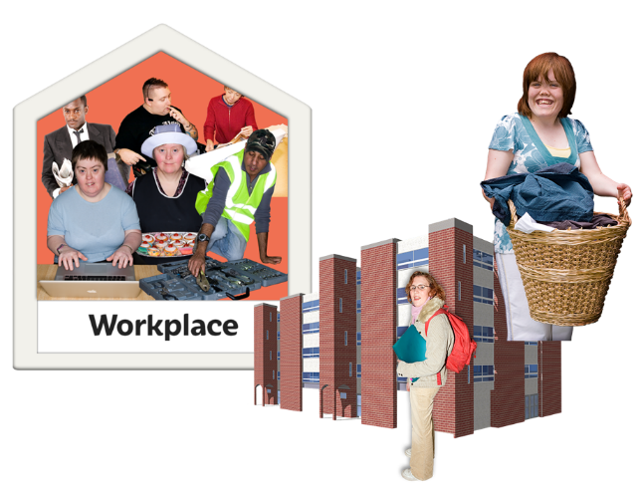
Question 11: Are you currently…?

- Please tick 1 box

☐ Employed - full time
☐ Employed - part time
☐ Self employed
☐ Unemployed
☐ Student
☐ Looking after the family home
☐ Long term sick
☐ Retired

How to send us your answers
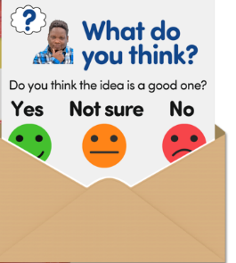
Put the survey in an envelope.

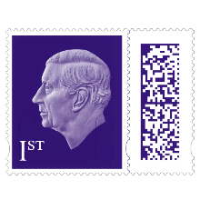

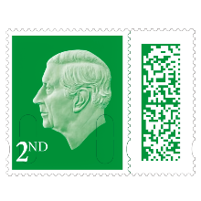
You do not need to put a stamp on the envelope.

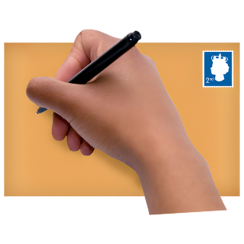
Put this address on the envelope:


BUDGET CONSULTATION 2027-2028
Freepost RTCL-XSTT-JZSK
Ground floor – South Wing
County Hall
Martineau Lane
Norwich
NR1 2DH
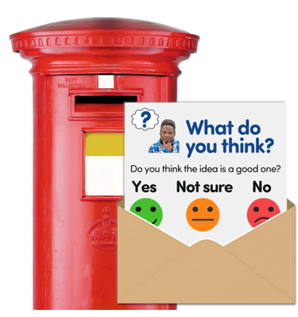

Send this survey back to us by
Monday 7 December

What happens next

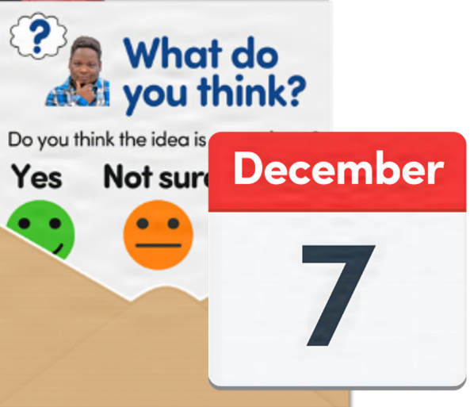

This survey closes on
Monday 7 December

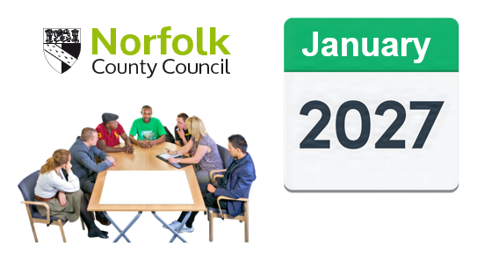
The County Council will think about what people have told us about our idea in January 2027.

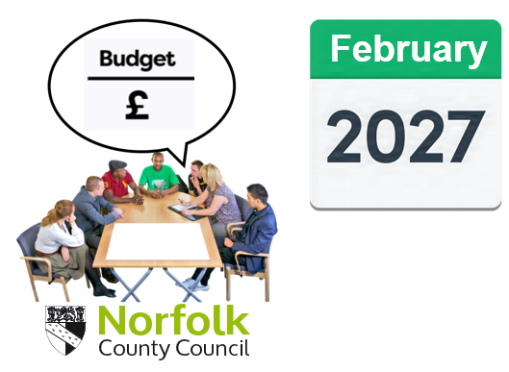
The Council’s budget will be decided in February 2027.

If you have more questions


If you have more questions, you can contact us:



Phone: 0344 800 8020

Email: haveyoursay@norfolk.gov.uk

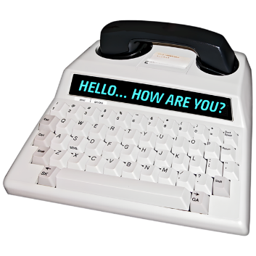
Text Relay:
18001 0344 800 8020


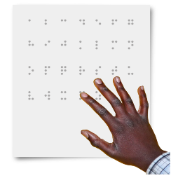
You can ask us for this document in large print, audio, Braille, or a different format.

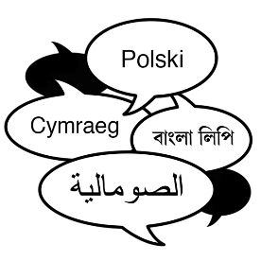
You can ask us for this information in a different language.



Most images in this document are from the Photosymbols Easy Read photo library.

