

Your views on the proposal to increase council tax, and other 2027-28 budget proposals

In this consultation we are asking for your views on our proposal to increase council tax, and on our other 2027-28 budget savings proposals.
There are also detailed consultation documents and response forms available for five specific proposals:

- Reduction in treated highway network / gritted routes by 5%
- Reduction in highway maintenance revenue activities by 5%
- Reduction in highway verge grass cutting
- Reduction in highway weed killing treatment
- Reduction in number of hazardous waste disposal events

A separate consultation is also planned for the Home to School Transport - Post-16 parental contributions proposal in November to mid-December 2026.

If you want more detail and to have your say on those proposals you can find out more at www.norfolk.gov.uk/budget or contact us using the details at the end of this form.

Overview

Norfolk County Council is responsible for a range of services including social services, trading standards, fire and rescue, highways and transport, recycling centres, libraries, museums, education and supporting children with special educational needs and disabilities, ensuring sufficient school and nursery places, and arranging school transport.

Each year, Norfolk County Council reviews its budget and proposes the efficiencies and cost reductions it will need to make for the following year to balance the budget.

Even though our overall spending is expected to increase next year, this is not enough to keep pace with inflation (the costs of providing our services) and the expected increases in demand for our services - particularly in adult social care and children's services.

This means that for 2027-28 there is a budget gap of £35.927 million. At their meeting of 5 October 2026, Cabinet agreed to take forward proposals totalling £32.273m for 2027-28.

To help us deal with our cost pressures and invest in vital services, our current budget planning for 2027-28 is based on an assumption to increase council tax.
Two options are being considered:

- An increase of 3%
- An increase of up to 5%

In this consultation we are asking for your views on the proposal to increase council tax, and on our other budget proposals.
No final decision has been made. The options and figures remain open to change or rejection following the consultation.

Why we are consulting

We want to find out what people think about our proposal to increase council tax, and on our other budget proposals.

We are consulting through:

- The online consultation, which is also available as a paper copy and in different formats
- Email /Letter to key stakeholders and partners
- Email to members of the Norfolk Residents’ Panel

The consultation runs from Monday 26 October 2026 and closes on Monday 7 December 2026.

Please note that if we receive any consultation responses after this date, we cannot guarantee that we will be able to take them into account.

We will feed back the findings from our consultation to our county councillors as part of the evidence they will use to help them come to a decision about the budget proposals.

If you need a copy of this consultation document in a different format please email haveyoursay@norfolk.gov.uk, call 0344 800 8020 or Text Relay on 18001 0344 800 8020 (textphone) and we will do our best to help.

The consultation questions should take about 10 minutes to complete.

The questions start on page 12 of this document.

Personal information, confidentiality and data protection

We will use any personal information to understand how different groups of people feel about our proposals.

We will process any personal information we receive from you in line with the UK General Data Protection Regulation (UK GDPR), the Data Protection Act 2018, and Norfolk County Council’s data protection policy and guidelines. This means that Norfolk County Council will hold your personal data and only use it for the purpose for which it was collected, being this consultation. You can find a copy of our privacy statement on the Norfolk County Council website.

We will not identify individuals when reporting back our findings and under our record management policy we will keep this information for five years. We will also, under normal circumstances, not pass your personal data on to anyone else. However, we may be asked under access to information laws to publish or disclose some, or all, of the information you provide in response to this consultation. We will only do this where such disclosure will comply with such relevant information laws which include the Freedom of Information Act 2000, the Data Protection Act 2018 and the Environmental Information Regulations 2004.

You can choose not to take part in the consultation, to stop responding at any time, or to ignore any personal questions that you do not want to answer.

Introduction

Norfolk County Council faces a significant challenge in developing the budget for 2027-28. There remains a budget gap and there are spending pressures across wider public finances.

Norfolk County Council is continuing to transform local services and look for efficient ways of working while navigating significant financial pressures.

Driven by rising demand for our services and inflationary pressures, Norfolk County Council has a budget gap of £35.927m in 2027-28 - rising to £148.531m over the next four years.

Work continues to identify further options to balance the budget, this will enable Norfolk County Council to continue to protect vulnerable residents while still delivering the key services which are relied upon every day by Norfolk’s residents, businesses and visitors.

Norfolk County Council’s 2027-28 strategic and financial planning has been undertaken in the context of continued uncertainty. Like other local authorities, we are impacted by inflation which is expected to continue to rise towards the end of this year. Government funding levels remain unconfirmed until the Local Government Finance Settlement, which means we must make difficult decisions to ensure we can continue to deliver vital services.

Our Cabinet has pledged to secure value for money for residents in its report which outlines five new priorities for Norfolk County Council, known as Standing Up for Norfolk 2026 to 2030.
A detailed delivery plan will be developed this autumn to turn the priorities into clear outcomes, commitments and measures.

The October 2026 Cabinet meeting agreed to take forward cost reduction proposals totalling £32.273 million in 2027-28 budget planning. The Cabinet meeting reports and minutes are available on the Norfolk County Council website.

The proposals make a significant contribution towards our gap of £35.927 million and will help Norfolk County Council to continue to deliver the key services for Norfolk’s residents, while balancing the books. Despite this, Norfolk County Council’s budget plans still provide for £343m budget growth over the period of four years to deal with demand and cost pressures.

Council tax remains a critical lever in balancing the budget. Norfolk County Council's current planning assumes a 5% increase, including a 2% adult social care precept. The Government has confirmed a referendum threshold principle of 5% for 2027-28, including a 2% adult social care precept and the Government's funding model assumes councils will apply the full 5% increase.

We want to hear your views on our proposals to help our elected councillors make the right, even if tough decisions, in agreeing a robust and sustainable budget for the year ahead.

Where the money comes from:

A significant proportion of our funding comes from council tax and we depend on this source of income to deliver vital services across the whole county. Council tax is one of the only sources of funding which Norfolk County Council directly controls.
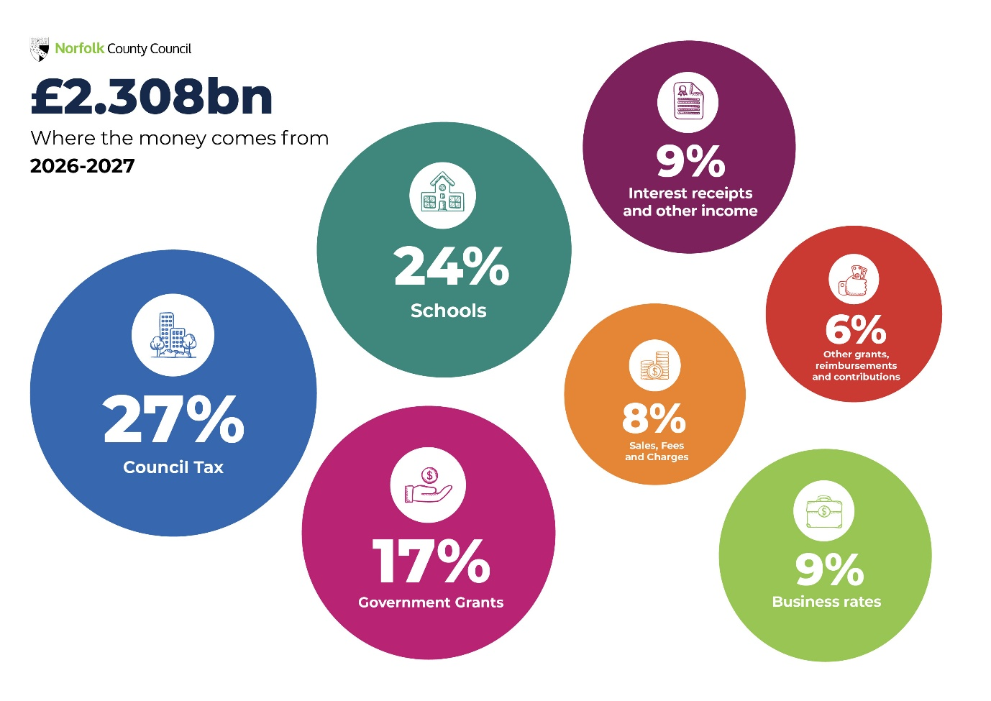
For 2026-27, Norfolk County Council has a gross income budget of £2.308bn. Funding comes from a variety of sources: 27% comes from council tax, 24% is schools funding, 17% from government grants,9% from business rates, 9% from interest receipts and other income, 8% from sales, fees and charges and 6% from other grants, reimbursements and contributions.

Where the money is spent:
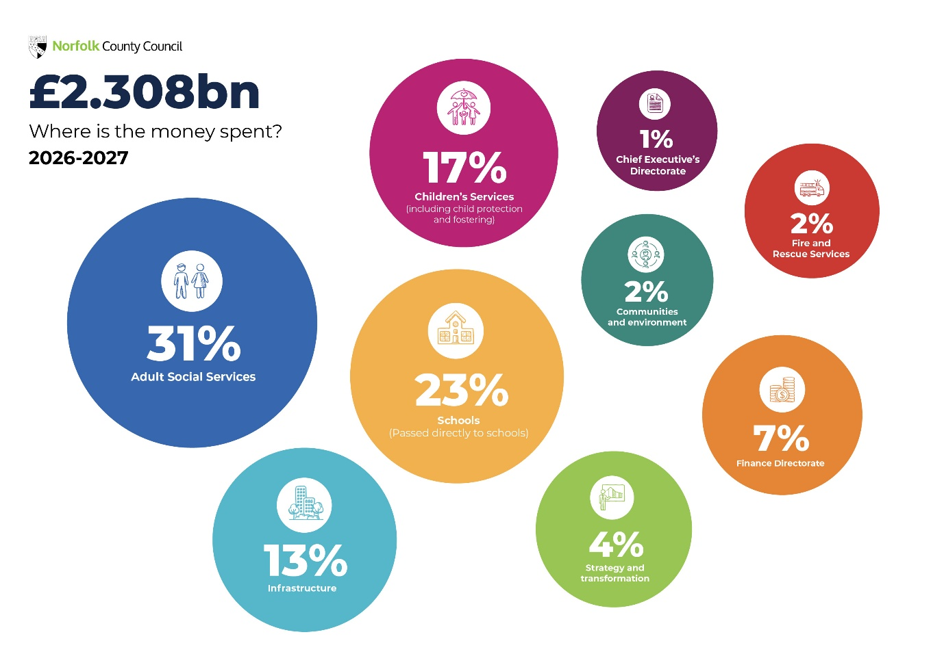
The departmental breakdown of Norfolk County Council’s £2.308bn expenditure budget is 31% spent on adult social services, 17% on children’s services (non-schools), 23% spent on schools, 13% is spent on infrastructure, 2% on communities and environment, 2% on fire, 7% on finance directorate, 4% on strategy and transformation and 1% on chief executive’s directorate.

Background to council tax

Council tax helps pay for local services and applies to all domestic properties whether owned or rented. How much you pay depends on the valuation band of your property. The responsibility to pay council tax usually lies with the occupier.

Each organisation that provides services in your area sets their own proportion of the council tax bill you receive. These are:

- Norfolk County Council
- your district/borough/city council
- your parish council (if you have one)
- Norfolk police

Statistics show that following changes in Government policy, all county councils in England have raised council tax in a broadly similar way since 2015-16. You can view data comparing local authority council tax rates on the GOV.UK website.

In the graph below the dashed line represents Norfolk and the solid lines represent other county councils.
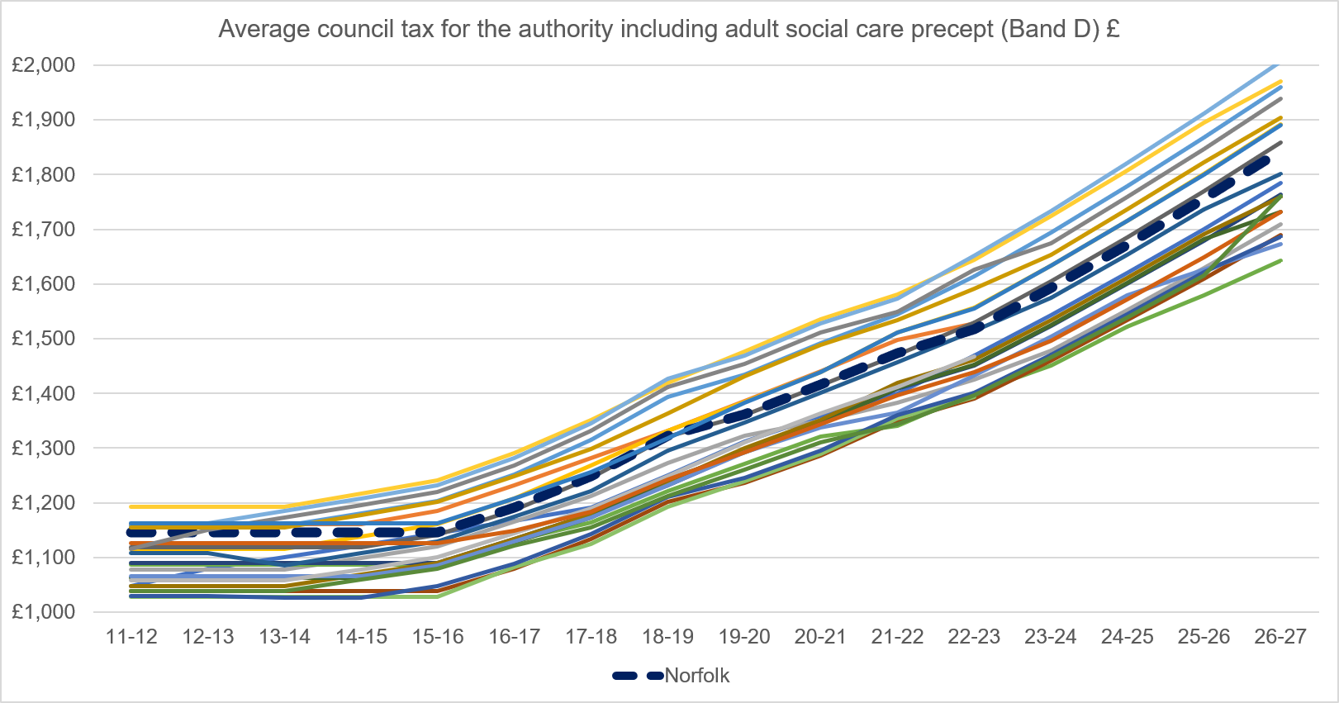

The money you pay as part of Norfolk County Council’s general share of the council tax helps fund the costs of all the services provided by Norfolk County Council and is not linked to specific services.

Part of your council tax bill is the adult social care precept - the adult social care precept was introduced by the Government in 2015 and has been part of the council tax bill since 2016-17.

The money we raise from the adult social care precept is ringfenced, this means we can only spend it on adult social care services.

Adult Social Care is a collection of wide-ranging activities aimed at helping people who may be older or living with disability or physical or mental illness. For some, this may include access to services that provide “personal care” either in their own homes or in more formal settings such as a care home. However, for many Social Care is about providing support to potentially overcome obstacles and enable people to live the lives they want to lead in a place they can call home. Norfolk County Council spends almost £2m a day in providing support through our Adult Social Services department.

Our proposal

To help us deal with our cost pressures and invest in vital services our current budget planning is based on an assumption to increase council tax. Two options being considered are:

- An increase of 3%
- An increase of up to 5%

Consulting on two options will allow flexibility in setting the budget, at a time when there is still substantial uncertainty about local government funding and demand for our services continues to increase, which means that costs continue to rise. Every 1% increase in council tax would equate to approximately £6m of additional income.

Final decisions about the level of council tax will be made by Norfolk County Council in February 2027.

The effect our proposals would have on council tax

An increase of 3% would mean in 2027-28 Norfolk County Council’s council tax charge for a typical Band D home would increase by approximately £1.06 a week, or £55 for the year, so the charge for a Band D home would be around £1,899 a year.

Each further 1% increase in council tax would see Norfolk County Council’s council tax charge for a typical Band D home increase by approximately 35p a week or £18 for the year.

For reference, a 5% increase would mean in 2027-28 Norfolk County Council’s council tax charge for a typical Band D home would see an increase of approximately £1.77 a week or £92 for the year, so the charge for a Band D home would be around £1,935 a year.

Our council tax questions

We want your views on the proposal to increase council tax by 3%, and on the proposal to increase council tax by up to 5%.

Q1. How far do you agree or disagree with the proposal to increase council tax by 3%?
Please tick (P) one answer only:

☐ Strongly agree
☐ Agree
☐ Neither agree or disagree
☐ Disagree
☐ Strongly disagree
☐ Don’t know

Q2. How far do you agree or disagree with the proposal to increase council tax by up to 5%?
Please tick (P) one answer only:

☐ Strongly agree
☐ Agree
☐ Neither agree or disagree
☐ Disagree
☐ Strongly disagree
☐ Don’t know

Q3. Please tell us more about why you chose those answers and whether you have any other comments on the proposals, and how any changes could impact you, using the box below:

Please write your comments here - please tell us whether your comment is about the 3% increase, the 5% increase or both increases:

Our 2027-28 budget proposals question

We welcome any comments you have, either about our budget approach or our efficiency proposals.

There is a full list of all the proposals in the tables below.

The following proposals have been identified as requiring specific public consultation. You can find more information on the following proposals, and a feedback form for each one – on our website at www.norfolk.gov.uk/budget

- INF006 - Reduction in treated highway network / gritted routes by 5%
- INF007 - Reduction in highway maintenance revenue activities by 5%
- INF008 - Reduction in highway verge grass cutting
- INF009 - Reduction in highway weed killing treatment
- INF010 - Reduction in number of hazardous waste disposal events
- CS008 - Home to School Transport - Post-16 parental contributions*

*A separate targeted consultation is planned for the Home to School Transport - Post-16 parental contributions proposal in November to mid-December 2026. Find out more and have your say at www.norfolk.gov.uk/budget

Q4: Do you have any comments about the proposals, or anything else you would like to tell us?

If yes, please write below. If you wish to comment on an individual proposal, please include its reference number beside your comments. The reference numbers are listed in the first column in our budget tables.

Please write your answer here:

Budget savings proposals 2027-28

Ref | Proposal | 2027-28  £m | 2028-29  £m | 2029-30  £m | 2030-31  £m | Total  £m
ASS001 | Population Health Management - Reducing the demand for formal Adult Social Care Services by shifting our focus to health prevention. By using data and working closely with health and care partners we’re identifying people at risk earlier, such as risk of falls and heart disease, and offer support before their health worsens. | -0.224 | -0.119 | -0.347 | -0.471 | -1.161
ASS002 | Integrated Neighbourhoods & Relational Practice - Reducing the demand for formal Adult Social Care Services by building stronger, more connected communities. By working locally with residents and partners, we will help residents make the most of local groups, activities, and resources in their community. Our new neighbourhood teams will work with communities to identify and address problems early, before they become more serious. | -5.860 | -7.522 | -0.525 | -0.342 | -14.249
ASS003 | Intermediate Care - Reducing the demand for formal ASC Services by delivering improvements and innovations in home based and bed based short term care | -1.090 | -2.798 | -2.759 | ​-0.277 | -6.924
ASS004 | Complex Community Care - Reducing demand for Adult Social Care services by improving support for people with complex needs through closer working between health and social care services. This means more personalised care and better joined up support, bringing together the different services people rely on and helping to prevent needs from escalating. | -0.569 | -0.843 |  |  | -1.412
ASS005 | Commissioned Care - Reducing the demand for, and cost of, formal ASC Services by making changes to the way we work with external care providers across age and need, to improve resident wellbeing, enhance care quality, and deliver better value for money | -6.928 | -3.788 | -3.129 |  | -13.845
ASS006 | Revise the projected Adult Social Care income budget to future expected income levels | -2.635 | -2.771 | -2.914 | -3.064 | -11.384
ASS007 | Use of reserves towards local area co-ordinators |  | 1.000 |  |  | 1.000
ASS008 | One-off use of reserves Road Safety​ | -0.040 | 0.040 | ​ | ​ | 0.000
ASS009 | One-off use of reserves Trading Standards​ | -0.200 | 0.200 |  | ​ | 0.000
ASS010 | Realigning health and care funding related to joint and shared responsibilities | -1.000 |  |  | ​ | -1.000
ASS011 | Restructuring of historic pooling arrangements related to Medicine Support Service | -0.031 |  |  | ​ | -0.031
ASS012 | Full year impact of reshaped process to support people home from hospital | -0.310 | ​ | ​ | ​ | -0.310
CS001 | Prevention, early intervention and effective social care - helping families stay together and ensuring fewer children in care: Reduction in placement spend through an increased number of children and young people being reunified to their family network | -0.500 |  |  |  | -0.500
CS002 | Prevention, early intervention and effective social care - helping families stay together and ensuring fewer children in care: Expansion of the Enhanced Family Help Team focusing on supporting families to remain together where neglect is a key factor | -0.500 |  |  |  | -0.500
CS003 | Transforming the care market and creating more of our own capacity for young people with complex needs. | -0.150 | -1.500 | -0.150 |  | -1.800
CS004 | Taking an alternative approach to delivering edge of care services | -0.900 |  |  |  | -0.900
CS005 | Streamline approach to purchasing equipment for children with disabilities. | -0.075 |  |  |  | -0.075
CS006 | Smarter Working – using technology and process redesign to deliver services more efficiently | -1.000 |  |  |  | -1.000
CS007 | Spending efficiencies including reduction in venue hire | -0.050 |  |  |  | -0.050
CS008 | Home to School Transport - Post-16 parental contributions | -0.092 | -0.277 |  |  | -0.369
CS009 | Home to School Transport - Working with families to move children into special school placements closer to home | -0.050 |  |  |  | -0.050
CS010 | Securing additional grant funding to fund NCC budgeted core functions and roles | -0.100 |  |  |  | -0.100
INF001 | Invest to save – additional Flood Risk Officer post to reduce consultant spend | -0.035 |  |  |  | -0.035
INF002 | Additional income associated to fees and charges | -0.850 |  |  |  | -0.850
INF004 | Closure of Morningthorpe Recycling centre at end of the current lease period | -0.095 |  |  |  | -0.095
INF005 | Cease external consultancy spend on Norfolk Strategic Flood Alliance | -0.025 |  |  |  | -0.025
INF006 | Reduction in treated highway network / gritted routes by 5% | -0.225 |  |  |  | -0.225
INF007 | Reduction in highway maintenance revenue activities by 5% | -0.475 |  |  |  | -0.475
INF008 | Reduction in highway verge grass cutting | -0.300 |  |  |  | -0.300
INF009 | Reduction in highway weed killing treatment | -0.110 |  |  |  | -0.110
INF010 | Reduction in number of hazardous waste disposal events | -0.200 |  |  |  | -0.200
INF011 | Civil Parking Enforcement rollout - Expand on-street car parking charges to more areas across Great Yarmouth | -0.020 |  |  |  | -0.020
INF012 | Moving Traffic Enforcement - full recharge of staff costs | -0.050 |  |  |  | -0.050
INF013 | Moving Traffic Enforcement - roll out of future sites and contribution towards Highways Maintenance Fund | -0.075 |  |  |  | -0.075
INF014 | Insurance saving through premium reduction | -0.100 |  |  |  | -0.100
INF015 | Streetlighting savings from previous initiatives | -0.100 |  |  |  | -0.100
INF016 | Increased use of Commuted Sums | -0.800 | 0.800 |  |  | 0.000
INF017 | Reduced activity associated to building maintenance fund | -0.150 |  |  |  | -0.150
INF018 | Civil Parking Enforcement - Norwich sites – conversion of existing 2-hour free parking bays into paid bays | -0.020 |  |  |  | -0.020
INF019 | Establishment changes - Infrastructure delivery team | -0.015 |  |  |  | -0.015
INF020 | Establishment changes - Highways boundary team | -0.020 |  |  |  | -0.020
INF021 | Remove inflationary uplift (3%) for third party (Town & Parish Councils, Community Groups etc) for recycling credits | -0.005 |  |  |  | -0.005
INF022 | Non renewal of Accorn payment (data for specific marketing to help improve recycling rates) | -0.006 |  |  |  | -0.006
INF023 | One off use of Waste Reserve funding | -0.500 | 0.500 |  |  | 0.000
INF024 | Removal of the redundant and end of service life traffic signals on Islington Road, Tilney St Lawrence in West Norfolk | -0.003 |  |  |  | -0.003
INF025 | Removal of Beryl micromobility initiative for staff | -0.075 |  |  |  | -0.075
INF026 | One off use of Transport Reserve funding | -0.100 | 0.100 |  |  | 0.000
INF027 | One-off use of Corporate Property Team reserves | -0.250 | 0.250 |  |  | 0.000
INF028 | Improve recovery of highway infrastructure repair costs from liable third parties (including insurers) following all road traffic incidents | -0.020 |  |  |  | -0.020
COM001 | Renegotiation of existing software contracts in Environment Service (pulling prior year budget saving forward a year) | -0.028 | 0.028 |  |  | 0.000
COM002 | Delivery of building maintenance and repairs associated to Windmills and Historic Buildings through alternative funding sources to allow a reduction in NCC revenue funding | -0.027 |  |  |  | -0.027
COM003 | Non-staff savings across Environmental specialist advice team as a consequence of long term vacancies in the team | -0.026 |  |  |  | -0.026
COM004 | Norfolk Museum Service - Additional income associated to external work for archaeology field units | -0.005 |  |  |  | -0.005
COM005 | Norfolk Museum Service - Establishment structural changes | -0.045 |  |  |  | -0.045
COM006 | Museums & Galleries Exhibitions Tax Relief | -0.300 |  |  |  | -0.300
COM007 | Vacancy management across Communities and Environment back-office support | -0.180 |  |  |  | -0.180
COM008 | Reduce non-staff expenditure in Libraries | -0.100 |  |  |  | -0.100
COM009 | Utilising alternative funding sources to allow a reduction in NCC revenue funding | -0.040 |  |  |  | -0.040
COM010 | Additional income from overhead recovery | -0.044 |  |  |  | -0.044
COM011 | Changes to performance monitoring platforms in Adult Learning | -0.035 |  |  |  | -0.035
FIR001 | To deliver further efficiencies through the existing red fleet vehicle maintenance contract to ensure best value | -0.100 |  |  |  | -0.100
S&T001 | HR review of staffing budgets | -0.200 |  |  |  | -0.200
S&T002 | Stopping Your Norfolk magazine | -0.130 |  |  |  | -0.130
S&T003 | Digital: Reduced Supplier Spend | -0.345 |  |  |  | -0.345
S&T004 | Digital: Apps Rationalisation and process automation including use of AI | -0.100 |  |  |  | -0.100
S&T005 | Digital: Increased external income | -0.200 |  |  |  | -0.200
S&T006 | Digital review of staffing budgets | -0.200 |  |  |  | -0.200
S&T007 | Cancel Royal Norfolk Show NCC tent and displays | -0.040 |  |  |  | -0.040
S&T008 | Communications team deletion of vacant posts | -0.082 |  |  |  | -0.082
S&T009 | I&A new operating model and review of staffing budgets | -0.216 |  |  |  | -0.216
S&T010 | SG&I review of staffing budgets | -0.205 |  |  |  | -0.205
S&T011 | SG&I Reduction of NCC contribution to Local Transport Plan | -0.200 |  |  |  | -0.200
S&T012 | SG&I Reduction of NCC contribution to Business Growth Fund | -0.200 |  |  |  | -0.200
S&T013 | SG&I – One-off use of reserves | -0.330 | 0.330 |  |  | 0.000
S&T014 | SG&I – Increased income from S278 Developer charges | -0.025 |  |  |  | -0.025
S&T015 | Communications team staff restructure | -0.261 |  |  |  | -0.261
CEX001 | Political Assistants deletion of posts | -0.164 |  |  |  | -0.164
CEX002 | Nplaw income increases | -0.200 |  |  |  | -0.200
CEX003 | Nplaw one-off from reserves | -0.300 | 0.300 |  |  | 0.000
CEX004 | Registrars’ additional income | -0.050 |  |  |  | -0.050
CEX005 | Adjustment to staffing structures | -0.100 |  |  |  | -0.100
CEX006 | Coroner’s reduction in venue hire and miscellaneous expenses | -0.010 |  |  |  | -0.010
CEX007 | Democratic and Regulatory Services one-off from reserves | -0.100 | 0.100 |  |  | 0.000
FIN001 | Full recovery of the cost of Council support services provided to the Norfolk Pension Fund | -0.157 |  |  |  | -0.157
FIN002 | One-off use of Insurance fund reserve | -0.500 | 0.500 |  |  | 0.000
FIN003 | Finance review of staffing budgets | -0.100 |  |  |  | -0.100
 |  | -32.273 | -15.470 | -9.824 | -4.154 | -61.721

About you

To make sure we are learning from a wide range of people – we would like to ask some questions about you. These are optional questions (so you may choose not to give this information), but this information is helpful to understand who is responding to our consultations.

Related information

On 12 September 2024 the ONS (Office for National Statistics) announced the findings of a review of gender identity estimates from Census 2021, which includes a reclassification of ‘official statistics in development’.
You can read more about this on the ONS website
We are using the ONS Census 2021 format for the 'About You' questions, but with an awareness of this update from the ONS.

Q1. Are you responding as...? Please choose one answer only from the list below:

☐ An individual / member of the public
☐ On behalf of a voluntary or community group
☐ On behalf of a statutory organisation
☐ On behalf of a business
☐ A Norfolk County Councillor
☐ A district or borough Councillor
☐ A town or parish Councillor
☐ A Norfolk County Council employee

If you are responding on behalf of another organisation, what is the name of the organisation, group, or business?

Please write your answer here:

Q2. How did you hear about this consultation? Please choose one answer only from the list below:

☐ Local media (e.g., newspaper, radio)
☐ From a social media post (e.g., Facebook)
☐ From a friend
☐ From a group I belong to
☐ From my place of work or education
☐ The Norfolk Residents' Panel
☐ District council web page
☐ Norfolk County Council web page
☐ My Parish Council
☐ From an email I received
☐ Other
Other, please write your answer here:

Q3. How old are you? Please choose one answer only from the list below:

☐ Under 18
☐ 18-24
☐ 25-34
☐ 35-44
☐ 45-54
☐ 55-64
☐ 65-74
☐ 75-84
☐ 85 or older
☐ Prefer not to say

Q4. What is your sex? Please choose one answer only from the list below:

☐ Male
☐ Female

Q5. Is the gender you identify with the same as your sex registered at birth?
Please choose one answer only from the list below:

☐ Yes
☐ No

If No, please write your gender identity here:

Q6. Do you have any long-term illness, disability or health problem that limits your daily activities? Please choose one answer only from the list below:

☐ Yes
☐ No
☐ Prefer not to say

Q7. If yes, which of the following best describes your condition or disability? Please select as many answers that apply:

☐ Blind or partially sighted

☐ Deaf or hard of hearing

☐ Limiting health condition e.g. heart disease, asthma, strokes, osteoarthritis, rheumatoid arthritis, fibromyalgia and myalgic encephalomyelitis (ME) etc.

☐ Learning disabilities

☐ Neurodiversity e.g. autism, dyslexia, dyspraxia

☐ Mental health conditions e.g. depression, schizophrenia, bipolar affective disorders, eating disorders, obsessive compulsive disorder

☐ Physical disability e.g. limb disorder, amputee, wheelchair user, cerebral palsy, motor neurone disease, muscular dystrophy

☐ Other:

Other condition or disability, please write your answer here:

Q8. How would you describe your ethnic background? Please choose one
answer only from the list below:

Asian or Asian British

☐ Indian
☐ Pakistani
☐ Bangladeshi
☐ Chinese
☐ Any other Asian background, please describe here

Any other Asian background, please describe here:

Black, Black British, Caribbean, or African

☐ Caribbean
☐ African
☐ Any other Black, Black British, or Caribbean background, please describe here

Any other Black, Black British, or Caribbean background, please describe here:

Mixed or multiple ethnic groups

☐ White and Black Caribbean
☐ White and Black African
☐ White and Asian
☐ Any other mixed or multiple group, please describe here

Any other mixed or multiple group, please describe here:

White

☐ English, Welsh, Scottish, Northern Irish or British
☐ Irish
☐ Gypsy or Irish Traveller
☐ Roma
☐ Any other White background, please describe here

Any other White background, please describe here:

Another ethnic group or background

☐ Arab
☐ Any other ethnic group please describe here

Any other ethnic group, please describe here:

☐ Prefer not to say

Q9. Do you have caring responsibilities? Please select as many answers that apply:

☐ No
☐ Yes – for children with additional needs
☐ Yes – for older family members
☐ Yes – other

Yes - other, please write your answer here:

Q10. Which District / Borough / City do you live in? Please choose one answer only from the list below:

☐ Breckland
☐ Broadland
☐ Great Yarmouth
☐ King’s Lynn and West Norfolk
☐ North Norfolk
☐ Norwich
☐ South Norfolk

Q11. Which of the following best describes you? Please choose one answer only from the list below:

☐ Employed (full time)
☐ Employed (part time)
☐ Self-employed
☐ Unemployed
☐ Student
☐ Looking after the family home
☐ Long term sick
☐ Retired

How we will make our decision and report back to you

We will take a report about the findings of this consultation to the Norfolk County Council Cabinet meeting in January 2027.

Norfolk County Council’s select committees will comment on the budget proposals, before Cabinet finalises its proposals in January 2027 and the Full Council makes a final decision on the budget in February 2027.

Our county councillors will consider the consultation responses we receive very carefully. In particular, they will take into account:

- The impact of any proposal on individuals, groups or communities and in particular on people identified as having 'protected characteristics' under the Equality Act 2010. The protected characteristics are: age; disability; gender reassignment; marriage and civil partnership; pregnancy and maternity; race; religion or belief; sex; and sexual orientation. As well as this equality impact assessment, councillors will consider the impact of proposals on rural areas
- The views of people and stakeholders consulted
- The evidence of need and what is proven to work effectively and well
- The financial and legal positions and any constraints at the time
- Any potential alternative options, models or ideas for making the efficiencies.

Your opinions are valuable to us. Thank you for taking the time to read this and respond.

You can fill in our online feedback form at: www.norfolk.gov.uk/budget

You can email return your feedback form to: haveyoursay@norfolk.gov.uk

You can post back a paper feedback form to:

BUDGET CONSULTATION 2027-28, Freepost Plus RTCL-XSTT-JZSK, Norfolk County Council, Ground floor - south wing, County Hall, Martineau Lane, Norwich NR1 2DH.
However, if you want to help Norfolk County Council save money, please use a stamp and send to this address: Stakeholder and Consultation Team, Norfolk County Council, Ground floor - south wing, County Hall, Martineau Lane, NR1 2DH.
You may wish to keep a copy of your response to our consultation for your own records.

 | If you need this document in large print, audio, Braille, alternative format or in a different language please email us at haveyoursay@norfolk.gov.uk or contact Customer Services on 0344 800 8020 or Text Relay on 18001 0344 800 8020 (textphone) and we will do our best to help.

https://www.legislation.gov.uk/eur/2016/679/contents
https://www.legislation.gov.uk/ukpga/2018/12/contents
https://www.norfolk.gov.uk/privacy
https://www.norfolk.gov.uk/article/38867/Council-vision-and-strategy
https://norfolkcc.cmis.uk.com/norfolkcc/CalendarofMeetings/tabid/128/ctl/ViewMeetingPublic/mid/496/Meeting/2157/Committee/169/Default.aspx https://norfolkcc.cmis.uk.com/norfolkcc/Committees.aspx
https://www.gov.uk/government/collections/council-tax-statistics
https://www.norfolk.gov.uk/budget
https://www.norfolk.gov.uk/budget
https://www.ons.gov.uk/news/news/betterunderstandingthestrengthsandlimitationsofgenderidentitystatistics

