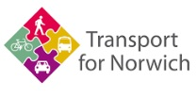  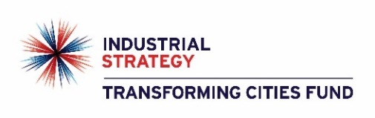 |  |  | Community & Environmental Services  County Hall  Martineau Lane  Norwich  NR1 2SG
NCC contact number: 0344 800 8020
Text relay no.: 18001 0344 800 8020

Your Ref: My Ref: PKA103
Date: November 2021 Tel No.: 0344 800 8020
Email: transportfornorwich@norfolk.gov.uk

Dear residents and businesses,

Transport for Norwich: consultation on new city centre loading and access times
In July this year, Norfolk County Council and the Transport for Norwich (TfN) partnership carried out a consultation on a series of proposals called Connecting the Norwich Lanes. These measures were designed to change how the Norwich Lanes area functions and feels by:
- Making it safer and easier to get around on foot or by bike
- Supporting outdoor hospitality and boosting the local economy
- Improving air quality
One element of the consultation was to make the temporary measures to remove general traffic on Exchange Street permanent. The temporary status of Exchange Street is a pedestrian and cycle zone with a closure to motorised traffic between 10am and 5pm, seven-days-a-week. It allows loading and access only at all other times.

Making the closure permanent had a good level of support but one of the points raised was whether an easing of the restriction for loading and access in the afternoon would be better for local businesses. With this in mind, we are putting forward proposed changes to access and loading times for the existing pedestrian and cycle zones in the city centre, as well as proposing the same access and loading restrictions on the new pedestrian and cycle zones put forward in July’s consultation.

What’s being proposed and why
Norfolk County Council has analysed the footfall figures in the city centre and these show that by 4pm each day, levels are similar to those at 10am. Taking this into account, it is considered that a 10am to 4pm restriction to traffic would provide a more balanced approach and a boost to the local economy without significantly impacting on the other project aims. It is proposed that the streets shown in the plan enclosed would restrict all motor vehicles from 10am to 4pm and allow loading and access only outside these times.

The purpose of this consultation is to get feedback on the proposals and to gather information that will help inform the final plans put forward for delivery.
How to comment
- Visit www.norfolk.gov.uk/norwichlanes where you can complete a brief online survey to share your thoughts.
- You can request hard copies by calling or emailing us using the details at the top of this letter. Large font and other formats are available on request.
- You can also email or phone us to book a meeting slot with a member of the project team if you have queries or wish to discuss proposals in more detail.
Deadline and next steps
The deadline for consultation responses is Monday 22 November 2021. The feedback received will then be reported back to the Transport for Norwich Joint Committee in January, along with the outcomes and final proposals following the Connecting the Norwich Lanes consultation. The local councillors on the committee from Norfolk County, Norwich City, Broadland District and South Norfolk councils will then decide how to proceed with the various elements of the project. The web page above will be kept up to date with the latest information, progress and any relevant committee dates.

Background
The Department for Transport (DfT) has awarded £32m of funding to the county council from the Transforming Cities Fund to deliver a range of schemes across Greater Norwich. These projects aim to improve access to jobs, training and retail by supporting improvements to sustainable modes of transport, while also responding to issues around air quality. More information about our application to the DfT and all the proposed schemes can be found at www.norfolk.gov.uk/transformingcities. You can also read more about previous, current and future TfN projects by visiting www.norfolk.gov.uk/tfn.

Yours faithfully,

Transport for Norwich

