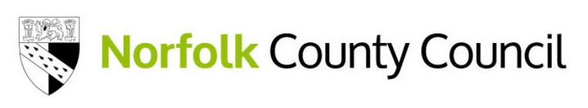

Your views on the future of Norse Care homes

Tell us what you think

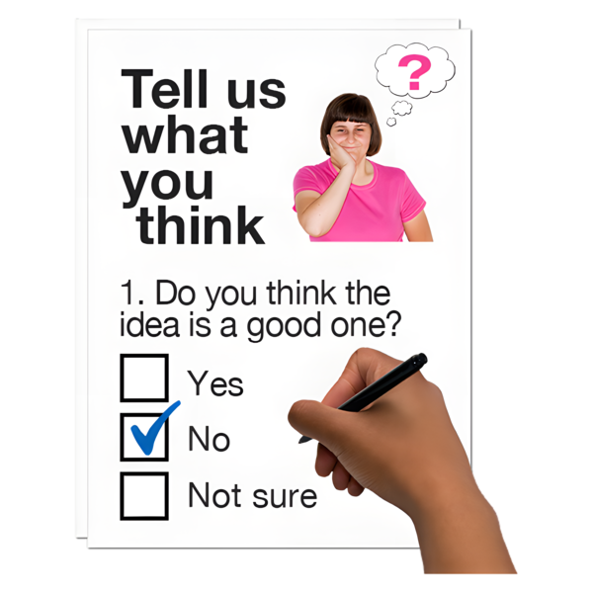
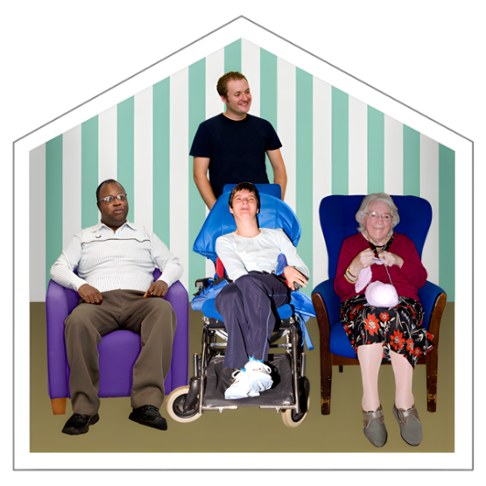

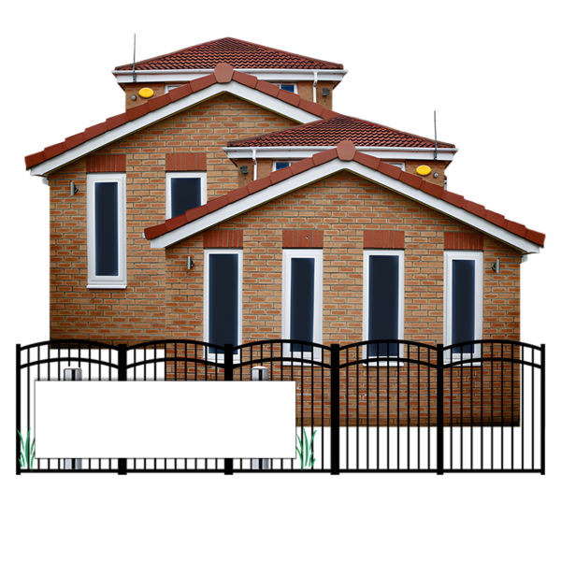

FOR SALE



This is an Easy Read survey.

Some of the things in this survey are not easy to understand.


You may need help from someone to read it.

About Norfolk County Council and Norse Care

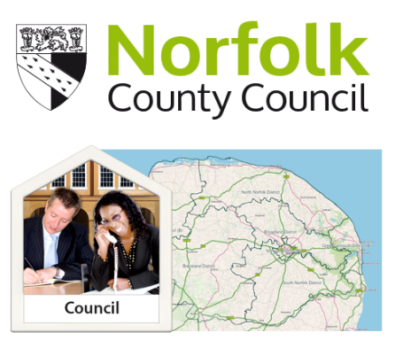
Norfolk County Council runs lots of services in Norfolk.

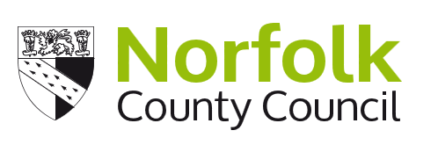
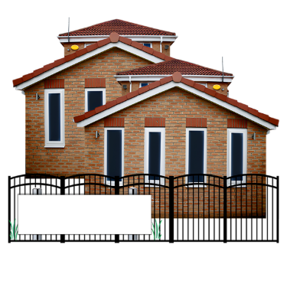
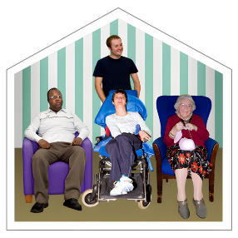
We own some care homes, and we own a company that runs these care homes.


This company is called Norse Care.

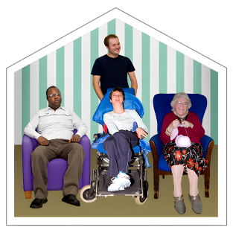
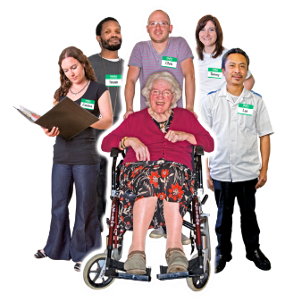
Many people live in these care homes and are cared for by people who work there.

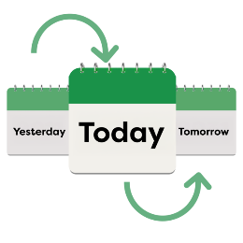
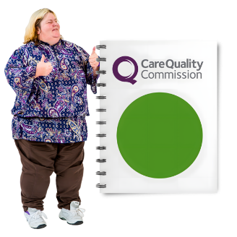
We want good and safe care for everyone - now and in the future.

About Norfolk County Council and Norse Care
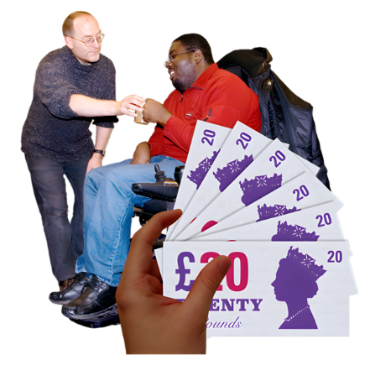
Some people who live in these care homes pay money to live there and to be cared for.


Some people who live in these care homes have their care paid for by Norfolk County Council.

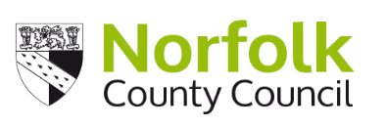



Our agreement with Norse Care to run the care homes stops on 31 March 2026.


We are planning what should happen after this date.

Making the care homes better

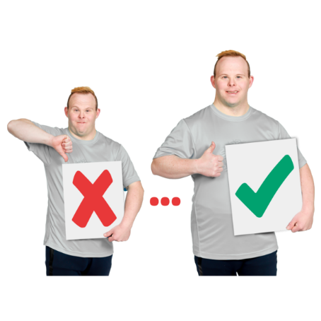

Some Norse Care homes are old. They need money spent on them to make them better for the people that live there.


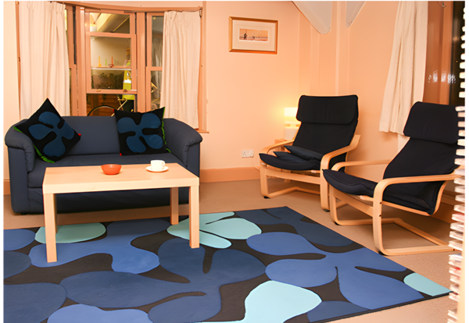
We want all care homes to be modern, comfortable and easy to move around.

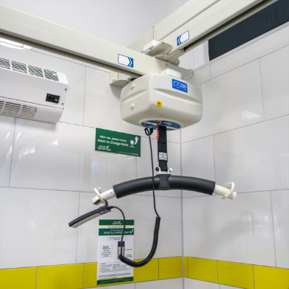
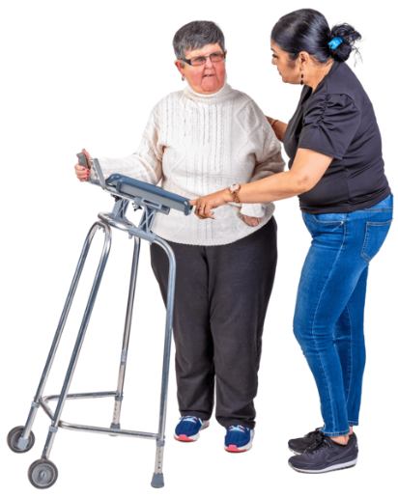
We want to be able to help people who need different kinds of care. To do this, we need the right rooms and equipment.

Our idea

We have an idea that we think will make sure the care homes are good places for people to live in future.


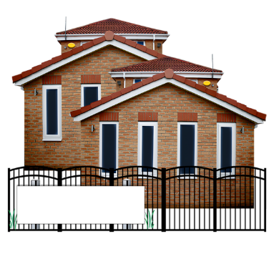
Our idea is to sell Norse Care and the care homes they run.
FOR SALE
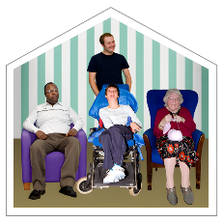
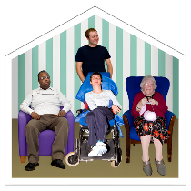
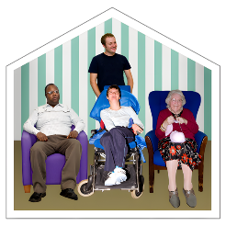

Three of the care homes run by Norse Care are closed but will also be included in the sale.

The 20 care homes are:
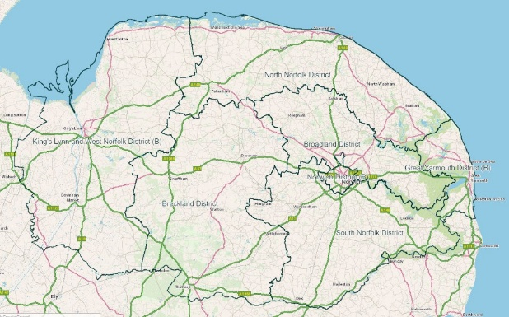
Beauchamp House, Chedgrave
Burman House, Terrington St John (closed)
Bishop Herbert House, Norwich
Cranmer House, Fakenham
Ellacombe, Thorpe Hamlet

Our idea
Harker House, Long Stratton
High Haven, Downham Market
Linden Court, Watton (closed)
Lydia Eva Court, Gorleston
Mayflower Court, Norwich
Mountfield, Norwich
Munhaven, Mundesley
Rebecca Court, Heacham
Rose Meadow, North Walsham
St Edmunds, Attleborough
St Nicholas House, Dereham
Springdale, Brundall (closed)
Sydney House, Stalham
Westfields, Swaffham
Woodlands, King's Lynn

You may live in one of these care homes now or know someone who does.

What changes would there be


We would only choose to sell these care homes to a good company who we think will be able to care for the people who will live there in future.
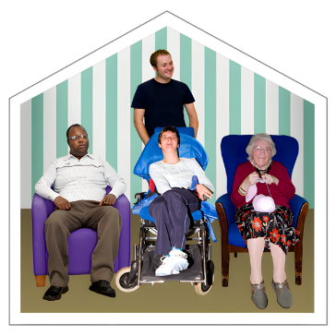
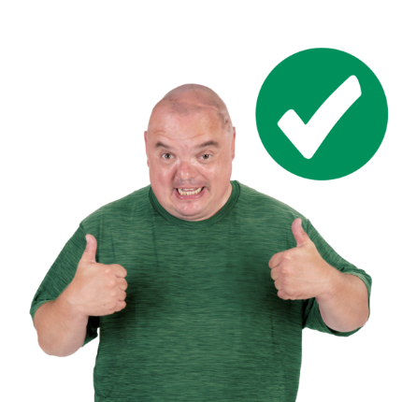

We are asking the company to make sure the people who live in the care homes now can stay in their care home.

Some people who live in these care homes have their care paid for by Norfolk County Council.

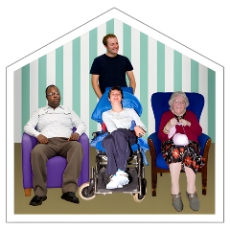
People who have their care paid for by Norfolk County Council will not see any change to the way they are cared for if we sell Norse Care.

What changes would there be
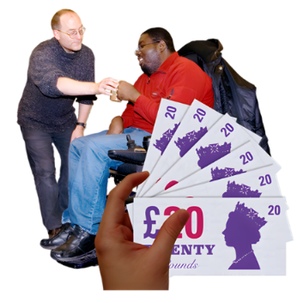
People who pay for their own care may see a difference in the way they will pay for their care in future.



They may have to pay another company for their care in future.


They may have to pay more money for their care in future. We want to make sure this is not too much money.
£


The people who work in the care homes and care for the people living there will be able to carry on working there.

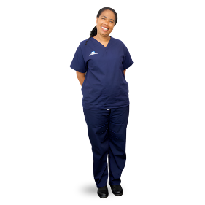
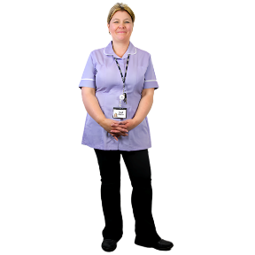
They might wear different uniforms in future.

Who do we plan to sell to

We asked lots of companies if they wanted to buy Norse Care and the care homes.


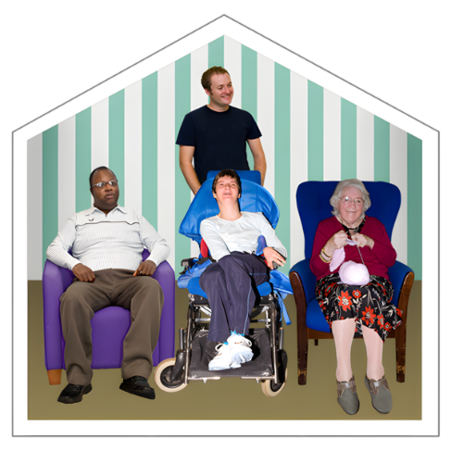
We chose a company called Stow Healthcare. Stow Healthcare has care homes in Norfolk, Suffolk and Essex. They give good or outstanding care.

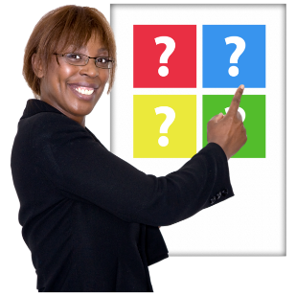
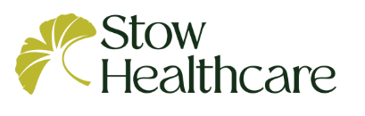
Stow Healthcare have told us they want to keep the care homes as care homes.

Stow Healthcare have told us they want to spend money to make the care homes better for the people who will live there in future.

What might happen in the future

If we sell Norse Care and the care homes, the new company may want to make changes to the care homes in future.

If we sell Norse Care, we will not be able to tell the new company what to do in future.
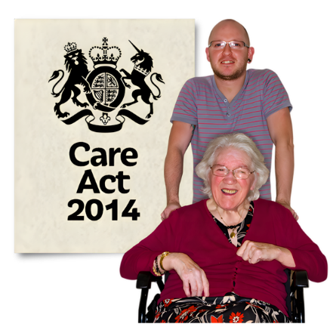
The law (Care Act) says we must make sure people living in the care homes now are cared for in future.

The way that people living in the care homes are cared for - including where they live - may change in future if we sell Norse Care.

Everyone who lives in the care homes will still be able to choose how they are cared for in future because the law protects them.

Other options


We looked at lots of other ideas - like not selling Norse Care or only selling some of the care homes.
FOR SALE

These ideas cost too much money.

£



These ideas would mean that the care homes could not be made better by us or Norse Care for the people who will live there in future.



We want to hear what you think of our idea to sell Norse Care and the 20 care homes.

Taking part

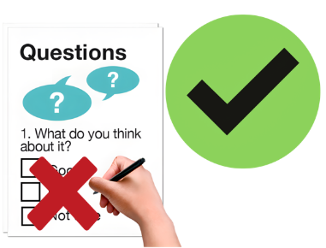
You don’t have to answer all the questions.

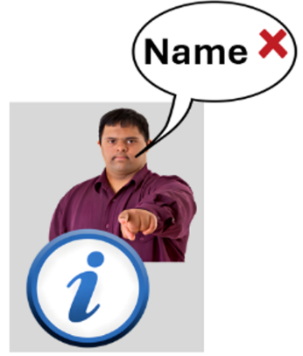

You don’t have to tell us your name or anything about you.


We must keep your information safe by law.

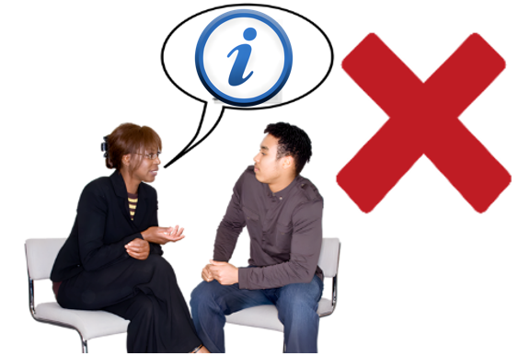
We will not share your information with people who don’t work for us.

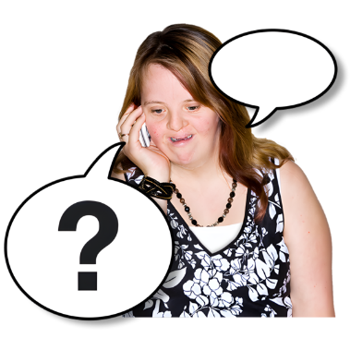
If you have a question about how we keep your information safe, call us on 0344 800 8020.

Our questions

Question 1: Which of the following best describes you?
Please tick all that apply to you:

☐ I am living at a Norse Care home

☐ I am helping someone who lives in a Norse Care home to fill the survey in

☐ I am someone else – please write in box below

Please write your answer in this box

Our questions

Question 2: If you live in a Norse Care home, or are helping someone who lives in a Norse Care home to fill in the survey, what is the name of the care home?

- Tick 1 box

☐ Beauchamp House, Chedgrave
☐ Bishop Herbert House, Norwich
☐ Cranmer House, Fakenham
☐ Ellacombe, Thorpe Hamlet
☐ Harker House, Long Stratton
☐ High Haven, Downham Market
☐ Lydia Eva Court, Gorleston
☐ Mayflower Court, Norwich
☐ Mountfield, Norwich
☐ Munhaven, Mundesley
☐ Rebecca Court, Heacham
☐ Rose Meadow, North Walsham
☐ St Edmunds, Attleborough
☐ St Nicholas House, Dereham
☐ Sydney House, Stalham
☐ Westfields, Swaffham
☐ Woodlands, King's Lynn

Our questions

Question 3: What do you think about our idea to sell Norse Care and the 20 care homes?


Please write any thoughts you have about this idea in this box.

Our questions

Question 4: Tell us how you think this idea to sell Norse Care and the 20 care homes will affect you.

Please write here anything you want to tell us.

Our questions

Question 5: If you are worried about how this idea to sell Norse Care will affect you, what will help you to be less worried in future?
Please write here anything you want to tell us.

Questions about you


It is helpful to know more about you. This helps us to see if different people think our ideas are good or bad.

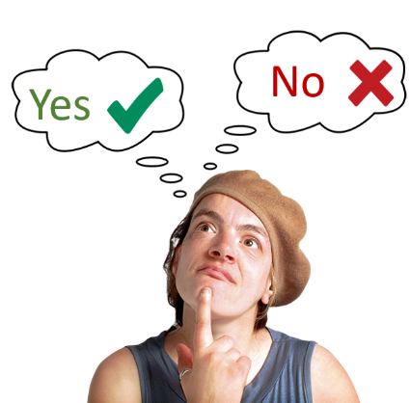

You do not have to answer these questions.



If you answer these questions, we will keep your information safe.

Questions about you

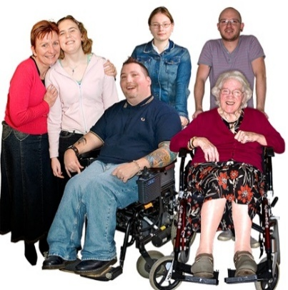
Question 6:

How old are you?

Please write your age in this box:

☐ I prefer not to tell you

Question 7:

What is your sex?

Sex: Your sex is whether you were born as a man or a woman.

- Please tick 1 box

☐ Male
☐ Female

Questions about you

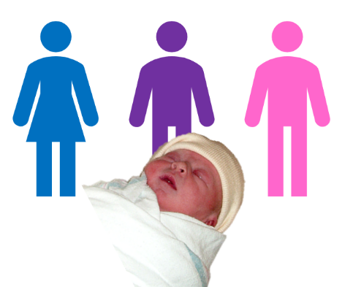
Question 8:

Is your gender the same as your sex?

Gender: This is whether you like to be known as male, female, or something else.

- Please tick 1 box

☐ Yes
☐ No

If you would like to, you can tell us your gender identity in this box:

Questions about you

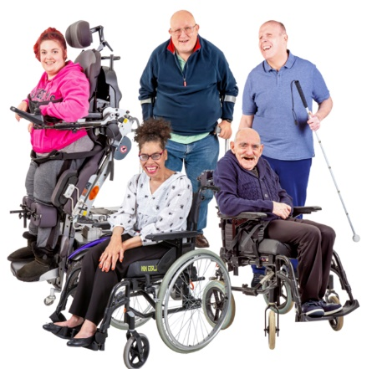
Question 9:

Are any of these true for you?

☐ I have a disability

☐ I have had a health condition for a long time

☐ None of these

☐ I prefer not to tell you

Questions about you


Question 10:

Which of these describes your health condition or disability?

Please tick all that apply:

☐ Blind or partially sighted

☐ Deaf or hard of hearing

☐ Limiting health condition
e.g. heart disease, asthma, strokes, osteoarthritis, rheumatoid arthritis, fibromyalgia and myalgic encephalomyelitis (ME) etc.

☐ Learning Disabilities

☐ Neurodiversity
e.g. autism, dyslexia, dyspraxia

☐ Mental health conditions
e.g. depression, schizophrenia, bipolar affective disorders, eating disorders, obsessive compulsive disorder

Questions about you

☐ Physical disability
e.g. limb disorder, amputee, wheelchair user, cerebral palsy, motor neurone disease, muscular dystrophy

☐ Other – please write below

If you have another type of disability or health condition, tell us in this box:

Questions about you


Question 11:

What is your ethnicity?

Ethnicity is your race or
background. For example, you may be Black, White or Asian.

- Please tick 1 box

☐ White or White British

☐ Asian or Asian British

☐ Black, Black British,
Black Caribbean or African

☐ Mixed or multiple ethnic groups

☐ Another ethnic group

☐ I prefer not to tell you

Questions about you

Question 12:

Do you help to care for someone else?

☐ No

☐ Yes – children with a special educational need or disability

☐ Yes – adult family member(s)

☐ Yes – I help care for someone different

Questions about you

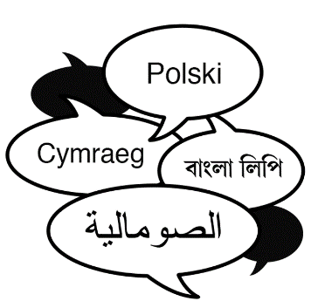
Question 13:

What is your first language?

☐ I speak English


If another language is your first language, please write the name of it in this box:

How to send us your answers
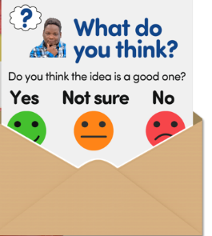
Put the survey in an envelope.



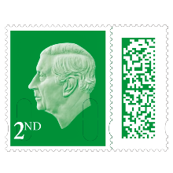
You do not need to put a stamp on the envelope.

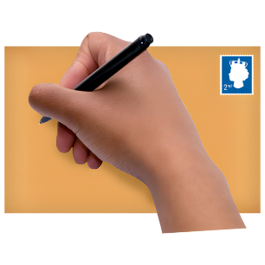
Put this address on the envelope:


CARE HOME CONSULTATION
Freepost RTCL-XSTT-JZSK
County Hall
Martineau Lane
Norwich

NR1 2DH
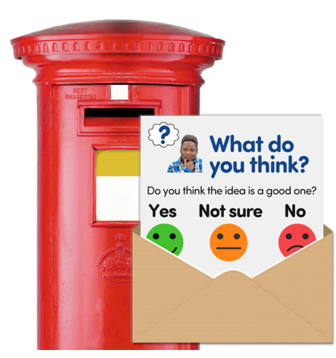

Send this survey back to us by
22 March 2026.

What happens next

This survey closes on
22 March 2026

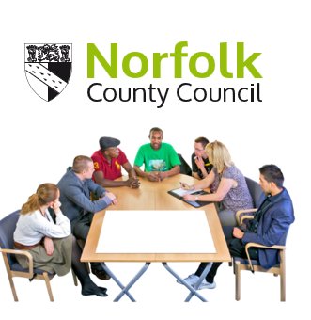

The County Council will then think about what people have told us about our idea.

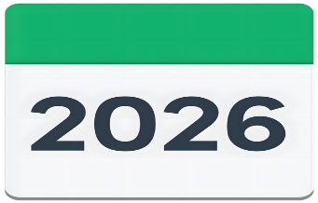


Our decision makers will make a decision about this idea later this year.

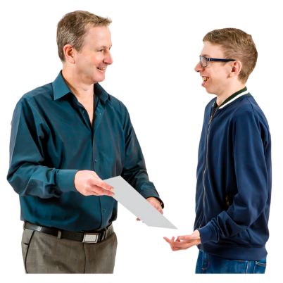
We will tell you what that decision is.

If you have more questions


If you have more questions, you can contact us:



Phone: 0344 800 8020



Email: haveyoursay@norfolk.gov.uk

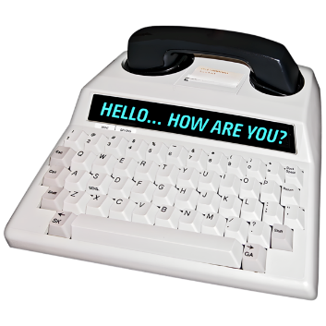
Text Relay:
18001 0344 800 8020


If you pay for your care and need help or support you can:
email the financial assessment team at fab@norfolk.gov.uk
or call 01603 222133
(press for option 2).

If you have more questions


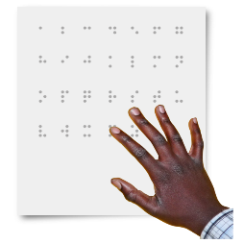
You can ask us for this document in large print, audio, Braille, or a different format.
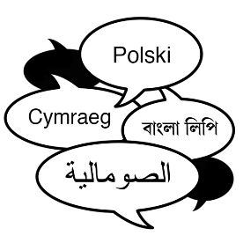
You can ask us for this information in a different language.

