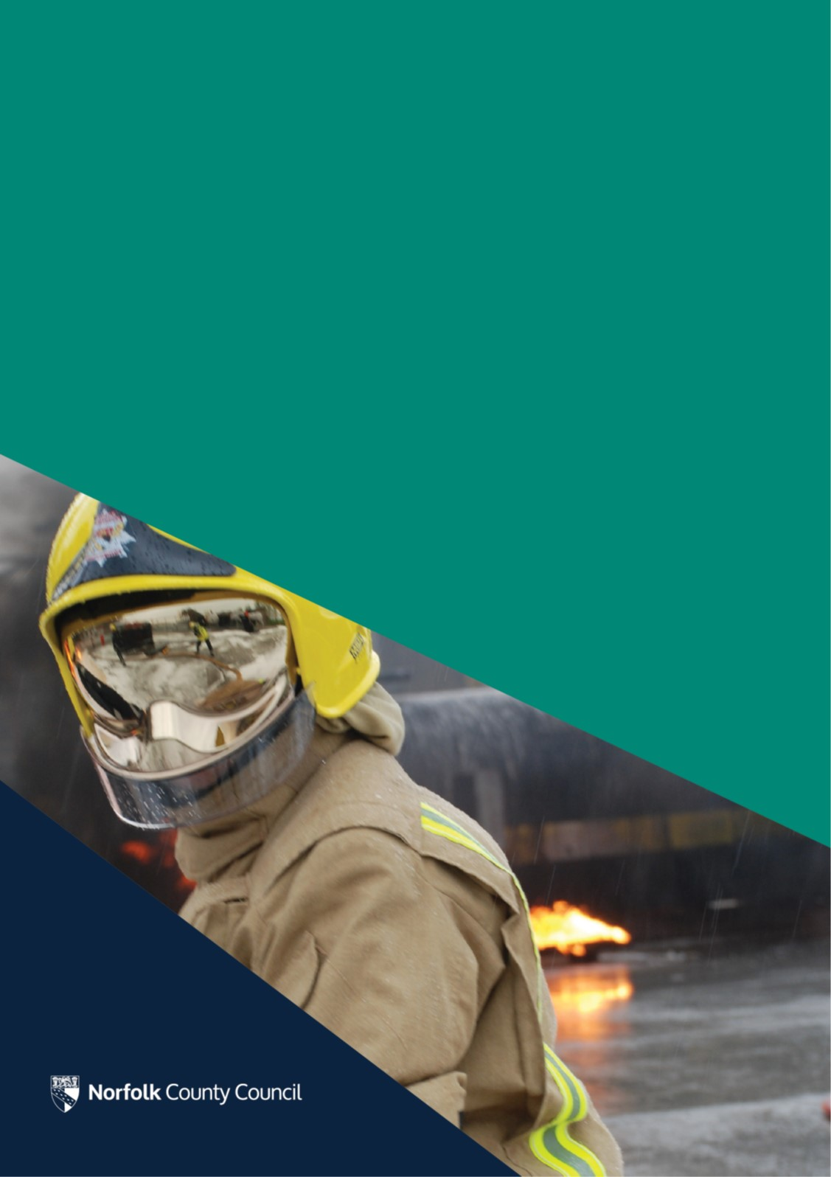
Norfolk Fire & Rescue Service

Improvement Plan in response to the 2019 Inspection by Her Majesty’s Inspectorate of Constabulary and Fire & Rescue Services
Introduction

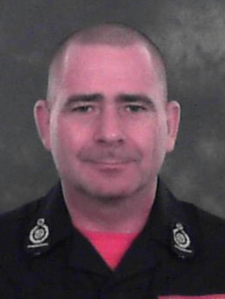  Stuart Ruff  Chief Fire Officer  Norfolk Fire and Rescue Service | In February 2019 we welcomed a team of Inspectors from Her Majesty’s Inspectorate of Constabulary and Fire & Rescue Services (HMICFRS) who assessed our Service across three core areas of effectiveness, efficiency and how well we look after our people.  I welcome the opportunity to learn from HMICFRS’s recommendations to help us further improve our service for Norfolk communities.  The effectiveness and efficiency of our whole service is very important to me. Reassuringly HMICFRS have concluded that we are good at delivering our operational duties such as responding to fires and other emergencies as well as being
good at responding to national risks such as terrorism. It is pleasing that the HMICFRS concluded that we are good at ensuring our service is affordable and that we are good at getting the right people with the right skills.

We invest heavily in developing our staff to ensure we can deliver a great service and it is notable that HMICFRS also found that “Protection staff receive comprehensive training, qualifications and continual professional development.” It is also reassuring that the HMICFRS recognised that our “Staff are well trained, well equipped and knowledgeable” and that “Incident commanders, at all levels, can command fire service assets assertively, effectively and safely”.

I really do believe in our service motto of Let us be judged by our actions. The report references that there have been isolated occasions where individuals have behaved in a way that does not represent what the service stands for. We will be carrying out further work to understand the reasons for this, including whether there are any underlying factors. We are one team in Norfolk Fire and Rescue Service and we will work across the service to put a new cultural framework in place so that the whole team can understand the behaviours we want and expect from ourselves and our colleagues.

Norfolk Fire and Rescue Service is a fantastic service and we want to ensure we are relevant, capable and agile. We have an ambitious programme of development work to drive improvement which will result in the publication of a new Integrated Risk Management Plan to identify the risks in Norfolk and how we plan to address them, a new cultural framework which will ensure our service continues to be a great place to work and an organisational review which will ensure we organise the resources we have in the most effective way to improve your service in the coming years.

Effectiveness

- How effective is the fire and rescue service at keeping people safe and secure from fire and other risks.
Requires improvement

Understanding the risk of fire and other emergencies
Requires improvement

Areas for improvement identified by HMICFRS | Actions already taken by NFRS | Further actions planned | Background information
The service should improve how it uses information from its engagement with the local community to build up a comprehensive profile of risk in the service area. | Developed a new engagement strategy which will improve how we gather and share information with/from local communities about risk in their area.  Changed our processes so that operational data and learning generated by our local crews will be used to test whether we have identified all of the community risks in our Integrated Risk Management Plan (IRMP).  Work is well progressed to develop a new fire prevention community risk profile and annual assessment of activity. | Jointly with Norfolk Constabulary, put a programme of Emergency Services Collaboration public meetings in place. This will be a programme of district based public engagement sessions across the county, giving local communities the opportunity to raise concerns about both the fire and policing related risks in their area, and for us to hear their views and local concerns. It also helps to build a shared understanding of community risk with Norfolk Constabulary.  As part of the development of the new IRMP, engaging with charities and business communities to help shape our new community safety strategy. | A community risk profile is intended to demonstrate an understanding and analysis of risks in relation to fire and rescue activity, enabling us to effectively plan our prevention, protection and emergency response services.
The service should ensure that its integrated risk management plan is informed by a comprehensive understanding of current and future risk. A wide range of data should be used to build the risk profile and operational data should be used to test that it is up-to-date. | The existing IRMP (2016-20) used the risk information from the previous Plan (2014-17) rather than review and update it. We are taking a different approach in developing the new IRMP 2020-23; the service is using a wide range of up-to-date data to help build a comprehensive understanding of the current and future risks in Norfolk. | A public consultation on the draft IRMP 2020-23 will be carried out in Autumn 2019.  The final proposed IRMP will be considered by Full Council for approval in February 2020. The Infrastructure and Development Select Committee and Cabinet will consider the draft prior to final approval. | The IRMP is a statutory document which every fire and rescue service is required to have in place. Development of a new Norfolk IRMP for 2020-23 is underway.

Preventing fires and other risks
Requires improvement

Areas for improvement identified by HMICFRS | Actions already taken by NFRS | Further actions planned | Background information
The service should ensure it targets its prevention work at people most at risk. This should include proportionate and timely activity to reduce risk. | We have been working hard to reduce the number of people waiting for a Home Fire Risk Check (HFRC) and have already reduced the backlog by 53% | Targeted work to clear the backlog of HFRCs will continue, and we are introducing new risk based customer service standards to ensure our HFRC visits are delivered in a more timely manner to those most vulnerable from fire.  As part of the formal collaboration agreement with Norfolk Constabulary, developing additional opportunities for a shared approach, making better use of our collective resources. This includes the potential for the police to deliver HFRCs and for us to raise awareness of scams and fraud through our existing HFRC visits.  Introducing better processes will improve how our prevention services are targeted to people most at risk and will make best use of our resources | The service delivers a wide range of prevention services including the Home Fire Risk Check (HFRC) service which aims to reduce the risk of fire occurring in the home.  The service already works with a range of other services and partners to deliver prevention activity, including delivering the #Impact road traffic reduction programme with Norfolk Constabulary, drowning prevention training with the RNLI and safety awareness for children through Crucial Crews.
The service should ensure that staff have a good understanding of how to identify vulnerability and safeguard vulnerable people. | A programme of refresher training for all staff has started to ensure they know how to identify vulnerable people and safeguard them by raising concerns through relevant referral routes. | The programme of refresher training for all staff will continue, and will be completed by March 2020.  Introducing a simplified way for our staff to raise safeguarding concerns.
The service should evaluate its prevention work, so it understands the benefits better. | The County Council’s Libraries and Information Service has developed a tool to help evaluate the impact of the prevention work it carries out with communities and vulnerable people. We are working with colleagues in Libraries to explore how this can be adapted for Fire and Rescue. | Exploring ways to evaluate the full range of prevention work undertaken. This includes considering extending the evaluation already carried out, using the tool developed by libraries and working with partners like Norfolk Constabulary to identify impact of shared activity. We will also work with other Fire and Rescue colleagues, through the National Fire Chiefs Council, to identify best practice. | Evaluation is already carried out on the some of our prevention activity. Making a direct link between prevention work and impact on measures/outcomes is challenging.

Protecting the public through fire regulation
Requires improvement

Areas for improvement identified by HMICFRS | Actions already taken by NFRS | Further actions planned | Background information
The service should ensure it allocates enough resources to a prioritised and risk-based inspection programme. This should include its arrangements for providing specialist protection advice out of hours. | An organisational review has started and all functions will be reviewed over the next 12-18 months. | Community Fire Protection will be a priority area for the organisational review. The review will include consideration of how we can improve access to specialist advice out of hours and how resources can best be organised to deliver outcomes. | There is currently a fire safety plan that prioritises inspections on those buildings that present the highest risk to the occupants, should a fire start.
The service should ensure that staff work with local businesses and large organisations to share information and expectations on compliance with fire safety regulations. | In May 2019, NFRS began piloting a service offering training sessions for residential social landlords to educate staff around fire safety and community safety. | Further improvements in business engagement are being considered as part of the development of the new IRMP 2020-23.
The service should ensure it addresses effectively the burden of false alarms. | Over the years we have successfully reduced the number of mobilisations to unwanted fire alarm signals to commercial premises (of the 241 automatic alarms received from commercial premises in Jan- March only 31 were attended). | Undertake a policy review to identify further opportunities to reduce our attendance at false alarms, and to work with businesses to avoid instances of false alarms taking place.  Introduce refreshed guidance for our staff to improve understanding of how to work with businesses to further reduce false alarms. | The service already has a policy of challenging signals for automatic fire alarms from commercial premises such as shops. This policy has successfully reduced the number alarms attended but this reduction has levelled off over the past few years.

Responding to fires and other emergencies
Good

Areas for improvement identified by HMICFRS | Actions already taken by NFRS | Further actions planned | Background information
The service should ensure it has an effective system for staff to use learning and debriefs to improve operational response and incident command. | We have refocused managers attention on ensuring all operational learning and debriefs are completed on time. This performance will be monitored. | Based on the performance of learning and debriefs, we will consider if further measures are required to further embed this. | After serious incidents we ask our crews to record any of the lessons they have identified. This operational learning is used to improve our response and in our training.

Responding to national risks
Good

Areas for improvement identified by HMICFRS | Actions already taken by NFRS | Further actions planned | Background information
The service should ensure its firefighters have good access to relevant and up-to-date risk information. This should include cross-border risk information. | The inspection found that a few of our staff did not know how to access this information on the appliance computers when not attending an emergency. Action is already underway through managers to ensure staff are aware. | As we make amendments and additions to risk information, continue to ensure that this is available to firefighters to access. | Our firefighters have access to the latest risk information through their fire appliance on board computers, including cross border risk information.
The service should arrange a programme of over-the-border exercises, sharing the learning from these exercises. | Our district plans now contain over the border exercises and these are currently being undertaken. This provides an opportunity for all services to share operational learning. | Over the border exercises will continue to be carried out. | We have arrangements for forming a multi - agency response to terrorist related incidents including a multi-agency team that responds to terrorist attacks.
The service should ensure it is well-prepared to form part of a multi-agency response to a terrorist-related incident and that its procedures for responding are understood by all staff and are well tested. | Our joint Police and Fire Communication and Control Room went live on 1 July; this will improve multi-agency coordination and communication during emergencies, and further strengthen our joint working in response to terrorism. | Continue to ensure staff are aware of the procedures for responding. | The recent publication of new National guidance will provide an opportunity to help improve our staff’s understanding of the procedures to follow when responding to terrorism.

Efficiency

- How efficient is the fire and rescue service at keeping people safe and secure from fire and other risks.
Requires improvement

Making best use of resources
Requires improvement

Areas for improvement identified by HMICFRS | Actions already taken by NFRS | Further actions planned | Background information
The service should ensure that resources are appropriately allocated to support the activity set out in its integrated risk management plan. | Development of a new IRMP 2020-23 is well progressed. | Resources and capacity will be considered as part of the development of the IRMP. If additional resources/capacity will be needed to deliver priorities within the IRMP, they will be highlighted with Members so that they can be fully considered. | The IRMP is a statutory document which every fire and rescue service is required to have in place.
The service should ensure that it makes best use of the resources available to it, including from elsewhere within Norfolk county council, to increase resilience and capacity. | An organisational review has started and all functions will be reviewed over the next 12-18 months. The first phase of the review was to develop a new permanent senior leadership team structure and recruitment to these posts will start shortly. | Community Fire Protection will be a priority area for the organisational review. The review will include consideration of the resources required and how they can best be organised to deliver outcomes. | The organisational review will identify opportunities for better working with colleagues in the wider County Council.

Making the fire and rescue service affordable now and in the future
Good

Areas for improvement identified by HMICFRS | Actions already taken by NFRS | Further actions planned | Background information
The service should ensure it makes the best use of available technology to improve operational effectiveness and efficiency. | Following significant capital investment, we will be rolling out new mobile data terminals to all of our fire appliances in the new year. | Reviewing some of our legacy systems and manual processes to identify opportunities put more efficient and effective arrangements in place, including streamlined digital processes This includes introducing the new ways of working being developed as part of the County Council’s Smarter Working programme.  Work with fire and rescue colleagues through the National Fire Chiefs Council to identify opportunities to test and adopt new technology. | Norfolk Fire and Rescue Service is working with other services regionally to share systems wherever possible.

People

- How well does the fire and rescue service look after its people.
Requires improvement

Promoting the right values and culture
Requires improvement

Areas for improvement identified by HMICFRS | Actions already taken by NFRS | Further actions planned | Background information
The service should ensure its values and behaviours are understood and demonstrated at all levels of the organisation. | Over the last few months, work has been undertaken to roll out a new cultural framework for the service, clearly defining the values and behaviours of the service.  A joint commitment to ensuring dignity in our workplace has been signed by our Chief Fire Officer, Unions and staff associations. This includes a clear statement that bullying and harassment of any form is not acceptable.  A new employee engagement strategy is under development.  A further staff survey has been carried out, as part of the County Council wide survey, and the results of this are being analysed. | Implementation of the cultural framework across the service. This will embed behaviours and values across the service, including through personal and performance management processes. This will help demonstrate how all staff are equally valued for their contribution in making Norfolk safer.  We are in the process of adopting the National Fire Chief Councils Leadership Framework. This sets out and defines the leadership behaviours needed at every level in the Fire and Rescue Service. It also sets out some of the key requirements to support and develop people’s careers and will be used in our promotion and personal development programmes.  We will continue to work with staff and unions to support staff to understand the behaviours we expect, and to feel able to raise any issues. This includes implementing the new employee engagement strategy. | The National Fire Chief Councils has this year published a new Leadership Framework. The cultural framework for the service incorporates this framework.
The service should assure itself that staff understand and have confidence in the purpose and integrity of health, safety and wellbeing policies. | A programme of rolling out wellbeing surveys across all teams in the service is underway. These surveys will help improve our staff understanding of the wellbeing support available to them and how to access it. | Complete the programme of wellbeing surveys by the Autumn 2020.  We will continue to work with staff and unions, as above.

Getting the right people with the right skills
Good

Areas for improvement identified by HMICFRS | Actions already taken by NFRS | Further actions planned | Background information
The service should ensure its workforce plan takes full account of the necessary skills and capabilities to carry out the integrated risk management plan. | We have established a new resources board of senior managers which will help to ensure we have effective succession planning arrangements. | To improve our workforce planning, a new workforce strategy will be developed which will take account of the necessary skills and capabilities to deliver our new IRMP 2020-23.

Ensuring fairness and promoting diversity
Requires improvement

Areas for improvement identified by HMICFRS | Actions already taken by NFRS | Further actions planned | Background information
The service should assure itself that it has effective grievance procedures. | The grievance procedure has been changed to so that better data about informal grievances is recorded, to ensure that we are able to review and learn from this information. | Information on the grievance procedure will be monitored regularly by managers and staff groups.  Working with staff and representative bodies to build confidence in the procedure.
The service should assure itself that staff are confident using its feedback mechanisms. | A service wide internal communication staff survey was carried out April. This has shown an improvement in our internal communications when compared to the results of a similar survey carried out in 2018.  As a result of the feedback from the survey, new arrangements have been put in place for regular senior management engagement with all teams, including a programme for the CFO and his team to visit all fire stations and other offices. | Undertake a review of our feedback mechanisms to identify further ways we can improve staff confidence.
To identify and tackle barriers to equality of opportunity, and make its workforce more representative, the service should ensure diversity and inclusion are well-understood and become important values of the service. | A self-assessment against the national Fire and Rescue Service Equality Framework is underway, to identify ways that the service can make the workplace more inclusive. | Implement actions and activities identified through the self-assessment process.  Work to attract applications to vacancies from across our diverse communities will continue.  To act as a critical friend and to help us track the, we have asked the Local Government Association to undertake a peer challenge of our service at the end of the year. | Nationally, fire and rescue services have found it challenging to attract and retain a diverse workforce. The latest wholetime recruitment campaign has been successful with 25% of apprenticeship firefighters being women.

Managing performance developing leaders
Requires improvement

Areas for improvement identified by HMICFRS | Actions already taken by NFRS | Further actions planned | Background information
The service should ensure its selection, development and promotion of staff is open, transparent and fair. | The recruitment to the new senior leadership team posts will be a national campaign open to both internal and external applicants. A staff consultation on the structure was carried out before it was finalised. | Introducing new panel style promotion interviews across the service. This new approach will provide confidence that the interview stage of our selection process is consistent, fair, open and clear. | For uniformed posts, NFRS uses assessment and development centres as part of the recruitment process, which helps to provide a consistent, open and fair selection process.
The service should put in place an open and fair process to identify, develop and support high-potential staff and aspiring leaders. |  | A talent management scheme will be developed and implemented. This will be informed by the talent management scheme being developed for the wider County Council and the talent toolkit being produced by the National Fire Chiefs Council.

