Summary: Telecoms – infrastructure note for NSF

December 2016

Broadband

Access to high-speed and reliable broadband is now frequently seen as the “fourth utility”, alongside water/sewerage, electricity and a fixed phone landline (although it is accepted that an increasing number of people no long have a landline, relying solely on mobile connectivity)). As such, broadband has moved over the last few years from nice-to-have, to important, , to essential for homes and businesses.

The main urban areas of Norfolk are, relatively well served by broadband, with BT Openreach providing connectivity through the traditional copper network (for other providers to use as well as BT), and Virgin Media using its own fibre-optic network. Not all urban areas are well-connected, however; as an example, new residential development rarely has broadband connectivity installed up-front. This is because these are commercial decisions, and unless BT and Virgin Media are confident that a profit can be made, they will only install such a network later on, once a critical mass of homes exists.

Changes to Building Regulations
In April 2016, changes to Building Regulations R1 were finalised (https://www.gov.uk/government/uploads/system/uploads/attachment_data/file/517789/BR__PDF_AD__R__2016.pdf). Applying to new building regulations, applications made on or after 1 January 2017,will require new buildings to have in-building high-speed (greater than 30Mbps, Megabits per second) physical infrastructure (i.e. ducting), from a network termination point for broadband networks.

However, there is no requirement to provide external or site-wide infrastructure beyond the access point. Paragraph 1.4 of R1 states that “the developer and broadband service provider should agree who will install such external infrastructure”, although how this could be enforced if there is a disagreement is unclear.

Better Broadband for Norfolk
In 2012, the BBfN project was launched (http://www.betterbroadbandnorfolk.co.uk/), with the aim of ensuring that by the end of 2015, more than 80% of Norfolk’s premises could access superfast broadband (24 Mbps download, also known as Next Generation Access, or NGA). 24 Mbps is considered to be the maximum download speed achievable on current generation (copper-based) networks. A second phase of the project, the Superfast Extension Programme, has committed more than £12m of funds from Norfolk CC, the New Anglia LEP, the DCMS and BT to help Norfolk reach the national target of 95% of UK homes and businesses by March 2018, which the Government has subsequently brought forward to the end of 2017.

It is difficult to get accurate maps showing currently available download speeds across Norfolk, as the situation is changing constantly and many only really “work” at a very local level. But two maps produced by the Better Broadband for Norfolk (BBfN) in 2014, and reproduced below, show the availability of NGA broadband (Figure 1), and “basic” broadband across the county (Figure 2) (clearly the picture will be slightly different today in late 2016):

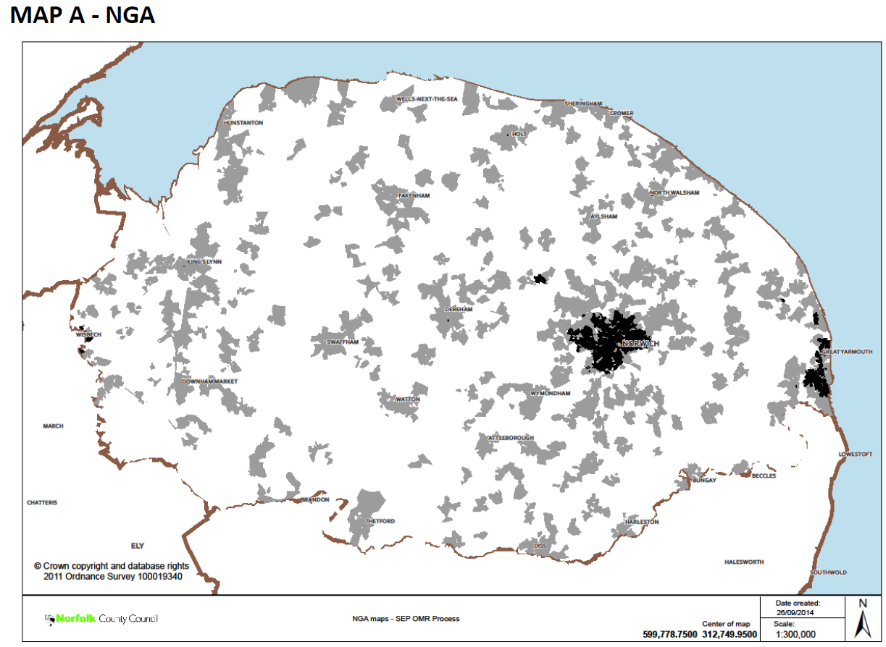
Figure 1: Map showing Next Generation Access (NGA). Area mapped in white don’t have NGS broadband services at affordable prices and therefore subject to additional funding and targeted investment. Grey areas have one affordable NGA broadband network with speeds of at least 15Mbps. Black areas provide two or more NGS networks with speeds of at least 15Mbps. Source: Better Broadband Norfolk, 2014
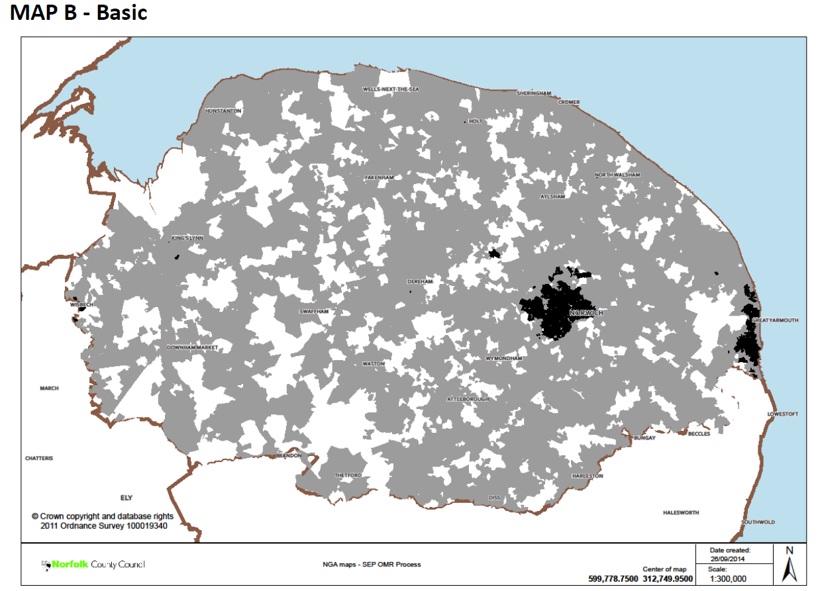
Figure 2: Basic Broadband Map where delivers download speeds of at least 2Mbps delivered. White - minimum download speed of 2Mbps not available at affordable prices. Grey - mimimum download speed of 2Mbps available, but no future plans for private sector infrastructure. Black - minimum download speed of 2Mbps and 2 or more basic broadband networks exist. Source: Better Broadband Norfolk, 2014

In order to extend the provision of superfast broadband further, additional money would be necessary to extend fibre connections and upgrade Cabinets. Where this is not possible or feasible, wireless (WiFi) solutions can be investigated as well as (or instead of) satellite broadband. Wireless broadband uses transmitted masts to deliver point-to-point broadband to homes and businesses (although it requires direct line of sight) and public WiFi hotspots can also be used where they exist (or can be set up).

Summary

The further rollout of broadband is probably less a strategic planning/Duty to Co-operate issue than a development management policy issue. Some coherence across Norfolk as to how the delivery of broadband infrastructure to buildings could be best delivered/required (alongside the Building Regulations requirements for ducting inside buildings) would be useful to explore through Development Management Policies in Local Plans.

It is difficult to envisage broadband infrastructure being required by condition or as part of a S106 agreement or Regulation 123 list (in CIL authorities), as it may be difficult to legally require this (in addition to implications for overall viability).

Mobile telephony

Mobile telephone connectivity has, like broadband, become increasingly important over the last decade or so, to the point where it too is regarded as an essential service. In 2015, 93% of the UK population owned/used a mobile phone, with two-thirds of the population having a smartphone.

The most significant change in recent years has been the rollout of 4G services. The use of smartphones to access the internet has increased hugely; in 2015, smartphones overtook the use of laptops as the number one device to access the internet in the UK.

It therefore seems clear that the trend amongst smartphone users is away from text messages and voice conversations and more towards online uses such as shopping, emailing, banking and social media use etc). Therefore, demands for better connectivity from network providers to deliver these services are inevitable.

Coverage in Norfolk
Interactive mapping (available at http://maps.ofcom.org.uk/check-coverage) shows the general coverage for voice calls, 3G data and 4G data across Norfolk (which must be treated with a degree of caution as the results are high-level). The Three network appears to have the poorest coverage of the county, particularly for 4G data, where most of the county away from Norwich, Gt Yarmouth and King’s Lynn are not able to receive reliable 4G data services. EE coverage is considerably better, but significant gaps remain, particularly in the west of Breckland district and in some parts of North Norfolk and the north-west Norfolk coastal area. O₂ voice calls coverage is generally very good, with just a few small areas of poor reception; 3G coverage is better than EE, but 4G much the same, with patchy coverage across much of northern Norfolk. Vodafone voice calls coverage is generally excellent and 3G generally very good, although 4G coverage is poor in parts of south and south-west Norfolk and in the Holt-Cromer-Aylsham “triangle” in the north of the county.

Therefore many mobile “not-spots” remain in Norfolk (some rural areas and parts of the coast in particular), particularly for 4G data coverage, although there are plans to improve this: for example, EE announced in 2016 that it intends to achieve 92% UK geographical coverage by 2017 and 95% by 2020.

5G
The next generation of mobile networks will be 5G (https://5g.co.uk/). Whilst there is no agreement as to the precise standards of 5G, they will probably encompass the following:

- Be much faster than 4G, perhaps 60-100 times, to enable download of a HD film in under 10 seconds
- Latency (speed to playback when downloading) will be about 1 millisecond – so, in effect, instantaneous
- 5G will provide sufficient bandwidth to enable the multitude of internet-connected devices to communicate effectively
- Near-enough perception of 100% coverage and availability
- The user experience will therefore be that of limitless bandwidth and continuous availability

5G will need to use higher frequency radio bands, however higher frequency signals travel less well than 4G, and can be disturbed by buildings, trees, weather etc. More base stations, booster stations and new antennae technologies will all be required, with some industry sources suggesting that thousands of sites will be needed to ensure sufficient coverage.

EE is beginning 5G trials in the UK in 2016, with the first pilot networks in the world expected in 2018. The rollout of 5G commercially in the UK is expected to commence in 2020, and take several years.

In the Chancellor’s Autumn Statement in November 2016, £740m funding was announced to develop 5G mobile networks (with Local Authorities likely to be able to bid for a share of this money). It was also announced in November that Bournemouth has been chosen as a test location for Ordnance Survey and other partners to develop a planning and mapping tool necessary to enable a 5G network to be developed and established.

Summary
By the time most of the next round of Local Plans have been adopted (2020), 5G will be a reality in the UK (albeit in its infancy), so planning for it needs to start happening now.

The main benefit of 5G is that it could, in theory, provide ultra-high speed broadband access to all, without the bandwidth capacity challenges of 4G. This should enable location to be much less of a barrier to receiving broadband than previously, with benefits for homeowners and businesses, increasing employment opportunities, particularly to home-based and rural-based businesses.

The main disadvantages are the significant number of further base and booster stations required to ensure adequate coverage. As with 4G, it is likely that commercial considerations will play a role in coverage (particularly in the early days of 5G), with more rural areas likely to be last to benefit. Whether there will be objections to a new generation of base stations and transmitters remains to be seen, but it is a possibility.

Conclusions

Helping to achieve greater broadband accessibility is clearly important for economic growth and as such is an issue of strategic planning importance. However, achieving more cabled broadband through strategic planning policies across Norfolk is difficult to envisage, and so it is concluded that little more needs to be done for now on this as part of the NSF.

5G would appear to offer the opportunity to reduce the reliance on fibre (cabled) broadband connections, particularly in more rural areas, and it is quite conceivable that 5G accessed through mobile or Wifi devices could make access to cabled broadband (at least for domestic properties) less necessary in the future. The adequacy and timeliness of 5G broadband connections will clearly be critical for Norfolk’s future attractiveness to businesses and developers, therefore further thought should be given as to whether the rollout of 5G in Norfolk should begin by concentrating on strategic employment sites. However, as stated above, the benefits of 5G should ensure that accessibility to strategic employment sites is likely to become a less significant factor in determining the locations of future housing and employment locations in the next round of Local Plans.

Consistency of approach from all Norfolk authorities is clearly important for 5G if the very high degree of nationwide coverage required for 5G to be effective is to be secured. Whilst it may be that much of the infrastructure could be developed under permitted development rights, broadly, it will need to be made as straightforward as possible for 5G base stations and transmitters to be constructed, and common development management policy text to facilitate this will need to be explored (by Policy and DM officers working together).

