Equality impact assessment

Budget proposals 2014-17

High level assessment

Summary

The Government grants that make up most of Norfolk County Council’s income have been reducing steadily since 2011 and will continue to do so. In addition, demand for services, particularly from vulnerable residents, continues to grow, and like everyone else, we face year on year rises in some unavoidable costs. Taking these into account, we face a three year funding gap for 2014/15 – 2016/17; currently estimated to be in the region of £189million.

We are considering a range of proposals to enable it to bridge the £189m funding gap and balance the budget for the next three years. From 19 September until 12 December 2013 a consultation with residents and stakeholders will take place to look at the implications of these proposals.

The purpose of this high level assessment is to highlight which protected groups are affected by the proposals, identify any emerging themes and set the context for further evidence gathering and consultation. This evidence will be used to compile a detailed equality impact assessment report which will be submitted to Cabinet on 27 January 2014 alongside the budget report, setting out the full impact of the proposals on protected groups and all associated equality issues.

At this stage in the process, the budget proposals, if implemented in their current form, would have greatest impact on disabled and older people. As the fifth largest shire county in England, with around 53% of the county classed as rural, the proposals will also impact upon rural communities.

Where an equality impact assessment reveals a risk of adverse impact on protected groups, a clear understanding of what that impact is must be provided so that any decisions made are informed, and where appropriate, action must be taken to address those risks. This summary recommends that in addition to carrying out further evidence gathering and consultation with protected groups on the proposals, consideration also be given to developing options to reduce or mitigate their impact on people with protected characteristics, in particular, disabled and older people, and rural communities, as these groups are most likely to be impacted overall.

1. Overview of the equality impact assessment process

The Council’s budget proposals for 2014-17 have implications for the future delivery of services. To ensure that all potential equality issues are identified and inform decision-making, a comprehensive equality impact assessment process has been put in place. This includes:

- A high level assessment of proposals, to identify which protected groups and communities they will affect, and their overall impact, to enable consultation and evidence gathering with these groups to take place. To be published alongside consultation materials in September.

- An individual assessment of proposals, which is evidence based and takes into account the views of residents from relevant groups, as well as community, voluntary organisations and stakeholders.

- Production of a final Equality Impact Assessment report, summarising the findings of consultation, setting out any potential equality issues for each proposal and mitigating actions, for consideration by Cabinet 27 January 2014.

- Finalised Equality Impact Assessments will sit behind each of the proposals in the January Cabinet report – this ensures that Members have had sight of all the impacts through the decision making process.

- A separate overarching Equality Impact Assessment on the workforce implications of budget proposals that will be used when consulting with the unions.

There is a clear legal framework setting out public authorities’ responsibilities for undertaking equality impact assessments on proposals. This is summarised in Appendix A.

2. Overview of the proposals

Over the three year period from 2014/15 Norfolk County Council faces a shortfall in funding of around £189m. Proposals have been developed that will fully bridge the gap of £66m in the first year, and go part way towards bridging the gap in years two and three.

The financial approach we are taking is based on four elements:
- Sound sustainable funding
- Tight financial monitoring and management
- Prudent and targeted use of reserves where it is clear that this has long term benefits
- A continued drive to hold down any additional borrowing

Based on these elements we propose to
- Deliver savings by faster redesign of our services - releasing more efficiencies
- Continue to reduce the costs of what we do and what we buy
- Rationalise property and other assets we own or rent by sharing with others
- Use or release land where we can to build new homes (Subject to sound business cases)
- Invest in the economy –building skills and creating real, sustainable jobs.
- Use new technology to help improve services and release savings
- Collaborate with others, especially colleagues in the NHS, to use public money which comes into Norfolk in the most effective way.

The proposals we are currently consulting on include both things that will improve the efficiency of the council, relating to how we organise our staff and resources, how we work with others and how we generate income, as well as proposals that will bring about service changes and reductions.

The proposals affect all departments across Norfolk County Council - Children’s Services, Community Services, Environment Transport and Development, and Resources.

3. Who is affected?

All residents of Norfolk, whether they live in a rural or urban area, could be affected by the proposals. This includes residents with the following protected characteristics:

Age (people of different age groups; older and younger etc) | YES
Disability (people who are wheelchair or cane users; blind, deaf, visually or hearing impaired; can’t stand for a long time; have a long-term illness such as HIV or a neurological condition such as dyslexia) | YES
Gender reassignment (people who identify as transgender) | YES
Marriage/civil partnerships | YES
Pregnancy & Maternity | YES
Race (different ethnic groups, including Gypsies and Travellers) | YES
Religion/belief (different faiths, including people with no religion or belief) | YES
Sex (men/women) | YES
Sexual orientation (lesbian, gay and bisexual people) | YES

4. Early implications and recommendations

It is important to note that the purpose of this overarching assessment is to highlight which protected groups and communities are disproportionately affected by initial proposals, to identify any emerging themes, and set the context for further evidence gathering and consultation. This evidence will be used to compile a detailed equality impact assessment report which will be submitted to Cabinet on 27 January 2014 alongside the budget report, setting out the full impact of the proposals on protected groups, and all associated equality issues.

Although the focus is on meeting the budget gap, not all of the proposals will have a negative impact. There are some that will enhance services, make them simpler to access, or provide residents with more information about the choices they have. Some proposals also respond to the feedback we have received from service users in the past. For example, there are proposals that look to further integrate health and social care services so that people receive seamless support.

At this early stage in the process, it is clear that the budget proposals, if implemented in their current form, would disproportionately impact on disabled residents of Norfolk, their carers and families. Because of the association between disability and the increased chance of developing medical conditions and frailty as people age, older people will also be disproportionately affected. This impact is likely to be felt in several ways. It may limit disabled and older people’s independence and resources, and affect their quality of life and mobility across the county. It may restrict their access to the built environment, public transport and leisure activities. It may increase their vulnerability to loneliness and social isolation, and place greater responsibilities of care on their families, friends and colleagues.

Just over a tenth of people in Norfolk provide unpaid care of between one and 50+ hours a week. Although this figure includes care for non-disabled relatives, people’s care needs increase with age and people are increasingly likely to experience disability as they get older: Half of all those people aged 65+ and two-thirds of people over 85 are disabled.

Of all nine protected groups, disabled people are some of the most marginalised in society, facing persistent inequalities in education, employment, access to services and social mobility. They are twice as likely as non-disabled people to live in low-income households, and 30 per cent more likely to be out of work than non-disabled people who share the same qualifications and social characteristics.

Disabled and older people make up a substantial part of the Norfolk population. According to the 2011 Census, around a fifth of the population in Norfolk consider themselves to have a long-term health problem which limits their day to day activities. These impairments can be physical or learning disabilities, sensory impairments, mental health and HIV/AIDS, or in many cases a combination. Norfolk has an ageing population and by 2020 Norfolk will have a much older population profile than it has at present. Norfolk’s over-85 population is projected to grow significantly, this age group is the most likely to require social care, so an increase in the size of this group will have a high impact on the demand for social care services. The number of older people with dementia will also rise: in 2010 the figure was around 11,789 and this is predicted to rise to 15,590 by 2020.

We are currently consulting on 43 proposals covering a wide range of issues, and it is possible that other protected groups could also be disproportionately affected by individual proposals. Where this is the case a full equality impact assessment including engagement with these groups will be undertaken and used to inform decision making.

In addition, it is important that the rural dimension is considered. Norfolk is a large rural county, with around a third of people living in small and isolated communities. This poses certain challenges for the delivery of services, and means that delivery mechanisms may differ to those in urban areas e.g. mobile facilities or the sharing of office space between agencies. Those people living in rural communities will likely have access to fewer local services and have greater transport needs. Unlike pockets of deprivation in urban communities, which tend to be concentrated in certain neighbourhoods, rural deprivation can be scattered or hidden amongst areas of apparent affluence.

Where equality impact assessments of individual proposals reveal risk of adverse impacts on protected groups and communities, a clear understanding of what that impact is will be made available so that any decisions made are informed, and where appropriate action will be taken to address those risks.

5. Actions

Actions to be carried out to address the issues described above:

 | Action/s | Lead | Date
 | Consultation with the general public on budget proposals, including engagement with rural residents and stakeholders to understand the likely impact, develop the full equality impact assessment report, and identify potential mitigation actions where appropriate | Planning, Performance & Partnerships Service | From 19 Sept 2013
 | Targeted consultation with disabled residents and stakeholders on the budget proposals to take place, to fully investigate and understand the likely impact, develop the full equality impact assessment report, and identify potential mitigating actions where appropriate | Planning, Performance & Partnerships Service/Service leads from relevant directorates | From  19 Sept 2013
 | Targeted consultation with older residents and stakeholders on the budget proposals to take place, to fully investigate and understand the likely impact, develop the full equality impact assessment report, and identify potential mitigating actions where appropriate | Planning, Performance & Partnerships Service/Service leads from relevant directorates | From  19 Sept 2013
3 | Consultation with all other protected groups affected to take place, to fully investigate and understand the likely impact, develop the full equality impact assessment report, and identify potential mitigating actions where appropriate | Planning, Performance & Partnerships Service/Service leads from relevant directorates | From  19 Sept  2013
 | Following completion of evidence-gathering and consultation, the final equality impact assessment report to be prepared on the findings, impact and potential mitigating actions, to be submitted to Cabinet on 27 January 2014, alongside the budget papers. | Planning, Performance & Partnerships Service/Service leads from relevant directorates | 27 Jan 2014
 | Full Council debate supported by the full equality impact assessment on proposals. | Planning, Performance & Partnerships Service/Service leads from relevant directorates | 17 Feb 2014
APPENDIX A: The Legal Framework

This appendix summarises the law and equality impact assessments regarding public authority decision making.

Under the Equality Act 2010, public bodies must in the exercise of their public functions have due regard to:

- Eliminating unlawful discrimination, harassment and victimisation and other conduct prohibited by the Equality Act 2010;
- Advancing equality of opportunity between people from different groups; and
- Fostering good relations between people from different groups.

Protected characteristics are disability, gender reassignment, pregnancy and maternity, race, religion or belief, sex and sexual orientation. ,

This is called the public sector equality duty. It is up to public bodies how they go about implementing the duty. However, they must be able to provide evidence upon request that due regard has genuinely been paid to the duty when planning, changing or commissioning services, prior to a decision being made or implemented.

The assessment must be a transparent form of analysis that systematically considers any adverse impact of the proposal on people with protected characteristics, and opportunities for actively promoting equality. It must be evidence based and contain sufficient information to demonstrate that due regard has been paid.

There is an explicit requirement to consult different ethnic groups under race relations law. The involvement of disabled people and men and women is strongly recommended in the statutory codes of practice.

Where decisions are found to have an adverse or disproportionate impact on people with one or more protected characteristics, authorities must consider what actions can be taken to avoid or mitigate this, and again, have due regard to promoting equality for the groups affected.

Individual assessments should be informed by any wider context of decisions, so that the cumulative effects of different decisions are taken into account.

The assessment must be carried out at a formative stage of the process, so that it is an integral part of development of the proposal, not a later justification of a decision that has already been made.

The findings of the assessment must be made publicly available.

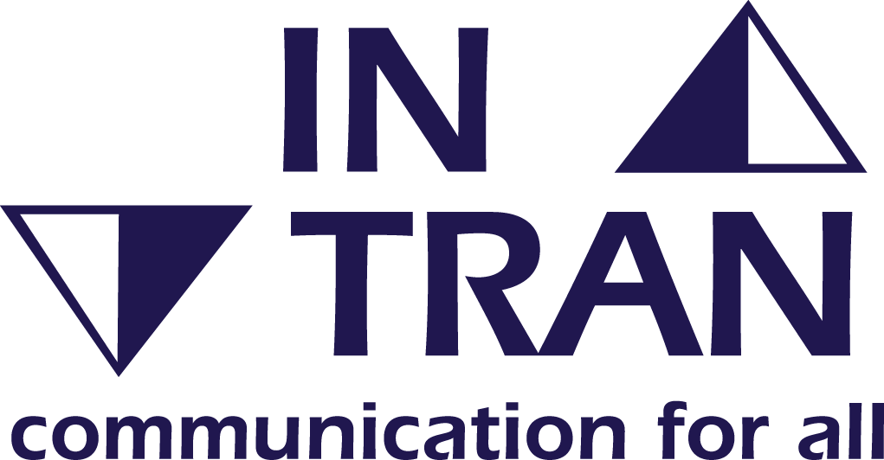 | If you need this document in large print, audio, Braille, alternative format or in a different language please contact Customer Services on 0344 800 8020 or 0344 800 8011 (Textphone).

The Norfolk Story July 2013, Norfolk Insight
http://www.norfolkinsight.org.uk/dataviews/tabular?viewId=177&geoId=15&subsetId= DWP (2012) Fulfilling Potential: Building a deeper understanding of disability in the UK Summary http://odi.dwp.gov.uk/dogs/fulfilling-potential/building-understanding-summary-slide-deck.pdf
Cabinet Office (2007) Fairness and Freedom: the Final Report of the Equalities Review http://webarchive.nationalarchives.gov.uk/20100807034701/http:/archive.cabinetoffice.gov.uk/equalitiesreview/upload/assets/www.theequalitiesreview.org.uk/equality_review.pdf
Leonard Cheshire Disability (2008) Disability Poverty in the UK http://www.lcdisability.org/?lid=6386
Fairness and Freedom (see endnote 2 for reference)
http://www.norfolkinsight.org.uk/dataviews/tabular?viewId=177&geoId=15&subsetId=
http://www.norfolkinsight.org.uk/jsna/groupsatrisk
Office of National Statistics, http://www.ons.gov.uk/ons/guide-method/geography/news/bulletin-2013-10--rural-urban-classification--august-2013/index.html which shows that 32% of Norfolk’s residents live in communities with fewer than 2,500 people.

