Norfolk - Putting People First

Working together to bridge a £189m funding shortfall – Norfolk County Council’s consultation

Introduction

By County Councillor George Nobbs, Leader of Norfolk County Council
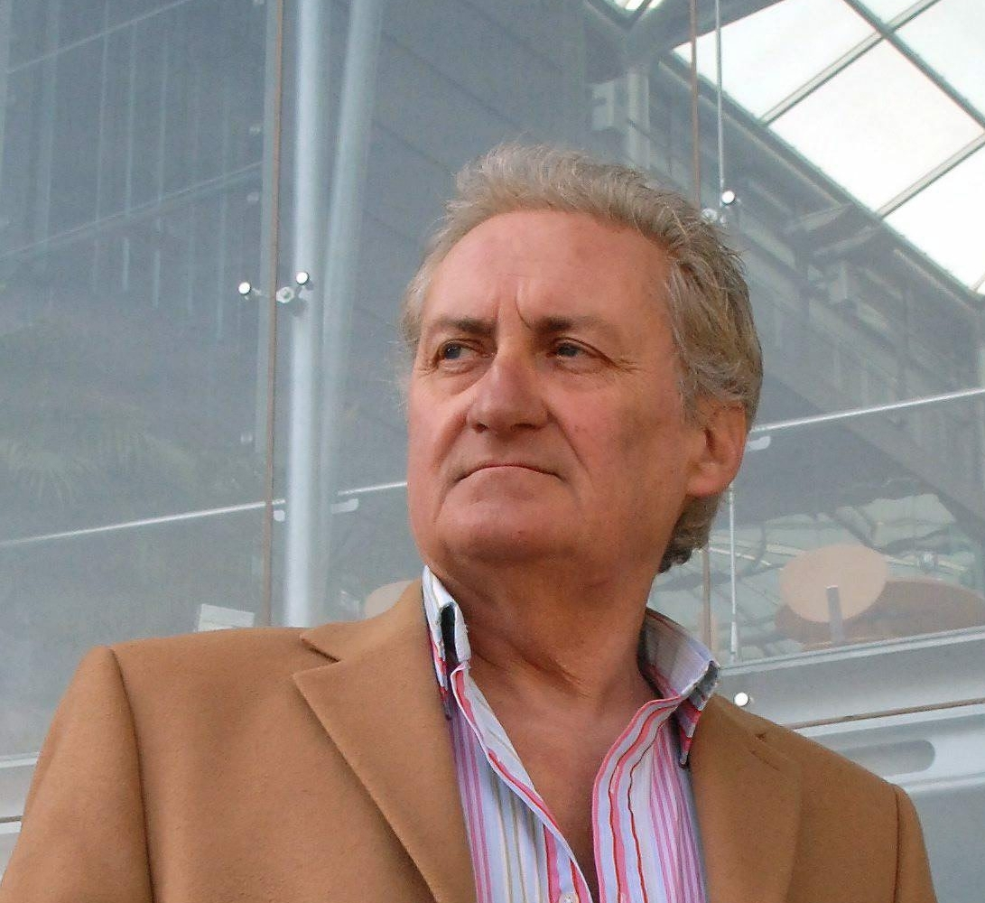
The money that Norfolk County Council receives from the Government in order to provide all the services that you, the people of Norfolk, need and use has been drastically reduced over the last three years. We, as your Council, have already made cuts of £140m and that hasn’t been done without a lot of pain and sacrifice.

Now, however, the Government is reducing its financial support even further over the next three years - even though demand for many of the services we have to provide, such as care and support for vulnerable older people and children and young people, is increasing.

The Government funding reduction and the increase in demand for our services, combined with rises in some unavoidable costs like fuel, means that from the latest financial information available, we have to plan to meet a shortfall of £189m and cut this from our spending. This will mean making even tougher decisions than before. We have made our own proposals for dealing with that shortfall. Every council in Britain is in the same position. We must work within the budget provided – however difficult that will be.

We have started by setting our own house in order but that can only do so much. Let there be no doubt there will be serious reductions in services and we will be honest about it. When we propose cuts we will say so and not try to disguise the fact. Cuts will be called ‘cuts’!

We frankly can’t do this without your help. That’s why we’ve set up the biggest listening exercise that has ever taken place in Norfolk. We need to listen to your views and find out what you think we should spend our limited income on. After all, it’s largely your money and your services.

We have been very clear about our ambition for Norfolk and our priorities for Norfolk people at this very tough time.

Our ambition for Norfolk is for everyone in Norfolk to succeed and fulfil their potential. By putting people first we can achieve a better, safer future, based on education, economic success and listening to local communities.

Our priorities are:

Excellence in education – We will champion our children and young people’s right to an excellent education, training and preparation for employment because we believe they have the talent and ability to compete with the best. We firmly believe that every single child matters.

Real jobs – We will promote employment that offers security, opportunities and a good level of pay. We want real, sustainable jobs available throughout Norfolk.

Good infrastructure – We will make Norfolk a place where businesses can succeed and grow. We will promote improvements to our transport and technology infrastructure to make Norfolk a great place to do business.

We will fulfil these priorities by:

- Standing up for the interests of people in Norfolk - arguing for resources and investment
- Promoting prosperity by championing homes, jobs and local economic success
- Working to increase opportunities so that everyone can fulfil their potential
- Listening to, learning from and working with our communities so local solutions can improve the quality of life
- Ensuring people get as high quality services as we can afford and clear information about how to access them
- Stepping up our efforts to be as efficient as possible, being open to the views of local people and helping your elected representatives influence decisions that affect you.

We understand there are many other calls on the Council’s resources and activities which we will continue to do our best to meet.

However we firmly believe it is by giving specific priority to these three critically important areas - which we do not believe have received sufficient priority over past years – that we will achieve the best overall results for Norfolk people.

Our continuing commitment to providing caring services is reflected in our overall aim of putting people first and the lower percentage reductions in the budgets we are proposing for children's services and those for vulnerable adults.

Only by working together can we expect to close such a massive funding gap and realistically hope to keep the level of service cuts needed to the minimum possible, given such harsh circumstances.

So I very much hope you will take the time to read this consultation document, consider the proposals we have put forward and give us your views.

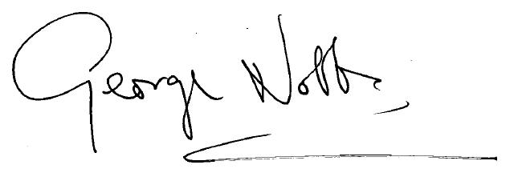
County Councillor George Nobbs
Leader of Norfolk County Council
The background – how can we cope with an estimated £189m budget shortfall for the years April 2014 - April 2017?

Like all other councils we are facing yet another big reduction in the funding we get from central Government, the effects of inflation and new legal requirements.

Over the next three years from April 2014, our Government grant is projected to go down by a massive £91m. That's not because of something you or the Council have done or decisions we can change.

At the same time, the demand for many of our services – especially those for vulnerable older people - continues to go up, as do many of the costs we can’t avoid, such as fuel and energy costs. Taken as a whole, this means that over the next three years from April 2014, we will have to cut an estimated £189m from our budget just to bridge the funding gap.

To give you some idea of what that means, we spend just over £30m a year on the Fire and Rescue service. So in the next three years, the amount we have to find is more than six times the cost of running the Fire and Rescue service for the whole of Norfolk for just one year.

We have never been required to find such a high level of savings before and a shortfall of this size means we are no longer able to avoid some tough and painful decisions. We have already cut our spending by £140m over the last three years. So having to save an even bigger sum over the next three years is an enormous and very difficult challenge.

The £189m figure may change. We can’t yet be absolutely certain of the exact savings needed, because some things are still unknown. For example:

- We will only know our precise grant settlement from the Government later this year. However we consider it extremely unlikely that this will reduce the size of the problem so we have to assume the worst.

- Government announcements mean we could potentially receive a large sum of money from the NHS in 2015/16 to help integrate health and social care services and keep people independent for longer. Because we do not yet know the amount or the terms for any such funding transfer, we can't say what difference it will make.

Because of these uncertainties and because the country’s economic climate is still volatile, we are planning prudently to prepare the Council for the need to cover the whole of the forecast shortfall of £189m.

Our proposals would balance the budget in the first of the three years and set us on course to achieve the savings needed in the second and third years. However, as the uncertainties for 2015/6 and 2016/7 are greater, there are still gaps to fill in order to reach the £189m savings target.

Our approach to financial planning

We are taking a strategic approach to our financial management based on:

- Ensuring that our finances and funding are sustainable. That means we do not commit to doing anything we are not sure we can pay for on a long-term basis. In summary, as we have to make ongoing savings we must ensure that our costs reduce to match our income.

- Very tight financial monitoring and management to keep all spending plans on track. We are committed to being as efficient and cost effective as possible and even when the budget is agreed we will continue to find better ways of managing our spending for the benefit of Norfolk.

- Using Council reserves prudently, in a targeted way, and only where it is clear that we will reap demonstrable, long-term benefits by doing so. We will not use short-term funding to put off hard decisions but we will invest to save and use reserves to help smooth difficult changes where we can.

- Holding down any additional borrowing and thereby avoiding adding extra debt repayment costs. We will invest in projects that support our priorities and return a benefit for the county or a return that helps fund other activity.

- Increasing income where we can, for example by selling expert or professional services to others where practical and sustainable, increasing Norfolk’s share of EU grant aid and selling assets that are no longer needed and for which we cannot find a sustainable and affordable use.

So we propose to keep our own house in order by:

- Streamlining processes and cutting out those that add cost, but no value. This will also lead to better results for people using our services. By redesigning our services in this way we will get ever more efficient, building a strong culture where the Council continually strives to improve.

- Investing where necessary to save more - we will invest where sensible when it is clear the Council will get long-term savings faster.

- Continuing to reduce our own running costs - for example reducing power and utility costs, travel costs and buying essential supplies as cost effectively as we can.

- Rationalising and reducing our property holdings and other assets we own or rent. We will also look to share more accommodation with others both to save money and wherever sustainable, to benefit the community.

- Using or selling land where we can to build new homes, either to generate an income or to support our jobs and infrastructure priorities.

- Investing in the economy – building skills and creating real, sustainable jobs and prosperity.

- Using new technology to support our priorities, improve services and release savings.

- Collaborating more widely with others, especially other public bodies who provide services by sharing services and making sure that money coming into Norfolk is used in the most effective way.

Further freezes on council tax

If we wanted to cover the £189m shortfall by raising council tax, we would have to put up our share of the council tax you pay by 63% over the three years (or over 20% a year). This is not acceptable.

So as we have no plans or proposals to increase our share of the council tax the proposals in this consultation do not assume any increase for next year or for 2015/16 and 2016/17.

Currently, by keeping council tax at its present level for next year, we can expect a one-off grant from the Government worth an extra £3m. However as it is 'one-off' money it does not go into the Council’s base budget and so it will not be available to spend in future years.

A 1% increase in council tax would mean an increase of £11.45 a year on a Band D council tax bill and would raise £3m that the Council could rely on receiving each year in future.

Any proposal to increase council tax above 2% in any year would trigger an expensive referendum.

Our savings proposals

At present, we have identified savings proposals that add up to £140m.

If they are accepted, then, combined with the use of the £3m Council Tax Freeze Grant, we will be on course to set a balanced budget for 2014/15 as we have to. That is not to say we are happy with the proposals as we know some will mean difficulty and hardship, something we would much prefer to avoid.

We will still need to find some £19m of extra savings in 2015/16 and another £27m in 2016/17 just to get to a balanced budget for those years.

Over the summer we have talked with many organisations we work with to share the scale of this financial challenge and discuss how, by working more closely together and joining up more, we may be able to find new ways of closing the gap, protecting Norfolk’s public services and still making progress on the issues that are so important to Norfolk people – such as education, jobs, skills and the economy.

We have already integrated a number of adult social care services with the NHS and agreed a number of joint service arrangements – for example ICT services with Great Yarmouth and Breckland councils. The impact of the proposals is such that these discussions with partners take on a new urgency and significance. We must look for changes, sometimes radical changes, if we are to maintain services to people and mitigate the consequences of budget cuts.

Not all services have been asked to cut their budgets by the same percentage

This diagram shows where the money is spent currently:

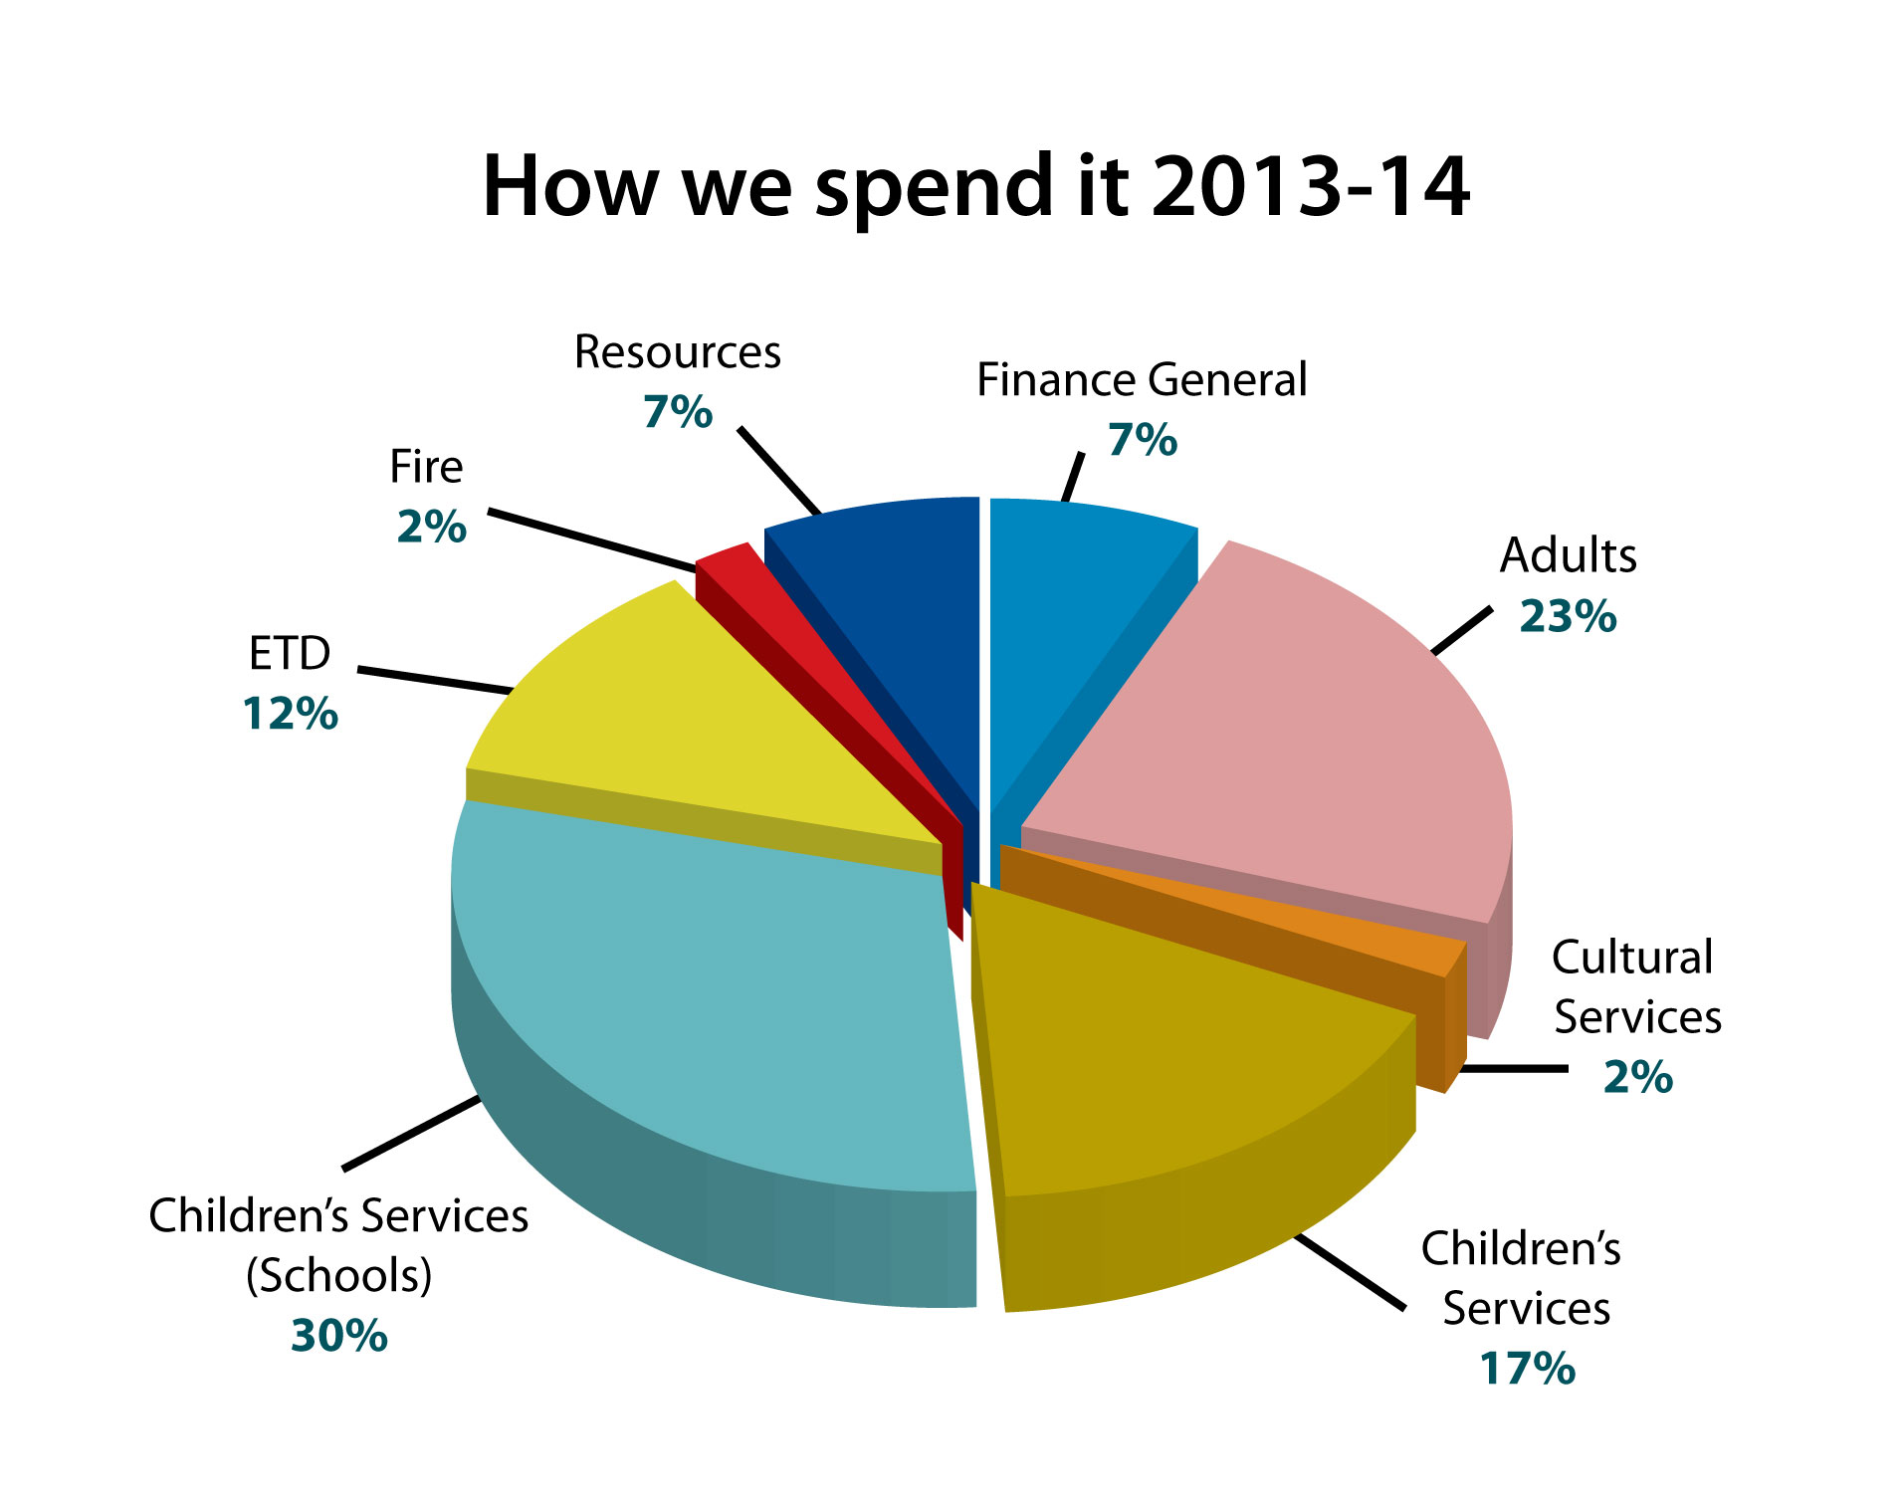
Some of the figures in this pie chart were updated on 9 October in line with our most accurate information on spend - This information supersedes that published in printed editions carrying the pie chart including hard copies of the consultation document and Your Norfolk magazine

- Children’s Services includes our funding to support education and keeping children and young people safe.
- Adult Social Care includes funding for helping older people remain
independent.
- Environment, Transport and Development includes funding for our roads and transport network, waste management and recycling, supporting businesses and Trading Standards.
- Cultural Services includes funding for libraries, museums, archives and arts.
- Finance General includes funding for making debt repayments and statutory accounting adjustments.
- Resources includes ICT, customer services, financial management, HR, performance management, democratic services and public health.

We are committed to putting people first. So we have not proposed the same percentage savings target for all our services. We propose that the ‘people’ services – principally those for children and vulnerable adults – should have a smaller percentage budget reduction than others.

This bar chart shows the percentage budget reduction we are proposing for each department from April 2014 – April 2017.
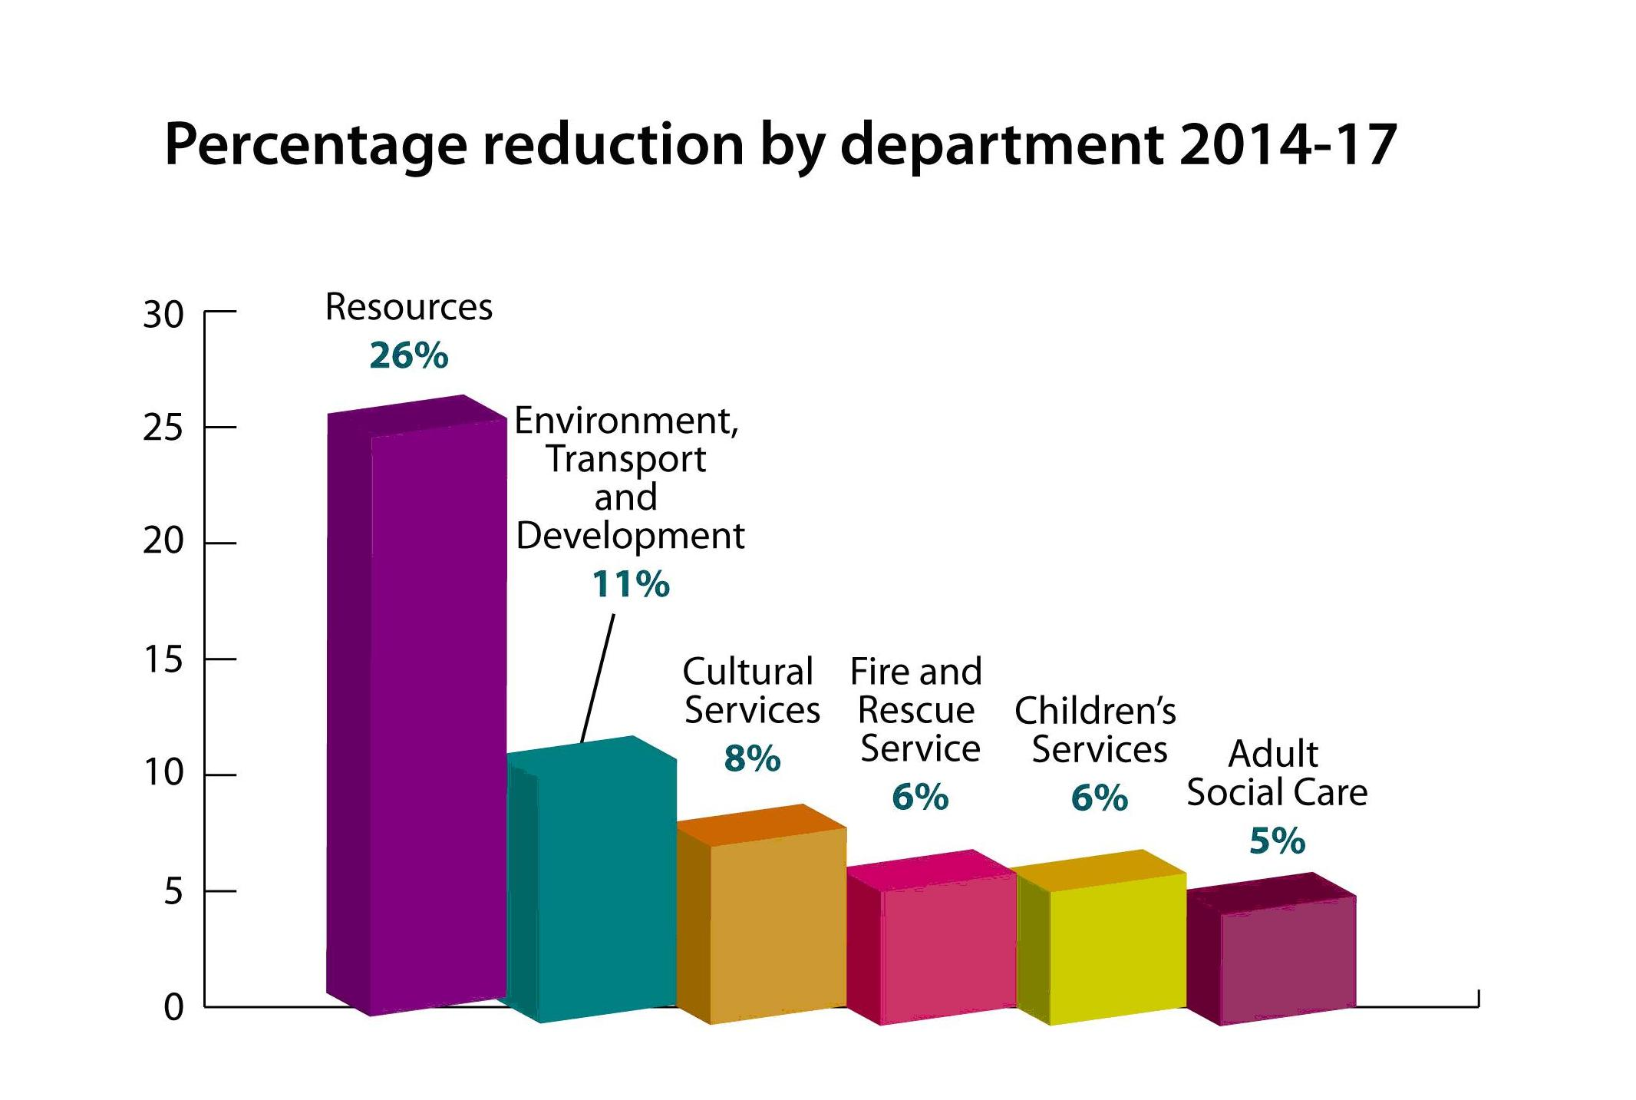

However, because the ‘people’ services have by far the biggest budgets and spend the most, though their proposals represent a smaller percentage reduction than others, the total savings needed from each still adds up to a very large sum of money over the three years. A full list of these proposals appears at the end of this document.

We have grouped our savings proposals into two separate categories:

1. Cutting our own costs. The savings proposed in this category will save some £74.7m over the next three years. This is more than half of the savings we have identified so far.

These proposals focus on cutting our own costs and getting ever more efficient – delivering a much leaner Council with fewer managers and more streamlined business processes. This category of savings also sees us cut or reduce budgets in areas such as training, travel, events and communications. It includes savings from greater efficiencies in the way we organise and manage our enabling services and business functions, enabling and encouraging the delivery of more services online and considering whether we can raise more income from the sale of specialist goods and services. A significant part of the total savings in this category will be delivered as a result of much greater and more efficient use of modern technology and better procurement (the way we buy goods and services).

This category of proposals is mainly about our internal processes - so we are getting on with them already. However the proposals will still be very tough to deliver and mean some difficult and painful decisions about jobs and valued internal services that support what we do. The past three years have already seen a lot of changes and while there is always more that can be done, the amount of money that we can save by cutting our own costs will reduce over time.

This is not a one-off process. Once we have achieved a more efficient system we will go back and keep looking for better ways of working so that we can get the best standards of service for the people that need them.

2. Unavoidable service changes, reductions or cuts. The savings proposed in this category will save some £59m over the next three years.

These are not easy proposals to make or deliver and if agreed, mean that many people will experience some change or cuts in service levels, or may be asked to pay for some services they currently get free of charge, or be asked to pay more. They are the proposals we have, in most cases, come to last of all, because we recognise they represent painful consequences for some. They are those that cause us most concern. We have had no choice but to include them because the sheer enormity of the funding shortfall we face (£189m) means that even with all the other savings we have identified, we simply can’t avoid them, even though we would like to.

Some of the proposals, for example the proposal to change the level and nature of early support for looked after children, are aimed primarily at helping more of our children and young people avoid having to come into, or stay in, long-term care. This will be significantly better for them and will save money at the same time. We will not cut corners or increase risk just to save money, and we will be honest where we know difficulties may be created.

If the opportunity arises, even after we have finished the consultation and are implementing proposals that are agreed, we will roll back from service cuts. They are there because we see no alternative at present, not because we want to make them.

Proposals in this category include:

- Asking some people who currently get free travel to day services to pay in future
- Cutting the budget we have to arrange packages of social care for vulnerable adults
- Limiting the use of personal budgets
- Reducing the frequency of some mobile library visits and reducing the amount of arts grants we give each year
- Charging for some services people currently receive free
- Reducing the amount of transport subsidy we currently give to students aged 16 -19.

In the full list of proposals at the end of this document we have also listed a number of savings that contribute to the total we have to find, and which have already been consulted upon.

We want your views

We are consulting openly and transparently about the issues we face and potential solutions. There are more details about each of our proposals for unavoidable service changes, reductions or cuts and you can read more about these and have your say at:

https://www.citizenspace.com/norfolk/consultation/norfolk-putting-people-first/consultation

We also welcome alternative options and proposals that will save money and wherever possible, improve the quality of a service and the outcomes for people it affects. There are many proposals we would rather not carry through and we will be looking for alternatives.

It is not possible to cut £189m from our budget over three years through more efficient working alone, although we will continue working hard to keep our own house in order. However, at £189m, the forecast shortfall is simply too enormous, especially coming on top of the £140m we have already had to cut from our spending over the past three years.

That is why, over the coming years in particular, we will work even harder in partnership with the many organisations who have already offered their help, to see where and how, collectively we can achieve more, do things very differently, raise more money and protect the services we all value. We welcome all constructive ideas and new thinking received as part of this consultation.

This consultation sees proposals that will have a direct, negative impact on some of the services many Norfolk people rely on, even though we have looked at these areas as the very last option.

We would choose not to have to put many of these forward if we had workable, sustainable alternatives. This consultation is to ask you to help us find alternatives if we can, and where we can't, to help us decide on behalf of the people of Norfolk where the priorities for spending should be.

Here is a brief summary of what we are consulting on and what we would like your views on:

We welcome views in general on:

- Our priorities for Norfolk people and their impact

- Our financial approach and strategy

- Other things you would like to be considered before County Councillors set the budget on 17 February 2014, for example ideas and solutions for different ways of supporting or delivering change to save money and help us achieve our priorities for less

- Our package of proposals taken as a whole, for example, have we prioritised the services that matter most to you?

- Our individual savings proposals

- The Council’s proposal to freeze its share of the Council Tax you pay next year and for 2015/16 and 2016/17.

Who we are consulting

We are consulting local residents, community groups, public sector organisations, town and parish councils, voluntary and community organisations, local businesses and anyone else in Norfolk, or elsewhere, who is affected by our proposals and wishes to have their say. Your view is as important as everybody else’s.

How we are consulting

This is our written consultation document that we are sending to our stakeholders to ask for their views and on which your views are invited.

We are also holding some face-to-face meetings with different groups to get their views. These include meetings with voluntary and community organisations and town and parish councils.

To make sure that our consultation is representative of our community we are taking extra steps to engage with underrepresented groups, such as older people, disabled people, people with learning difficulties, carers, people from Black, Asian and minority ethnic backgrounds, young people and the LGBT community.

Our proposals will be on our Council website at: http://www.norfolk.gov.uk/puttingpeoplefirst and you will be able to comment on our budget proposals online.

There will be the opportunity for residents to feed back their views through Your Norfolk magazine, which will go to households in Norfolk week beginning 28 October.

Your County Councillor is also there to represent your views and help you understand how the Council works. If you are not sure who it is please check on www.norfolk.gov.uk or ask at your local library or Council office.

When we are consulting

Our consultation starts on Thursday 19 September 2013.

Norfolk County Council would like your views on the proposals set out in this document.
We need your views by Thursday 12 December 2013.

That closing date will ensure your views are taken into account in formulating the budget proposals that Councillors will consider. However, we are always pleased to hear your ideas and receive comments.

Our approach to Equality Impact Assessments

Equality Impact Assessments is the term used for the process we use to work out how the proposals will affect people in practice.

Our budget proposals for 2014-17 will have implications for how we deliver services in the future. To ensure we have identified which groups of people will be affected and inform decision making, we have put in place a comprehensive equality impact assessment process. This includes:

- A high-level assessment of all the proposals, to identity whether they will particularly impact any group of residents, and if so, what the implications are.

- An individual assessment of each proposal, which is evidence-based and takes into account the views of residents from relevant groups, as well as community, voluntary organisations and stakeholders representing diverse communities.

- The production of a final equality impact assessment report, summarising the findings of the consultation, setting out any potential equality issues that need to be considered for each proposal along with any mitigating measures, to be considered by Cabinet on the 27 January 2014 alongside the budget report.

Our initial, high-level equality impact assessment is available on our website at: www.norfolk.gov.uk/puttingpeoplefirst

In addition, we will also work closely with others to assess the rural impact of our proposals.

How you can respond to the consultation

Norfolk County Council would like your views on the proposals set out in this document.

We need your views by Thursday 12 December 2013.

When responding, please state whether you are responding as an individual or representing the views of an organisation.

If you are responding on behalf of a group please give a summary of the people and organisations you represent and, where relevant, who else you have consulted in reaching your conclusions.

If you are responding about a specific savings proposal, please help us by making it clear which proposal your comments are about by including the reference number and/or name of the proposal.

- You can respond online at: www.norfolk.gov.uk/puttingpeoplefirst

- You can email your response to: haveyoursay@norfolk.gov.uk

- Or you can respond in writing to:

Freepost Plus RTCL-XSTT-JZSK, Norfolk County Council, County Hall, Martineau Lane, NORWICH, NR1 2DH (You do not need to use a stamp)

- However, if you want to help the Council save money please use a stamp and send to this address:

Norfolk Putting People First, Norfolk County Council , Room 501, County Hall, Martineau Lane, NR1 2DH

How we will make our decision and report back to you

Norfolk County Councillors will be considering these proposals along with the responses we receive at a series of Overview and Scrutiny Panels in November and again in January. We will feed back the views expressed through this consultation to Councillors so they can take them fully into account.

Members of the County Council’s Cabinet will consider the views from these Panel meetings at their meeting on 27 January 2014. At this meeting, Cabinet may agree the proposals, amend them or make new ones in the light of what they have heard and then recommend a Budget to Full Council.

We will also report back your views to our Cabinet elected members at their 27 January 2014 meeting so they can take them into account when agreeing the Budget recommendations that they will make to Full Council. You will be able to read these in the minutes from the meeting. We will also place them on the Council website and encourage media coverage.

All members of the County Council will debate, decide and agree the final Budget at their Council meeting of 17 February 2014. We will publish that on our website at: www.norfolk.gov.uk

The factors Councillors will take into account before coming to a decision

In making their decision about a proposal Councillors will take into account:

- The impact of any proposal on individuals, groups or communities and in particular on people identified as having 'protected characteristics' under the Equality Act 2010. The protected characteristics are: age; disability; gender reassignment; pregnancy and maternity; race; religion or belief; sex; and sexual orientation
- The views of people and stakeholders consulted
- The evidence of need and what is proven to work effectively and well
- The financial position and constraints at the time
- Any potential alternative models or ideas for making the savings.

Information about responding to this consultation

Personal information, confidentiality and data protection
Information you provide in response to this consultation, including personal information, may be published or disclosed in accordance with the access to information laws. This includes the Freedom of Information Act 2000 (FOIA), the Data Protection Act 1998 (DPA) and the Environmental Information Regulations 2004.
If you want the information that you provide to be treated as confidential, please be aware that, under the FOIA, there is a statutory Code of Practice that we have to comply with that deals with issues of confidentiality. Because of this it would be helpful if you could explain to us why you regard the information you have provided as confidential. If we receive a request for disclosure of the information we will take full account of your explanation but we cannot give an assurance that confidentiality can be maintained in all circumstances. An automatic confidentiality disclaimer generated by your IT system is not enough, in itself, to be regarded as binding.

We will process your personal data in accordance with the Data Protection Act, which means that we will not give your personal data to any third parties.

Receiving your comments

We are sorry but, given the scale of the responses anticipated and our timescale, we are unable to respond to individual questions or comments. However, we assure you that Cabinet members will consider all the consultation responses we receive very carefully before making their final recommendations.

Your opinions are valuable to us. Thank you for taking the time to read this document and respond.

Where can I go to for more information?

If you have any questions about this consultation document, please contact Norfolk County Council on:

Tel: 0344 800 8020
Email: haveyoursay@norfolk.gov.uk

If you need this document in large print, audio, Braille, alternative format or in a different language please contact us on Tel: 0344 800 8020.
Email: haveyoursay@norfolk.gov.uk and we
will do our best to help

Our budget proposals 2014/2017

Please find below a full list of savings proposals for the next three financial years.

Over that period we face a shortfall in funding of £189 million. We have put forward proposals to bridge the year one gap of £66 million but we have not fully closed the gap for years two and three.

We have grouped our savings proposals into two separate categories.

The first group focus on cutting our own costs and getting ever more efficient. They relate to our working practices, streamlining processes, using staff and resources efficiently and procuring (buying) effectively. Residents have told us in previous consultations that these are things that they expect us to be doing as a matter of course. We have included them here so that you can see the extent of savings we plan from these changes. We welcome feedback on them.

The second group are proposals that require public consultation. These are about unavoidable service changes, reductions or cuts. You can read more about these proposals and have your say on them at:
https://www.citizenspace.com/norfolk/consultation/norfolk-putting-people-first/consultation

We have also listed a number of savings that contribute to the total we have to find, and which have already been consulted upon.

Please note: This document shows the value of all savings proposals in £millions – so for example, £50,000 is shown as £0.050.

Each proposal has a title and a reference number. When feeding back your views on our proposals please mention the reference number so that we can match your comments with the specific proposal – thank you.

Group 1 – A focus on cutting our own costs and getting ever more efficient

How we buy things
Ref. | Title | Description | Total 14/15 (£million) | Total 15/16 (£million) | Total 16/17 (£million) | Total (£million)
1 | Changing the systems and arrangements we use for buying things | Some key changes to arrangements within our procurement service, including better use of e-tendering, automated document preparation and improved data management, and reductions in management and staff. | £0.066 | £0.050 | £0.133 | £0.249
2 | Make use of newer and cheaper ICT systems and practices | This includes implementing Digital Norfolk Ambition and the replacement and redesign of the Council’s overall ICT infrastructure. It includes the renegotiation of contracts for telephone use and internet, electrical testing and stationery. It also includes improvements to Children's Services' systems, the introduction of SMART ticketing in public transport, and using technology to improve transport monitoring. | £1.899 | £3.554 | £2.408 | £7.861
3 | The outcome of the re-tendering of the contract for Highways Maintenance | We will achieve lower prices through the procurement process to reduce our overall expenditure without reducing our activity. | £4.400 | £0.000 | £0.000 | £4.400
4 | Improve the way we manage, buy, lease and fuel vehicles and equipment | This means we will better coordinate the purchasing of vehicles across the Council. We will hire fewer vehicles and use ‘operational lease financing’ for new vehicles, review how we purchase yellow buses and renegotiate our contracts for buying and leasing minibuses. We will bring together staff and expertise in fleet management. We will seek to reduce private car use for business travel and review the contracts for fuel cards. These proposals also include measures to reduce the funding for transporting people in residential care. | £2.020 | £1.201 | £1.135 | £4.356
5 | Change key waste management contracts and approaches to reduce costs | Includes changing and renegotiating the contract for waste disposal, new agreements for services running County Council recycling centres and new approaches to recycling street sweepings to reduce landfill. | £1.730 | £0.000 | £0.000 | £1.730
6 | Change the way we set up and monitor key social care contracts to reduce costs | This includes reducing the costs of the Council's residential care contract with NorseCare and the mental health services contract with Norfolk and Suffolk Foundation Trust. It will also improve our use of what we call 'block' contracts with home care providers and providers of respite care. We will also increasingly use electronic monitoring technology to monitor service use. | £3.100 | £1.100 | £2.000 | £6.200

How we organise our staff and resources

Ref. | Title | Description | Total 14/15 (£million) | Total 15/16 (£million) | Total 16/17 (£million) | Total (£million)
7 | Improving our internal financial planning arrangements | This means that we will improve the way we move money around the Council, and how we use under-spent budgets or money set aside for contingencies. | £0.351 | £0.000 | £0.000 | £0.351
8 | Reviewing management, staffing and accommodation arrangements in services | This means we will review services with a view to rationalising the number of managers, staff and resources required to support, provide or commission services. This includes managing vacant posts, reducing temporary and intern staff and creating the Managing Director role. It also includes reviewing the accommodation requirements of services to reduce the amount of buildings we use, and sharing buildings to minimise costs and make energy savings/reduce waste. We will be reviewing and scaling business support services to match the shrinking size of the Council. This also includes senior management restructuring in Children's Services, the joining up of some management functions in back office services, and a staffing review in the Fire & Rescue service. | £6.764 | £1.150 | £0.773 | £8.687
9 | Reducing training, subscriptions, events and other areas of spending that don’t directly support services | We will only provide training and organisational development support for staff where it is critical to the running of the Council. We will also minimise other spend not linked to the delivery of services – such as subscriptions, event attendance and some kinds of business travel. | £1.773 | £0.154 | £0.000 | £1.927
10 | Make our systems and processes smarter and more efficient | Closely linked to proposals for using cheaper ICT systems, this proposal means we will make our processes for managing information and staff as efficient and straightforward as possible. This includes a reduction in our postage spend, and the increased use of digital media for marketing instead of printed material. It also includes more efficient financial processes through the better use of technology. | £5.444 | -£0.440 | £0.054 | £5.058
11 | Make better use of the information we have about Norfolk and its citizens to ensure that Council services better reflect local needs | This includes the development of a new Business Intelligence service that will help services and commissioners provide the right services to the right people at the right time. | £0.280 | £0.188 | £0.115 | £0.583
12 | Reduced retirement costs for teachers because of an increase in academy schools | The Council has fewer responsibilities towards the growing numbers of academy schools. One impact of this is a reduction in the need to pay retirement costs. | £0.000 | £0.000 | £0.400 | £0.400
13 | Spend some money on ‘invest-to-save’ projects so we can buy equipment or improve systems that will enable us to save money over time | Includes proposals for improving the equipment at Household Waste & Recycling Centres and investment in improvements to the way health and social care services work together. | £3.300 | £0.000 | £0.000 | £3.300
14 | Continue to explore and develop alternative ways of managing and organising adult social care services | Includes the continued support for the Independence Matters social enterprise for personal and community care services, and evaluating the options for moving the Council's Adult Social Care Arranging Service to an external organisation. | £0.250 | £0.390 | £0.000 | £0.640

How we work with others
Ref. | Title | Description | Total 14/15 (£million) | Total 15/16 (£million) | Total 16/17 (£million) | Total (£million)
15 | Use Public Health skills and resources to improve the way the Council promotes people’s health, wellbeing and independence | This will include merging and reshaping resources and services in children’s and adult care services to reflect new opportunities and ways of working with Public Health. | £1.205 | £0.000 | £1.275 | £2.480
16 | Work alongside district councils and other organisations to reduce duplication and costs, and improve services | Includes delivery of specialised joint minerals & waste services, the better coordination of emergency planning provisions, and improving how we manage statutory recycling credit payments. It also includes the renegotiating the joint funding arrangements we have with district, city and borough councils for the Museums Service. | £0.057 | £0.206 | £0.005 | £0.268
17 | Renegotiate how much we reimburse bus operators for concessionary travel schemes |  | £0.350 | £0.350 | £0.350 | £1.050
18 | Improve the way we work with the NHS and health services by sharing staff, funding and priorities | This includes work that will target people most at risk of health problems and reduce the number of people being admitted to hospital. It will also include establishing joint senior management posts across health and social care. | £3.200 | £15.150 | £0.000 | £18.350
19 | Improve the way we support, challenge and intervene in schools | This means that we will review our services and service levels to make sure they are effective and sustainable. | £0.850 | £0.000 | £0.000 | £0.850

How we generate income

Ref. | Title | Description | Total 14/15 (£million) | Total 15/16 (£million) | Total 16/17 (£million) | Total (£million)
20 | Make more income from chargeable services by improving our services, offering new services where there is a demand for them, and increasing charges where appropriate | Income will come from a range of proposals including:  - Selling our communications services to others.  - Increasing NPLaw’s external income from trading.  - Making more money from museums by establishing a fundraising foundation to enable giftaid to be reclaimed on admissions, and developing new ways of creating income.  - Developing commercial opportunities in the Records Office.  - Generating new income in key environmental services so that they pay for themselves in the long term.  - Ensuring that we are paid enough money for the chargeable services we provide to ensure that we fully cover our costs. Examples include stricter charges and regulations for companies undertaking streetworks, and charging for the full cost of support to developers during travel planning and support to bus providers involved in Smart ticketing.  - Deliver a wider range of specialist highway services, such as laboratory services and Rider & Driver development, to increase income.  - Develop a more joined up set of public safety services for schools and other key customers.  - Secure more money from European Union and other funding schemes to use in delivering services.  - Provide social care management services to people who fund their own care support.  - Increase fees for registration services - which means the cost of registering things like births, deaths and marriages may go up. | £2.040 | £2.035 | £1.924 | £5.999

Group 2: proposals that require public consultation

You can read more about these proposals and have your say on them at:
https://www.citizenspace.com/norfolk/consultation/norfolk-putting-people-first/consultation

Changes to services that people will either receive or use

Ref. | Title | Description | Total 14/15 (£million) | Total 15/16 (£million) | Total 16/17 (£million) | Total (£million)
21 | Increase the number of services we have to prevent children and young people from coming into our care and reducing the cost of looking after children | We would put in place more services that would help to prevent children from having to go into care, and carry out additional work with families so that more children can remain at home. We would also focus on improving our processes so that the cost of looking after each child is reduced. | £4.871 | £5.215 | £7.559 | £17.645
22 | Change services for children and young people with Special Educational Needs and Disabilities in response to the Children and Families Bill | The Children and Families Bill that is currently going through Parliament will have an effect on the services that we provide to children and young people with Special Educational Needs and Disabilities. | £0.000 | £0.000 | £1.912 | £1.912
23 | Reduce the funding for restorative approaches | We would develop alternative ways of delivering training and support around restorative approaches, which is a method of managing conflict. | £0.160 | £0.000 | £0.000 | £0.160
24 | Stop our contribution to the Schools Wellbeing Service, Teacher Recruitment Service, Norfolk Music Service and Healthy Norfolk Schools Programme and explore if we could sell these services to schools | We would stop all the funding that we contribute to the following services for schools; the Schools Wellbeing Service, Teacher Recruitment Service, Norfolk Music Service and the Healthy Norfolk Schools Programme. We would explore whether we could sell these services to schools instead. | £0.474 | £0.215 | £0.000 | £0.689
25 | Change how we support childminders, nurseries and other childcare providers | We would reduce the amount of free training that we provide to ‘Good’ and ‘Outstanding’ early years and childcare providers, and sell other training, support and improvement services. | £2.670 | £0.000 | £0.000 | £2.670
26 | Reduce the cost of transport for children with Special Educational Needs | We would create more school places for pupils with complex needs in Norfolk so that they don't have to travel so far to go to school. This would have the knock-on impact of reducing the cost of school transport for children with Special Educational Needs. | £0.000 | £0.000 | £1.000 | £1.000
27 | Reduce the transport subsidy provided to students aged 16-19 | This means the cost of a bus pass for students aged 16-19 travelling to school or college would increase, although it would still be subsidised. | £1.000 | £1.000 | £0.000 | £2.000
28 | Reduce the amount of funding we contribute to the partnerships that support young people who misuse substances and young people at risk of offending | We would reduce the funding we contribute to these partnerships, review how these services are provided, find more efficient ways to deliver these activities and seek alternative sources of funding. | £0.000 | £0.000 | £0.250 | £0.250
29 | Reduce funding for school crossing patrols | We would reduce our funding and encourage community groups, schools or volunteers to provide school crossing patrols rather than these being provided by Council staff. | £0.000 | £0.150 | £0.150 | £0.300
30 | Change the type of social care support that people receive to help them live at home | This means focusing on delivering care to support people in local communities more effectively and reducing the pressure on residential care services. | £0.200 | £0.200 | £0.000 | £0.400
31 | Reduce funding for wellbeing activities for people receiving support from Adult Social Care through a personal budget | This means limiting the use of social care funding to pay for personal care, respite day care and residential care, but not for all wellbeing activities which would need instead to be funded by individuals or provided by the community. | £6.000 | £3.000 | £3.000 | £12.000
32 | Cut the costs of the contract we have with the provider delivering community health support to people with a learning disability | This means there will be a change in how the provider delivers this support. How this will change is still not decided but we will consult with users and carers once the provider has devised a proposal. | £0.960 | £0.000 | £0.000 | £0.960
33 | Reorganise how we provide care for people with learning disabilities or physical disabilities | We would re-negotiate the contracts that we have with organisations that provide care, look to reduce the number of people that receive care 24 hours a day, seven days a week, and speed up the building of new housing with care schemes. Some people would see a change in their care package. | £1.000 | £2.000 | £3.000 | £6.000
34 | Work better with the NHS to deliver the Reablement and Swifts Services and look to share costs equitably | We would reduce the amount of money we spend on these services. We would look to increase funding to support their delivery from elsewhere, but if we are unable to do this, we would stop providing the services to those people who have come out of hospital. | £0.000 | £3.000 | £0.000 | £3.000
35 | Scale back housing-related services and focus on the most vulnerable people | We would focus on providing housing services that we have to, by law, to vulnerable people including those who are homeless, victims of domestic violence, ex-offenders and people suffering from drug and alcohol abuse and cut back on discretionary services. | £1.200 | £1.200 | £0.000 | £2.400
36 | Reduce the number of Adult Care service users we provide transport for | We would change the way we work out who is eligible to have transport provided by Adult Social Services and who can use their personal budget allocation to buy transport, particularly if they have a motability vehicle or mobility allowance. | £1.800 | £0.150 | £0.150 | £2.100
37 | Stop ongoing (revenue) spend on the Strong & Well programme | We had planned to roll out a five year programme this year that would fund voluntary groups to support vulnerable people to enhance their wellbeing. This would mean that we would not start this new work, instead focusing our resources on our existing services. | £0.500 | £0.000 | £0.000 | £0.500
38 | Reduce spend on library books and other materials | There would be a reduction in the range, choice and access to books and other materials at the library. We would buy fewer copies of items and fewer magazines, newspapers and online subscriptions. | £0.350 | £0.000 | £0.000 | £0.350
39 | Reduce the number of library staff | There would be fewer staff on hand to help the public when libraries are open, and managers would be given more than one library to oversee. | £0.400 | £0.000 | £0.000 | £0.400
40 | Charge for some activities provided in libraries | This includes charging for activities like storytelling sessions, visits by authors, courses that take place in the library and talks. | £0.030 | £0.000 | £0.000 | £0.030
41 | Share library buildings with other organisations | You could see other services being provided in library buildings, such as the Police, or libraries may move locations within communities so that they are provided in buildings that are already occupied by other services. | £0.180 | £0.000 | £0.000 | £0.180
42 | Reduce how often mobile libraries call at some places. | The mobile library would visit some communities less frequenty than it does at the moment. Communities on mobile library routes that have the fewest visitors would see the mobile library less frequently. | £0.109 | £0.000 | £0.000 | £0.109
43 | Reduce funding for the arts service, including arts grants | This would involve a reduction in staffing and the grants we are able to provide other organisations for arts activities, for example theatre, meaning that there could be fewer opportunities for people to participate in arts events. | £0.110 | £0.000 | £0.000 | £0.110
44 | Close Norfolk Record Office on Saturday mornings | The Norfolk Record Office would only be open during the week, and not on Saturday mornings as it is now. | £0.012 | £0.000 | £0.000 | £0.012
45 | Stop or scale back the availability of music and play sets from the library | Music and play sets would either no longer be available from the library or would cost more money. | £0.010 | £0.000 | £0.000 | £0.010
46 | Send overdue item reminders electronically | We propose to stop sending notices to customers by post and instead notify customers by email, text or voice message. | £0.020 | £0.000 | £0.000 | £0.020
47 | Scale back Trading Standards advice to focus on the things we have to do by law | We would scale back the advice and support we provide to consumers, reduce our support for schemes like Trusted Trader, Consumer Champions and No Cold Calling Zones and run fewer checks on products, services and businesses to identify fraud or unsafe practices. | £0.123 | £0.250 | £0.000 | £0.373
48 | Charge for advice to business from our Trading Standards Service | We would no longer provide advice free of charge to businesses to help them understand what the law expects from them with respect to goods and practices. | £0.000 | £0.000 | £0.020 | £0.020
49 | Charge people for the advice they receive from us prior to submitting a planning application | This means that people submitting a planning application for quarries or sites for processing waste would no longer be able to get free advice from us prior to submitting their planning application. It also means that larger developers seeking planning permission, for example for a new supermarket, from the District Council would no longer be able to get free transport advice from us before they submit their planning application. | £0.113 | £0.135 | £0.150 | £0.398
50 | Reduce our costs of consulting on planning applications | We would reduce the amount of consultation we do when considering a planning application. | £0.037 | £0.000 | £0.000 | £0.037
51 | Scale back planning enforcement | We would target our enforcement activity on incidents of serious breaches in planning permission for mineral quarries and sites for processing waste. | £0.000 | £0.037 | £0.000 | £0.037
52 | Charge for site inspection reports for operators of mineral and waste sites | We would charge for copies of inspection reports prepared by County Council officers, following an inspection of sites where waste management or non-extractive mineral operations are underway. | £0.000 | £0.005 | £0.000 | £0.005
53 | Reduce our subsidy for the Coasthopper bus service | We would reduce our subsidy for the Coasthopper bus service which would mean it would run less frequently. | £0.075 | £0.075 | £0.000 | £0.150
54 | Reduce highway maintenance for one year | We would reduce for one year the amount of maintenance we do on the highway across the county which could include fewer grit bin refills, replacing fewer safety barriers when they are damaged, not replacing road markings as often and reducing the maintenance of bridges and traffic signals. We are also seeking views on increasing the maintenance of public rights of way. | £1.000 | -£1.000 | £0.000 | £0.000
55 | Purchase different, cost-effective fire vehicles for some stations | At 12 of our part-time fire stations we would change the fire engines used, so that in some cases smaller fire engines carrying less equipment will be available alongside a full-sized fire engine. | £0.855 | £0.135 | £0.135 | £1.125
56 | Stop supplying and fitting free smoke detectors | We would no longer supply and fit free smoke detectors to people in their homes. | £0.080 | £0.000 | £0.000 | £0.080
57 | Reduce funding to organisations that support and represent the local voluntary sector | This means we will reduce the support we currently provide to cover the core running costs of some organisations which support and provide a voice for smaller voluntary sector groups. We will not stop our funding entirely, and will work with them to establish a more transparent and sustainable approach to funding these groups in the future. | £0.045 | £0.000 | £0.000 | £0.045
58 | Move the historical registration records to the Norfolk Record Office | This means we would move all historical records, including birth and death certificates, to one central point in the county - the Norfolk Record Office, which is situated in Norwich. | £0.000 | £0.050 | £0.000 | £0.050
59 | Cut the cost of providing school transport | This involves encouraging school children to use alternative methods of getting to and from school, specifically: by walking; by cycling; and by using public buses, thereby reducing the money we spend on school buses. | £0.250 | £0.060 | £0.020 | £0.330
60 | Charge for the disposal of tyres at recycling centres | This includes introducing a charge for disposing of tyres, and restricting the number of recycling centres that will accept them. | £0.039 | £0.000 | £0.000 | £0.039
61 | Stop routine disposal of paint at recycling centres | This involves only accepting paint tins with liquid paint still in them at recycling centres during our annual amnesty, rather at any point during the year as we currently do, and stopping our paint reuse schemes. | £0.300 | £0.000 | £0.000 | £0.300
62 | Charge at some recycling centres | There would be a charge of £2 per visit to use 9 of our recycling centres across the county. The other recycling centres would remain free. | £0.000 | £0.000 | £0.280 | £0.280
63 | Reduce opening hours at some recycling centres | We would reduce the opening hours at 5 of our recycling centres - Ashill, Heacham, Morningthorpe, Strumpshaw and Worstead - so they operate on a part-time basis from April 2015. | £0.000 | £0.167 | £0.000 | £0.167

Savings that we have already consulted on and made a decision to deliver

Ref. | Title | Description | Total 14/15 (£million) | Total 15/16 (£million) | Total 16/17 (£million) | Total (£million)
64 | Change the support we give to families, children and young people | We will negotiate new prices for parenting and family support services, positive activities for young people and children's centres. | £0.500 | £0.000 | £0.000 | £0.500
65 | Deliver the Willows energy from waste plant in King's Lynn | Implementation of a new waste treatment facility in King's Lynn. | £0.000 | £0.000 | £6.000 | £6.000
66 | Charge people who fund their own social care the full cost of transport | People who pay for their own social care will be charged the full cost of transport if it is provided by us. | £0.140 | £0.000 | £0.000 | £0.140

Totals

Total 14/15 (£million) | Total 15/16 (£million) | Total 16/17 (£million) | Total (£million)
£64.692 | £41.132 | £34.198 | £140.022

