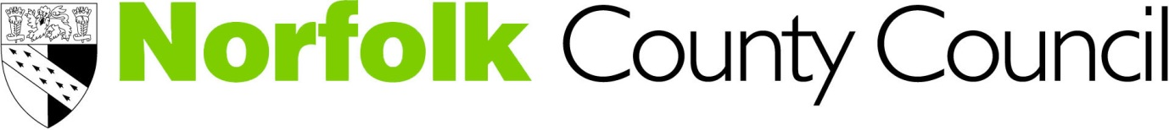
As part of its role as a Lead Local Flood Authority, Norfolk County Council has prepared a draft Local Flood Risk Management Strategy. We are now seeking your feedback on the draft strategy so that we can incorporate your comments. Consultation is taking place between 13 April and the 25 May 2015.
The draft strategy and all associated documents are now available on the Flood and Water section of the council’s website:
You are invited to give your feedback in this form on the content of the strategy.
Name: (or District, Borough, City, Parish Council, Organisation, etc)
Contact Name:
Telephone Number:
Email:

If you do not wish your name or organisation to be identified in any published material, please indicate this by checking the box below.

I do not wish my name or organisation to be identified in any published material

Flooding and Flood Risk Management (Refer to Part 1, pages 5-29 of the Strategy)

Question 1: | Does the strategy make clear what the sources of flood risk are?
Question 2: | Does the strategy make clear what flood risk management is?
Question 3: | Are the roles and responsibilities of the risk management authorities clearly defined in the strategy?
Flood Risk in Norfolk (Refer to Part 2, pages 30-102 of the Strategy)

Question 4: | Does the strategy provide a good overview of local flood risk in Norfolk?
Question 5: | Is the highlighting of flood risk at a district level effective in communicating local flood risk?
Question 6: | Do you feel there is anything in the Flood Risk in Norfolk section which requires amending or needs to be added?
Objectives and Policies (Refer to Part 3, pages 103-133 of the Strategy)
Question 7: | Are the objectives of the strategy clearly defined?
Question 8: | Are the policies of the strategy relevant and appropriate?
Question 9: | Are there any other objectives or policies that should be included?
Question 10: | Do you feel there is anything in the objectives or policies section which requires amending or needs to be added?
Measures and Funding (Refer to Part 4, pages 134-157 of the Strategy)
Question 11: | Is it clear what the Strategy means by measures?
Question 12: | Is it clear what funding mechanisms and priorities affect the funding of measures within the Strategy?
Question 13: | Is it clear what measures the Strategy proposes to deliver over the next six years and how these would be funded?
Question 14: | What other measures could the County Council include to address local flood risk in Norfolk?
Question 15: | Do you agree with the proposed timeframes for reviews of the strategy?
Question 16: | Do you agree with the principle of annually reviewing this part of the strategy?
Question 17: | Do you feel there is anything in the measures and funding section which requires amending or needs to be added?
Question 18: | Do you agree with the monitoring and implementation regime set out in Table 13 of the Strategy (Page 146)
Question 19: | Does the Strategy provide a clear direction on how the County Council intends to manage local flood risk?

Please provide any additional comments on the draft strategy or any of its accompanying documentation:

Period of Consultation

Please ensure the County Council receives your views by 5pm on Monday 25 May 2015.
Post or email your responses for the attention of:

The Flood & Water Management Team
Norfolk County Council
FREEPOST 1H 2076,
Norwich
NR1 2BR

Or email: water.management@norfolk.gov.uk

Please return the form before the consultation closing date of 25 May 2015.
News Updates: Twitter: @NorfolkFlooding Facebook.com/NorfolkFlooding

