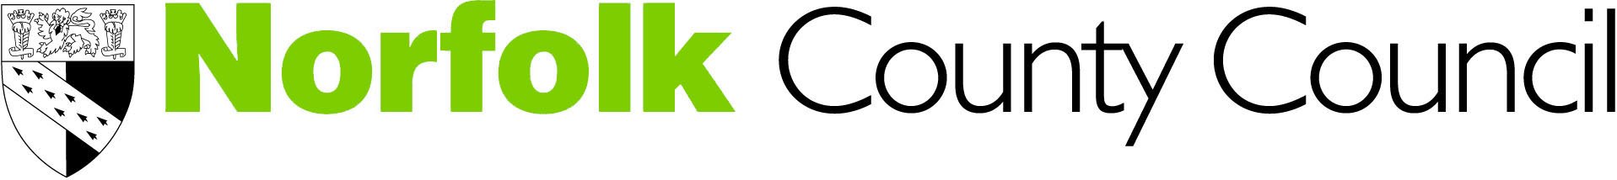

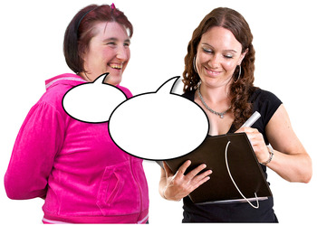
Your views on our idea to increase how much money people pay in council tax.

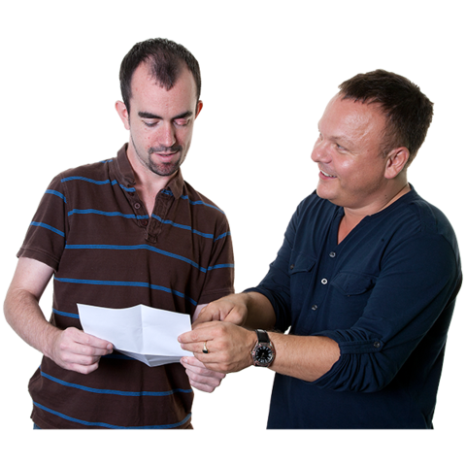
Before you begin

Some of the things in this paper are not easy to understand. You may need some help from someone to read it.
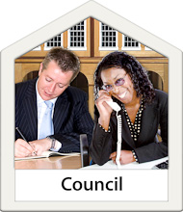
We need to save money

Norfolk County Council plays a large part in people’s lives. We spend over a billion pounds each year on services.

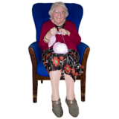

We are facing some big challenges. Our population is growing, people are living longer and people need different services.


Things are becoming more expensive and the amount of money we have coming in isn’t keeping up.


Saving money each year
The amount of money we get from the government is going down.

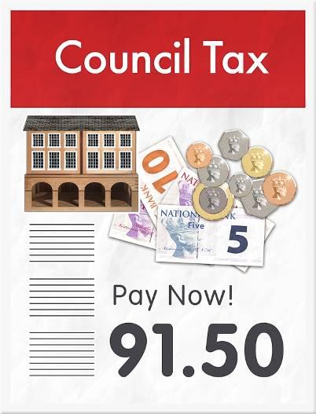
We also get money from people who live in Norfolk. This is called council tax. We use this money to pay for peoples services.

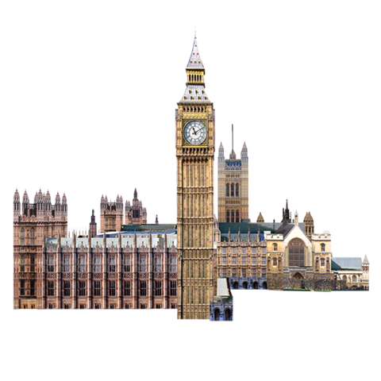 | In 2016 the Government said we could increase council tax to help support disabled people, older people and people with mental health problems.

We want to know what you think
 | Our idea is to ask people to pay a bit more council tax.
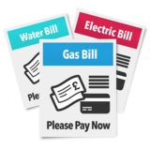 | This would give us some money to help us pay our bills.
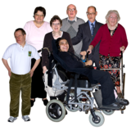 | It would also give us more money to help support disabled people, older people and people with mental health problems.
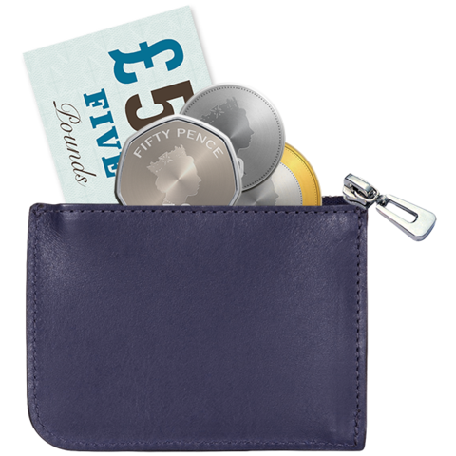 | If we asked people to pay a bit more council tax most people would pay around £1.17 more each week. That’s around £61 a year.
 | On 19 December the Government told us we could put council tax up even more. If we decided to do this most people would pay around £1.43 a week. That’s around £75 a year.
 | How do we plan to spend the extra money?
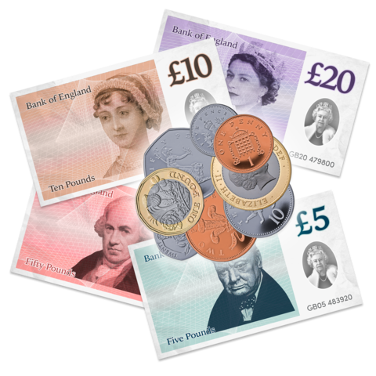 | We would spend most of the money supporting disabled people, older people and people with mental health problems.
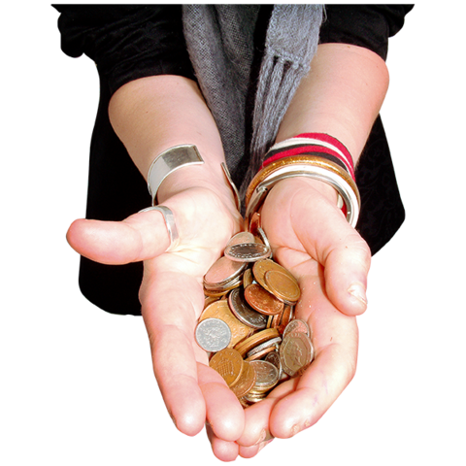 | The rest of the money would help us to pay for other services people need.
 | Tell us what you think
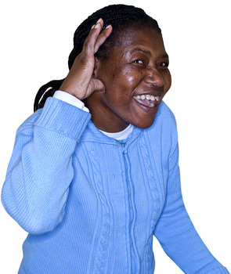 | We want to know what you think about our plans to increase council tax.  You have until Tuesday 2 January 2018 to tell us what you think.

You can tell us what you think

- On our website

www.norfolk.gov.uk/budget


- You can send us an email haveyoursay@norfolk.gov.uk


- You can write to us by filling out the form at the end of this letter and sending it back to us.

You can send your form to this address – you do not have to put a stamp on it
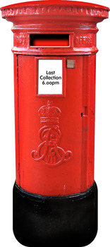
Freepost Plus RTCL-XSTT-JZSK, Norfolk County Council, Ground floor – south wing,
County Hall, Martineau Lane, NORWICH, NR1 2DH


Thank you for helping us by telling us what you think.

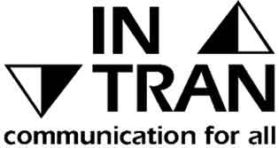
If you need this document in large print, audio, Braille, alternative format or in a different language please contact us on 0344 800 8020, Text Relay on 18001 0344 800 8020 (textphone) or email haveyoursay@norfolk.gov.uk and we will do our best to help.

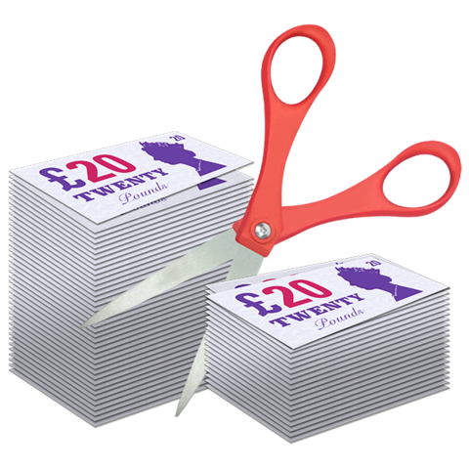
Fill in this form and send it back to us to tell us what you think of our idea

What do you think of our idea to increase council tax?
Please write your answer in the box
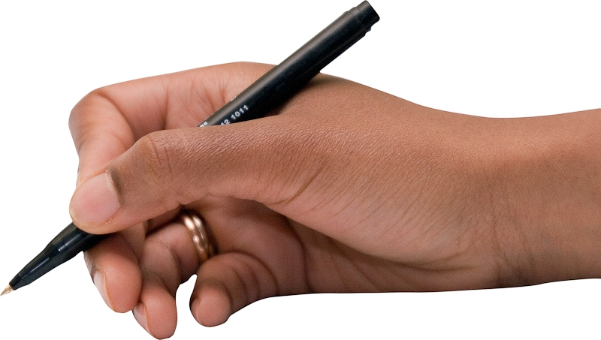

What do you think about the Government’s idea which means we could increase council tax even more?
Please write your answer in the box


About you

Please tell us about yourself

This will help us make sure we have listened to a range of people

Please tick 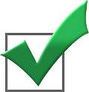the right answers

◻ I get care and support from the council

◻ I care for someone who gets support from the council

Do you have a disability, learning difficulty or long-term health problem which means that there are some daily activities or work that you can’t do that you would like to? This includes problems that are due to old age.

◻ Yes ◻ No

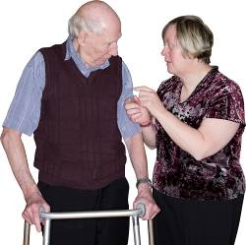
If you are an advocate or carer, please provide the details of the person you are caring for – for the next questions.

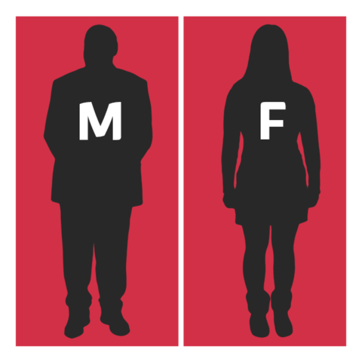
Are you: (Tick one box)

◻ Male

◻ Female

◻ I prefer to describe myself as (please write in here)

◻I prefer not to say

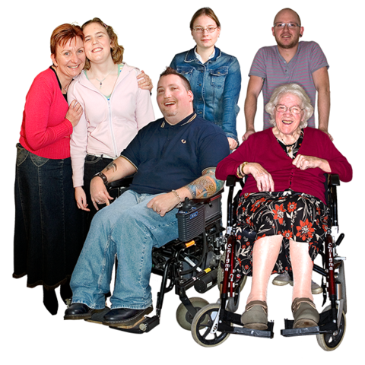
How old are you? : (Tick one box)

◻ 18-24

◻ 25-34

◻ 35-44

◻ 45-54

◻ 55-64

◻ 65-74

◻ 75-84

◻ 85 or older

◻ Prefer not to say

What is your ethnic background?

(Tick one)

◻ White background (e.g. British, European, Irish)

◻ Asian background (e.g. Bangladeshi, Indian, Pakistani)

◻ Black background (e.g. African, Carribean)

◻ Chinese background (e.g. Korean, Tibetan)

◻ Dual / Multiple Heritage (e.g. White and Asian, White and Black)

◻ Other (e.g. Gypsy, Romany, Irish Traveller)

◻ Prefer not to say

Now put this form in the envelope that come with your letter and send it back by 2 January 2018
If you have lost you envelope then send this form back to: Freepost Plus RTCL-XSTT-JZSK, Norfolk County Council, Ground floor, south wing, County Hall, Martineau Lane, NORWICH, NR1 2DH. You do not need to use a stamp.

Thank you for telling us what you think

