Chapel Road initial consultation – Relocation and expansion
Responses received: 127
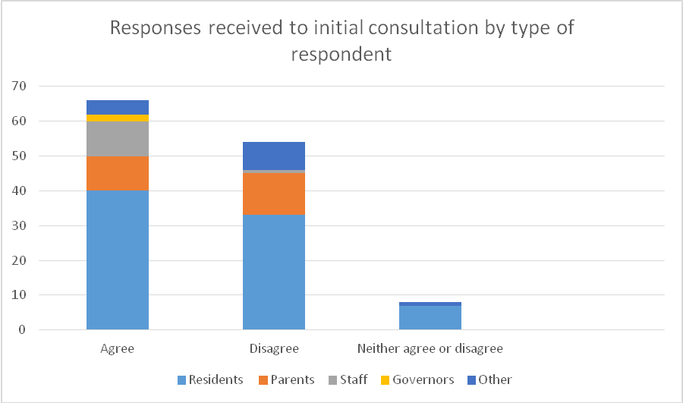
Agree with the proposal: 66
26 respondents commented on the educational merit of the proposal
22 respondents commented on the highways issues
3 respondents made other comments which included: a perceived lack of investment at the high school, that the community should be allowed the use of facilities, good pathways were needed to connect all three school sites.
Of the respondents, 40 are residents; 10 are parents of pupils; 10 are members of staff; 2 are school governors; 4 gave no identification.
Of those with connections to schools, 7 named Chapel Road School; 6 named Old Buckenham Primary School; 4 named Old Buckenham High School; 2 named Old Buckenham Pre-School; 1 named a school outside the cluster.
Disagree with the proposal: 54
1 commented in favour of relocation provided the parking and highways matters were resolved. However for 41 respondents the highways issues were of concern.
13 respondents made other comments which included: a perceived lack of investment at the high school, lack of community facilities, poor linkage between the three sites, fewer opportunities for student integration in Old Buckenham, poor infrastructure in Old Buckenham, the potential for high level noise from the pitches, that education merits were unclear and students less isolated in Attleborough, the village should remain as a village.
Of these respondents, 33 are residents, 12 are parents of pupils, 1 is a members of staff, 8 gave no identification.
Of those with connections to schools, 7 named Chapel Road School, 16 named Old Buckenham Primary School, 7 Named Old Buckenham High School, 2 named Old Buckenham Pre-School, 1 named a school outside the cluster
7 respondents neither agreed or disagreed
Of these all are residents, except one who did not give any identification.
Their comments included
Interaction between the 3 schools should be encouraged and the community allowed use of all facilities e.g. swim pool, create VI provision at the high school, village boundary should not be extended given expansion of Attleborough to the south, the relationship between the Old Buckenham schools given their move to Trust status, sensible access arrangements and highways issues, adequate parking arrangements, lack of pathways/pavements and health and safety of students and residents.

