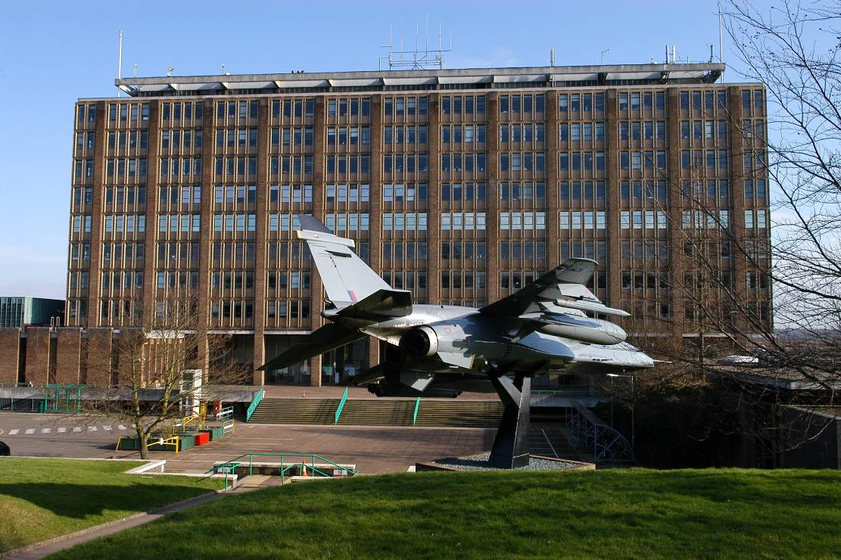
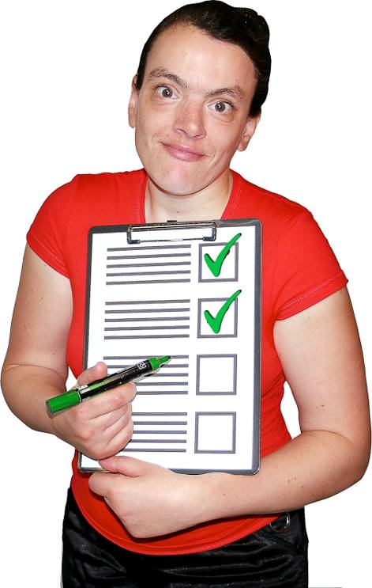

Norfolk County Council
Our budget and services 2015-2018

This book tells you about the council’s ideas to save money

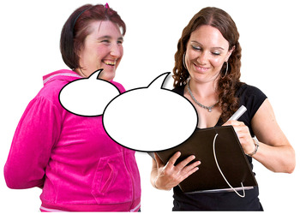
We want to know what you think of our plans to save money


Please read this book about the ideas we have for changing things. After each idea we ask you what you think of it.

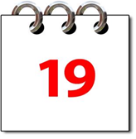
You have until Friday 19 December 2014 to tell us what you think.
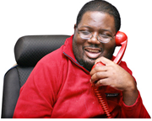

If you have any questions you can get in touch with us by: Telephone 0344 800 8020

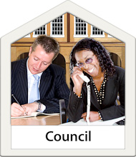
What is going to happen with the council’s money?

Norfolk County Council gets money from the government.

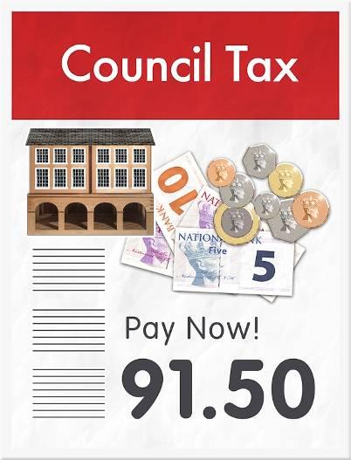

We also get money from people who live in Norfolk. This is called council tax. We use this money to pay for services for people in Norfolk.
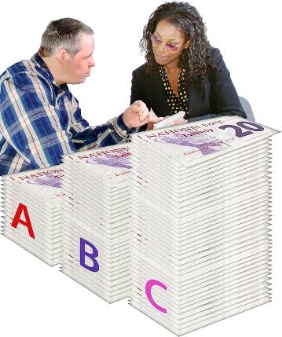
Each year, we divide up all the money we have and spend it on different services.


Saving money each year
The amount of money we get from the government is going down.

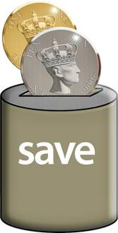
We have to save money each year.

We always ask people what they think about our ideas to save money.


What happened last year?

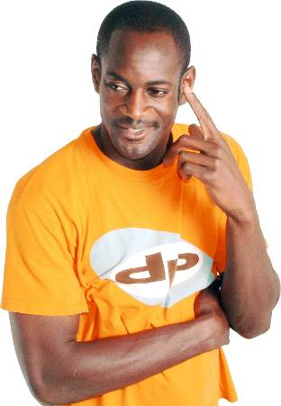
Last year we had to save £189 million pounds before 2017. That is a lot of money. We asked people in Norfolk about their ideas to save money.

We listened to what people told us and agreed to save £40 million pounds next year.

What do we need to do now?

Things have changed since last year. We now have to save more money. We need to save an extra £12.9 million pounds next year.

We must find more ways to save money.

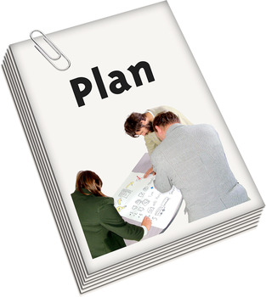
Our ideas

Here are our ideas on how to save money. Some of our ideas might change things for people with a learning disability and disabled people.

Idea number 1
Ask people to pay more council tax

Council tax is money that people pay us for local services. We could ask people to pay more.

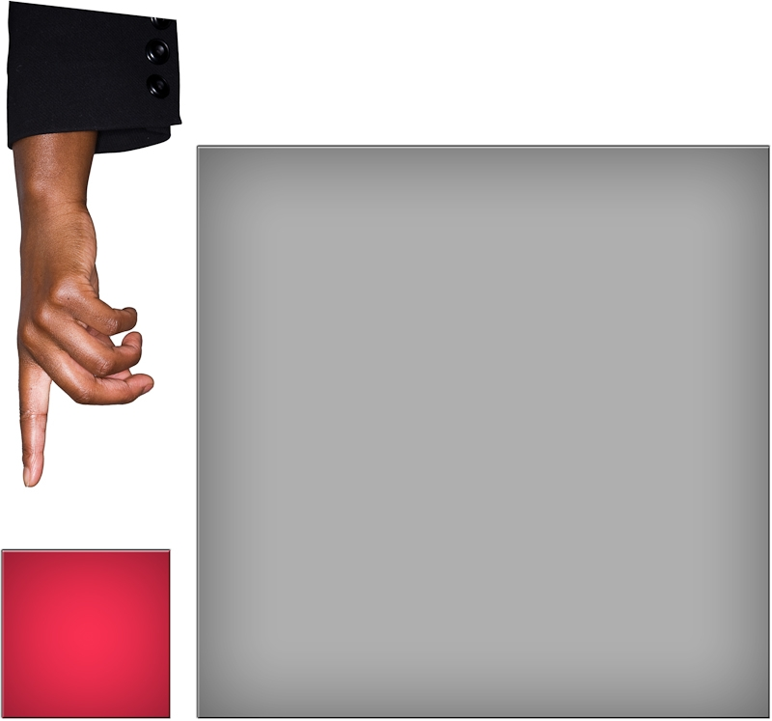
If people paid more council tax we would not have to cut some services. We would only put council tax up a small amount.

Do you think we should do this? Please tick ✓ the answer.



Yes No

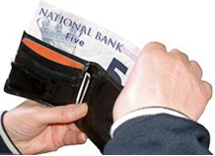
If we put the council tax up, what services do you think we should spend the money on? Please write your answer in the box.

Idea number 2
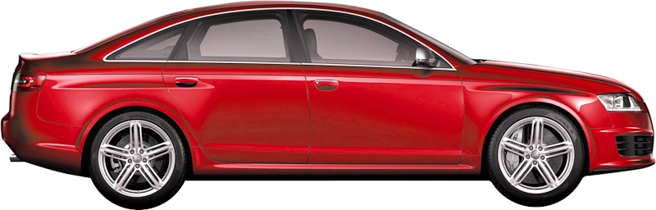
Reduce the money we spend on transport for people who use adult social care

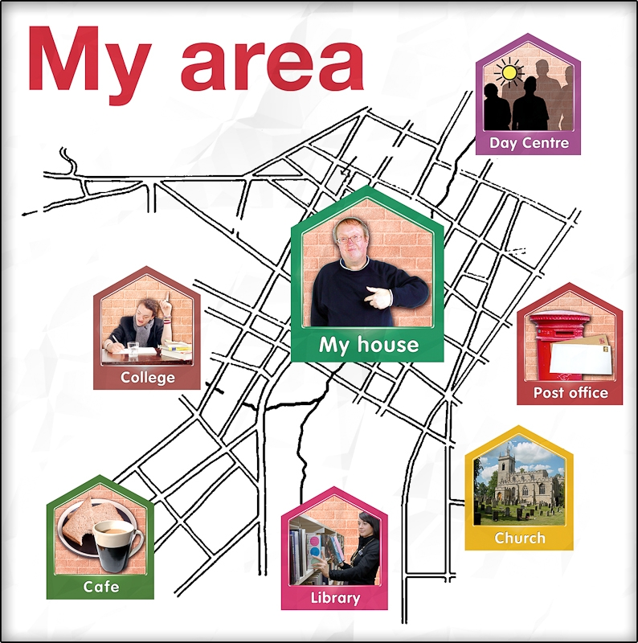
If people have a motability vehicle or motability allowance, we will make sure they use this for their transport.

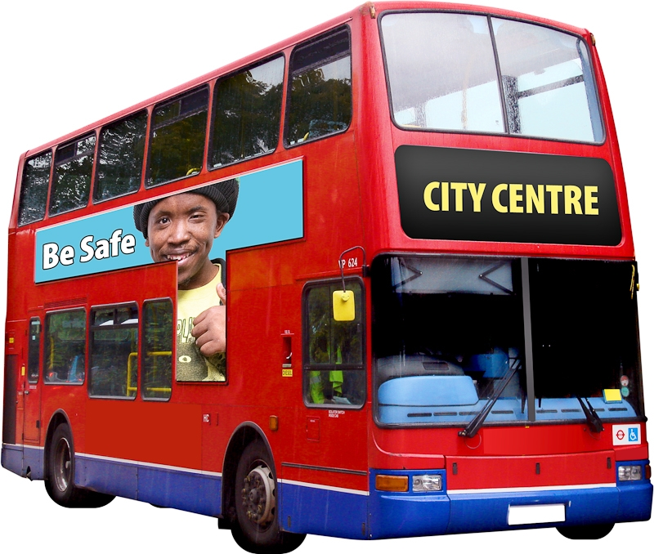
We will ask people to use services that are nearby. If people don’t want to go there but want to go to a service that is far away we will not pay for them to get there.

We will ask more people to use the bus or community transport.

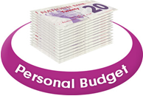
If we can’t meet people’s care needs in any of these ways we will pay for transport through their personal budget.

Do you think we should do this? Please tick ✓ the answer.

Yes No

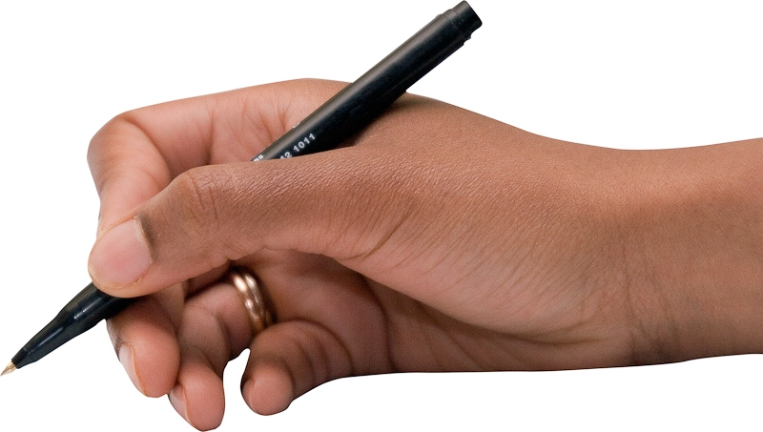
Why do you say this? Please write your answer in the box

Idea number 3
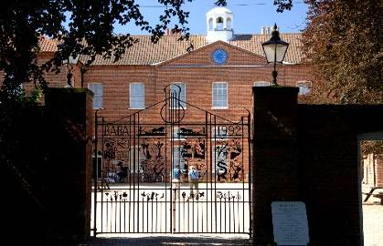
Charge people to park at Gressenhall Museum

We will ask people to pay under £2 to park all day at Gressenhall. Disabled people and Blue Badge holders will not have to pay for parking.

Do you think we should do this? Please tick ✓ the answer.

Yes No
Why do you say this? Please write your answer in the box

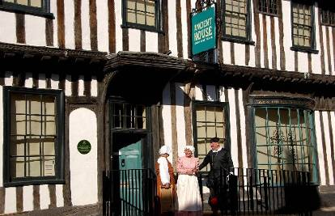
Idea number 4
Ask people to pay to visit the Ancient House Museum in winter

Do you think we should do this? Please tick ✓ the answer.

Yes No
Why do you say this? Please write your answer in the box

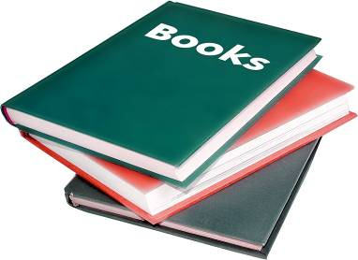
Idea number 5
Sell off some old, rare library books to make money.

Do you think we should do this? Please tick ✓ the answer.

Yes No
Why do you say this? Please write your answer in the box

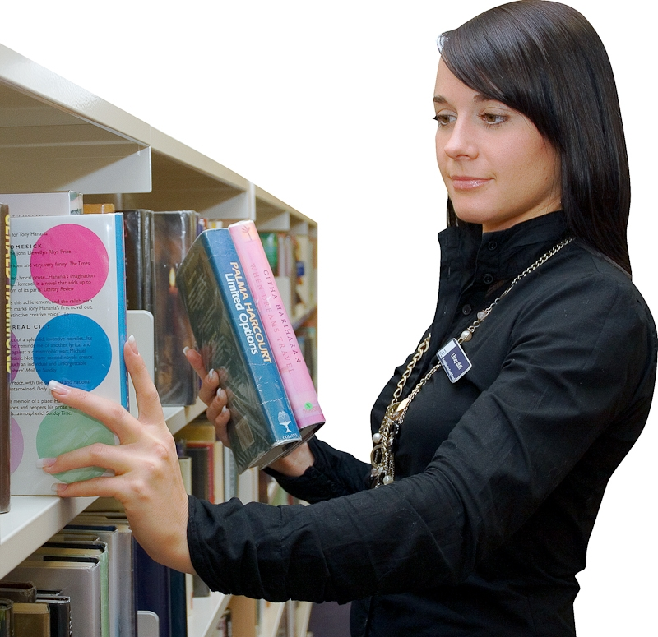
Idea number 6
Reduce the number of library staff

This would not change library opening hours.

Do you think we should do this? Please tick ✓ the answer.

Yes No
Why do you say this? Please write your answer in the box

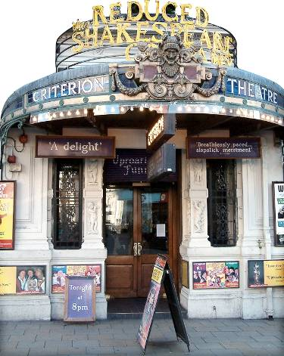
Idea number 7
Give less money to arts organisations

This means there might be less theatre, dance, art, cinema and music.

Do you think we should do this? Please tick ✓ the answer.

Yes No
Why do you say this? Please write your answer in the box

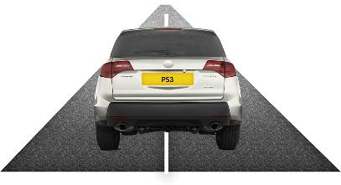
Idea number 8
Spend less on mending roads

If a road is unsafe we will still mend it quickly.

Do you think we should do this? Please tick ✓ the answer.

Yes No
Why do you say this? Please write your answer in the box

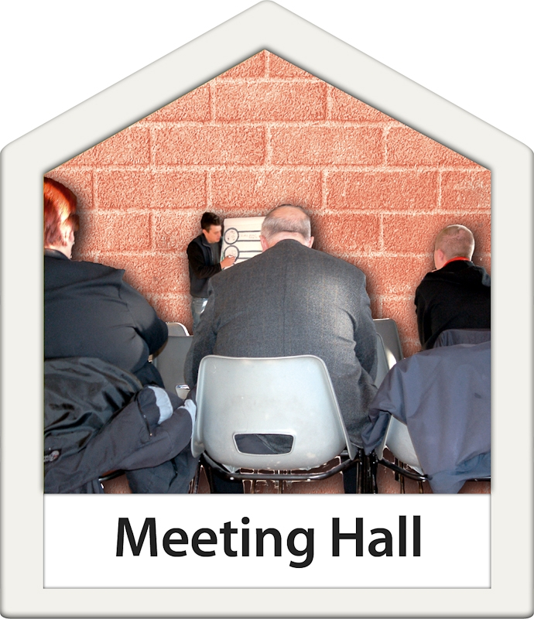
Idea number 9
Stop giving money to schools that helps them charge low prices for other people to use their rooms

Some community groups may have to pay more to use a room in a school.
Do you think we should do this? Please tick ✓ the answer.

Yes No
Why do you say this? Please write your answer in the box


You can read more about the cuts we might make on our website:
www.norfolk.gov.uk/budgetandservices

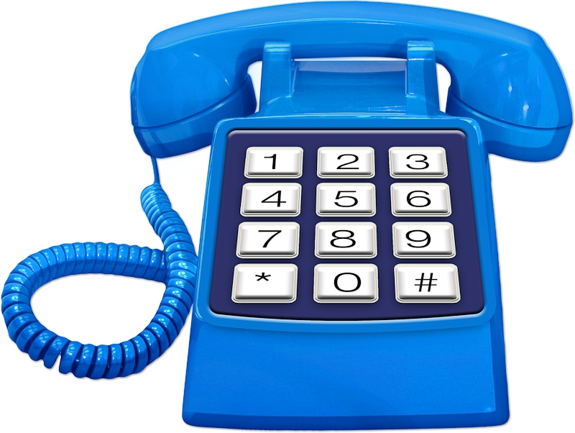
Or phone 0344 800 8020 and we will send you a booklet.


Please tell us about yourself
What is your first name?

Do you have a disability, learning difficulty or long-term health problem which means that there are some daily activities or work that you can’t do that you would like to? This includes problems that are due to old age.

Please circle the right answer:
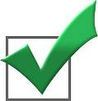 Yes  No
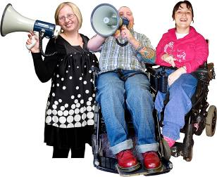
If you are an organisation, service or group, please tell us your name and address here:

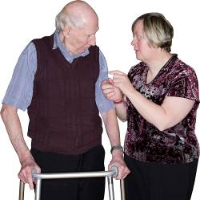

If you are an advocate or carer, please tell us your first name here:


If you are a paid member of staff from Norfolk County Council or NHS health service, please tell us the name and address of your organisation:


You can fill in this book. You can use more paper to write on if you need to.

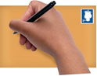
When you have filled in this book, please send it in an envelope to Freepost Plus RTCL-XSTT-JZSK, Norfolk County Council, County Hall, Martineau Lane, NORWICH, NR1 2DH. You do not need to use a stamp.


You can also send an email to: haveyoursay@norfolk.gov.uk

Or you can tell us your views on the web: www.norfolk.gov.uk/budgetandservices

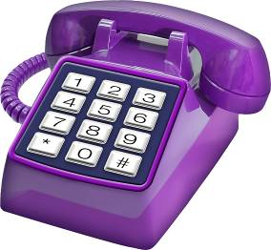

Or you can call us on 0344 800 8020


If you need this leaflet in audio, Braille, alternative format or in a different language please contact us on 0344 800 8020

Email: haveyoursay@norfolk.gov.uk and we will do our best to help

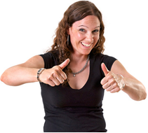

Thank you to Photosymbols for the pictures
www.photosymbols.com

