Your views on our Budget 2024-2025

Overview

Norfolk County Council will set a new budget on 20 February 2024. In this consultation we are asking for your views on our proposed council tax level for
2024-25, including a proposal for the adult social care precept.

Why we are consulting
We want to find out what people think about our proposed increase in council tax.
We are consulting through:
- This online consultation, which is also available as a paper copy
- Letter to key partners and stakeholders
- Letter to members of the Norfolk Residents’ Panel
We are consulting from 20 October to 1 December 2023. Please note that if we receive any consultation responses after this date, we cannot guarantee that we will be able to take them into account.
We will feed back the findings from our consultation to our county councillors as part of the evidence they will use to help them come to a decision about our budget proposals.

If you need a copy of this consultation document in a different format please email haveyoursay@norfolk.gov.uk, call 0344 800 8020 or Text Relay on 18001 0344 800 8020 (textphone) and we will do our best to help.

The consultation should take about 10-15 minutes to complete.

The questions start on page 9 of this document.

Personal information, confidentiality and data protection

We will use any personal information to understand how different groups of people feel about our budget proposals.
We will process any personal information we receive from you in line with the General Data Protection Regulation (GDPR) (Regulation (EU) 2016/679), the Data Protection Act 2018 and Norfolk County Council’s data protection policy and guidelines. This means that Norfolk County Council will hold your personal data and only use it for the purpose for which it was collected, being this consultation. You can find a copy of our privacy statement on the Norfolk County Council website.
We won't identify individuals when reporting back our findings and under our record management policy we will keep this information for five years. We will also, under normal circumstances, not pass your personal data on to anyone else. However, we may be asked under access to information laws to publish or disclose some, or all, of the information you provide in response to this consultation. We will only do this where such disclosure will comply with such relevant information laws which include the Freedom of Information Act 2000, the Data Protection Act 2018 and the Environmental Information Regulations 2004.
You can choose not to take part in the consultation, to stop responding at any time, or to ignore any personal questions that you do not want to answer.

Introduction
Norfolk County Council is committed to making Norfolk a county where businesses, organisations and communities continue to thrive together. Our Better Together, For Norfolk strategy is available to read on Norfolk County Council’s website. The strategy sets out the Council’s five, interlinked, priorities: a vibrant and sustainable economy; better opportunities for children and young people; healthy, fulfilling and independent lives; strong, engaged and inclusive communities; and a greener, more resilient future. We’re proud to provide the valuable services that our residents need and deserve.

However, we continue to face significant challenges which includes higher costs and demand for services, after more than a decade of reduced funding. The October 2023 Cabinet meeting considered 2024-25 savings proposals totally £26.5 million. The 2023 Cabinet meeting minutes are available on the Norfolk County Council website. They make a significant contribution towards our target of £46.2 million and will enable the council to continue to deliver the key services for Norfolk’s residents, while balancing the books.

As we continue with major uncertainty around our finances, and ahead of further announcements on funding from the Government, Norfolk County Council is continuing to work to bridge the gap in our budget. As a part of this, we are consulting on this proposal to raise council tax and gathering feedback about the proposed level of council tax from people across Norfolk. We want to hear your views on our council tax and budget approach to help our elected councillors make the right, even if tough, decisions in agreeing a balanced budget for 2024-2025.

Where the money comes from:
A significant proportion of our funding comes from council tax and we depend on this source of income to deliver vital services across the whole county. Council tax is the only source of funding which the County Council directly controls.

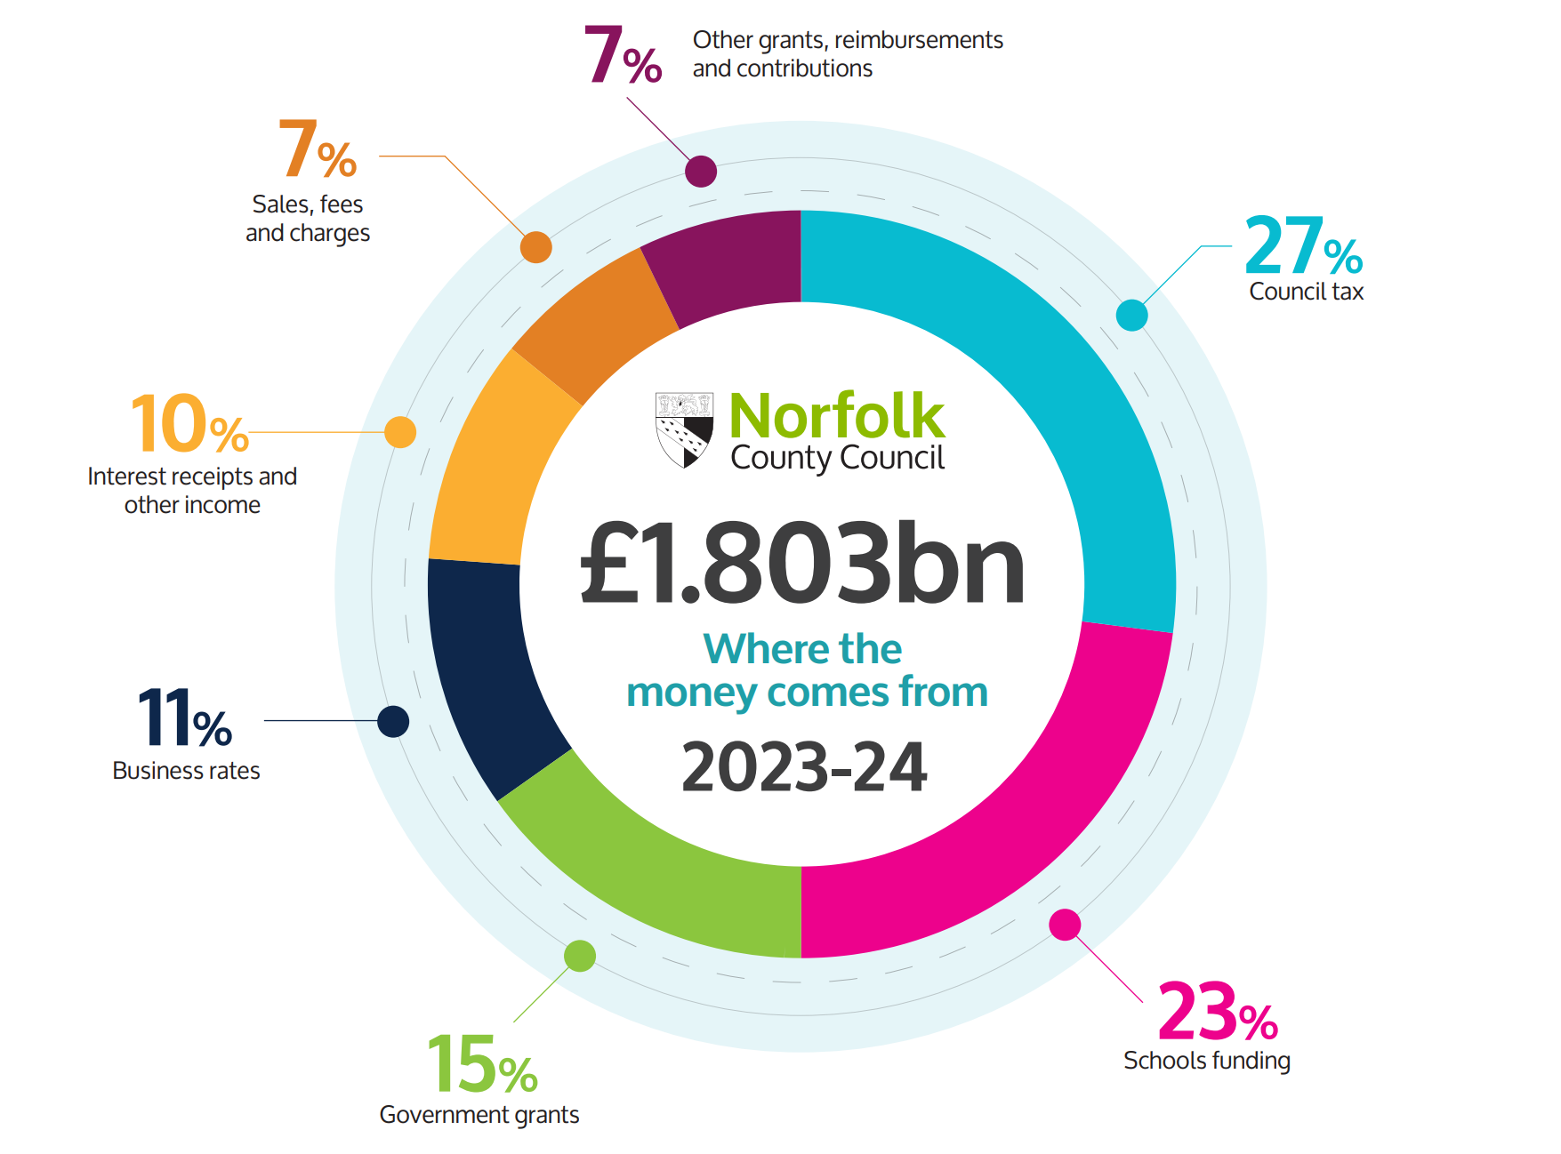

For 2023-24, Norfolk County Council has a gross income budget of £1.803bn. Funding comes from a variety of sources: 27% comes from council tax, 23% is schools funding, 15% from government grants, 11% from business rates, 10% from interest receipts and other income, 7% from sales, fees and charges and 7% from other grants, reimbursements and contributions.

Where the money is spent:

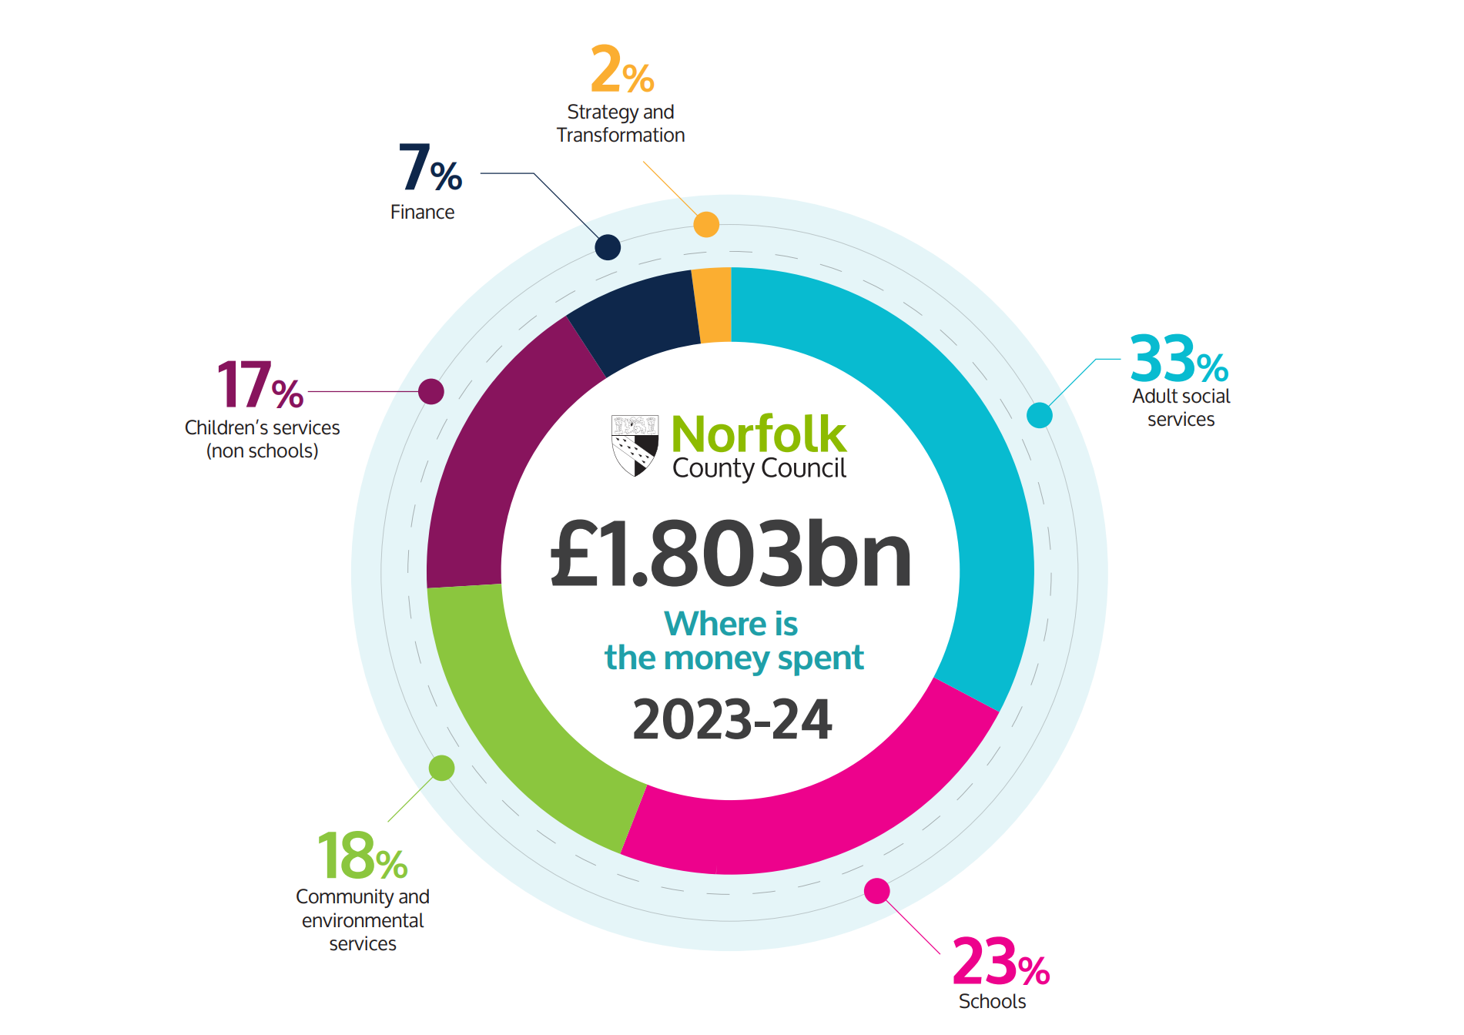

The departmental breakdown of the council’s £1.803bn expenditure budget is 33% spent on adult social services, 23% spent on schools, 18% on community and environmental services, 17% on children’s services (non schools), 7% on finance and 2% on strategy and transformation.

Background to council tax

Council tax helps pay for local services and applies to all domestic properties whether owned or rented. How much you pay depends on the valuation band of your property. The responsibility to pay council tax usually lies with the occupier.
Each organisation that provides services in your area sets their own proportion of the council tax bill you receive. These are:
- Norfolk County Council
- your district council
- your parish council (if you have one)
- Norfolk police
Last year, Government set a referendum limit of 4.99%, and this is the level currently included in our financial planning for 2024-25. If the Council wishes to increase council tax by more than the limits set by Government, we would be required to hold a local referendum to agree this. Central Government has not confirmed the limits for 2024-25, but they are expected to be 3% for increases in general council tax. In addition, councils responsible for social care, like Norfolk, are expected to be able to increase the Adult Social Care precept by up to 2%.

Statistics show that following changes in Government policy, all County Councils in England have raised council tax in a broadly similar way since 2015-16. You can view data comparing local authority council tax rates on the GOV.UK website.
In the graph below the dash line represents Norfolk and the solid lines represent other local authorities.
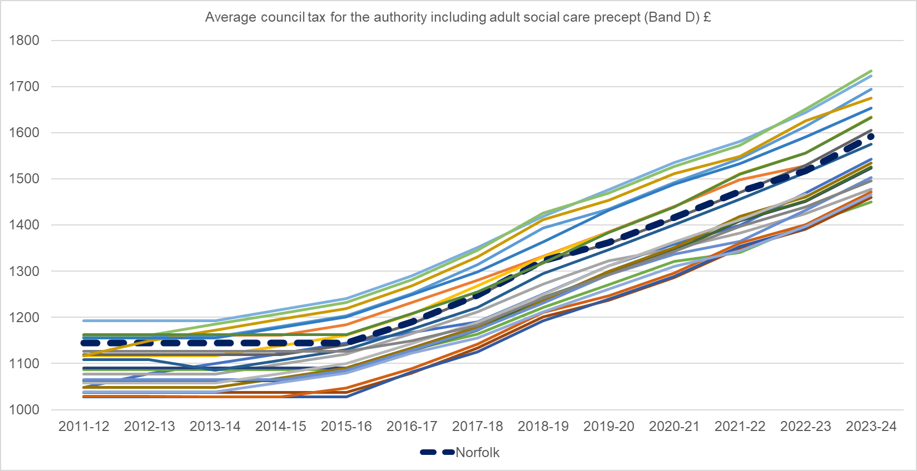

Our council tax questions

To help us deal with our cost pressures and invest in vital services our current budget planning is based on an assumption to raise general council tax by 2.99% and the Adult Social Care precept by 2% in 2024-25. However, final decisions about the level of council tax will be made by the Council on 20 February 2024. The money you pay as part of Norfolk County Council’s general share of the council tax helps fund the costs of all the services provided by the Council and is not linked to specific services.
Like household bills, the cost of the services that the Council provides are impacted by the level of inflation. The Consumer Prices Index (CPI) in September 2023 confirmed inflation is currently running at 6.7%. The proposed council tax increase is below current CPI inflation.

Adult Social Care is a collection of wide-ranging activities aimed at helping people who may be older or living with disability or physical or mental illness. For some, this may include access to services that provide “personal care” either in their own homes or in more formal settings such as a care home. However, for many Social Care is about providing support to potentially overcome obstacles and enable people to live the lives they want to lead in a place they can call home. The County Council spends over £1.6m a day in providing support through our Adult Social Services department.
To help us maintain our adult social care services our budget planning is based on an assumption outlined in our Cabinet paper on 2 October, to increase the adult social care precept by 2% in 2024-25. A final decision about the level of the adult social care precept will also be made by the Council on 20 February 2024. The money we raise from the adult social care precept is ringfenced, this means we can only spend it on adult social care services. The adult social care precept was introduced by Government in 2015 and has been part of the council tax bill since 2016-17.

The effect our proposals would have on council tax

An increase at the currently assumed level of 4.99% would mean in 2024-25 Norfolk County Council’s council tax charge for a typical Band D home would see an indicative increase of approximately £1.52 per week or £79 for the year (made up of £47 for general 2.99% increase + £32 for 2% Adult Social Care Precept increase) and the charge for a Band D home would be around £1,672.
- How far would you agree or disagree with increasing Norfolk County Council’s share of the general council tax by 2.99% in 2024-25? Please tick () one answer only:

☐ Strongly agree
☐ Agree
☐ Neither agree or disagree
☐ Disagree
☐ Strongly disagree
☐ Don’t know

- Why do you say that?

Please write your answer here:

How far would you agree or disagree with our proposal to increase the Adult Social Care precept) by 2.00% in 2024-25? Please tick () one answer only:

☐ Strongly agree
☐ Agree
☐ Neither agree or disagree
☐ Disagree
☐ Strongly disagree
☐ Don’t know

- Why do you say that?
Please write your answer here:

Our budget approach 2024-25

At our Cabinet Meeting on 2 October 2023, a total of £26.5 million in savings were presented to councillors. The minutes from the October 2023 Cabinet meeting are available on the Norfolk County Council website. We continue to face significant challenges and enormous uncertainty as we work to bridge a £46.2 million budget gap.

Each year it is tougher and tougher to achieve our savings targets, after more than a decade of reduced funding. All councils are facing these pressures and that is why we continue to press for multi-year settlements and fairer funding, so that the Government can give us more certainty when planning our budgets.

The council is waiting to hear whether more funding will be provided in the autumn statement of November 2023, or the provisional local government funding settlement in December 2023.

Strategic and financial planning for 2024-25 has been undertaken in the context of this continued uncertainty about Government funding. We have also taken into consideration uncertainty around the ongoing war in Ukraine and the situation in the Middle East, in terms of global energy and food supply, as well as inflationary pressures and the consequent impact on both the cost of services we deliver, and the demand for services as households and communities continue to struggle with the rising cost of living.

Consumer Price Index (CPI) inflation stands at 6.7% in September 2023. At its meeting of 21 September 2023, the Bank of England’s Monetary Policy Committee maintained the Bank Rate interest rate at 5.25%, the highest level since February 2008.

Falls in real household incomes have had a significant impact on people and families, particularly, but not limited to, those experiencing financial or employment vulnerability. This, in turn, could have a knock-on impact on demand for our services.

It is in these difficult times that the County Council cannot afford any complacency and, working with its partners, will have to consider how best to deploy its own limited resources to support the most vulnerable people and communities, whilst continuing to provide wider public services.

Our strategic and financial planning papers have been published on our website and provide details of our budget approach. If, once the budget is agreed and the Council starts to implement all proposals, we identify that any of the proposals impact on delivering services, we may need to carry out detailed consultation on those proposals in the future.

Your views on our budget

Our Better Together, For Norfolk strategy is available to read on Norfolk County Council’s website. The strategy sets the Council’s strategic policy direction. It demonstrates the organisation’s level of ambition and how it intends to deal with key challenges.

Local authorities continue to face a growing shortfall between funding and service pressures, which is caused in large part by a combination of inflation, demographic changes, policy decisions, and the needs of vulnerable social care users becoming increasingly complex.

Against the current financial and external constraints, our ongoing service transformation programmes are intended to support us in continuing to meet our strategic priorities. Importantly, our transformation programmes will enable us to improve services and manage demand, making the council more effective and efficient.

Work has been undertaken over the summer to develop savings proposals to contribute to closing the 2024-25 Budget gap. These new proposals total £26.5m and are summarised in the table below.

Our budget proposals for this year concentrate on prevention and early intervention and using digital technology to become more efficient, modern and business-like.

The table presents the saving proposals for each department: Adult Social Services, Children’s Services, Community and Environmental Services, Strategy and Transformation and Finance.

Table 5: Detailed Budget savings proposals 2024-25
(Note: N/A means Not Applicable)
Adult Social Services (ASS)

Dept | Saving Proposal | 2024-25  £m | 2025-26  £m | 2026-27  £m | 2027-28  £m | Total  £m
S2425ASS001 | Review contracts providing respite for adults with learning disabilities and identify a more cost effective and efficient way of delivering this service. | -0.250 | -0.250 | N/A | N/A | -0.500
S2425ASS002 | Shifting our payments for 1:1 care in Residential Care to being based on actual delivery rather than commitment basis | -0.100 | N/A | N/A | N/A | -0.100
S2425ASS003 | Reduction in budget for a historic pension scheme based on people exiting the scheme over time. | -0.050 | N/A | N/A | N/A | -0.050
S2425ASS004 | One-off release of reserves to offset budget pressures. | -3.000 | 3.000 | N/A | N/A | 0.000
S2425ASS005 | Plans to build 2,800 units of extra care housing for older adults. This proposal is aimed at increasing independence and making savings by reducing demand for residential care. | 1.100 | -1.000 | -1.700 | -2.000 | -3.600
S2425ASS006 | Plans to provide 183 units of supported housing for young adults. This proposal is aimed at increasing independence and making savings by reducing demand for residential care. | -0.500 | -1.100 | -1.200 | -1.100 | -3.900
S2425ASS007 | Supporting more people through an enhanced reablement service that prevents, reduces and delays the need for ongoing care | -1.500 | N/A | N/A | N/A | -1.500
S2425ASS008 | Reduce purchasing of short-term residential care, by focusing on more independent outcomes following hospital discharge. | -1.000 | N/A | N/A | N/A | 1.000
S2425ASS009 | A programme of work based on data designed to support people earlier and connect them to services and support in their communities. The saving would be from prevention and early intervention (Connecting Communities additionality) | -4.000 | N/A | N/A | N/A | -4.000
S2425ASS010 | Expand the Falls Pilot to promote prevention and early intervention with a larger cohort of people at risk of falls. | -0.050 | -0.150 | N/A | N/A | -0.200
S2425ASS011 | Investment in additional staffing to promote earlier intervention and maximise independence amongst young people with additional needs. | -0.250 | N/A | N/A | N/A | -0.250
S2425ASS012 | Use grant funding to replace NCC budget. | -2.128 | N/A | N/A | N/A | 2.128
S2425ASS013 | Potential use of additional reserves, including Public Health reserves. | -1.000 | 1.000 | N/A | N/A | 0.000
S2425ASS014 | Use digital technology to streamline services and make productivity and efficiency savings across priority areas for Adult Social Care. | -1.000 | N/A | N/A | N/A | -1.000
S2425ASS016 | Delivering improved choice and independent outcomes for those with Mental Health needs. | -0.500 | -1.000 | N/A | N/A | -1.500

Children’s Services (CS)

Dept | Saving Proposal | 2024-25  £m | 2025-26  £m | 2026-27  £m | 2027-28  £m | Total  £m
S2425CS001 | Prevention, early intervention and effective social care - helping families stay together and ensuring fewer children in care: Reducing demand for social care intervention through earlier help and prevention. | -0.642 | -1.285 | -1.285 | -1.285 | -4.497
S2425CS002 | Prevention, early intervention and effective social care - helping families stay together and ensuring fewer children in care: New Roads approach to help children and young people with neurodevelopmental disabilities and enable them to remain living within their families. | N/A | -0.125 | -0.250 | -0.500 | -0.875
S2425CS003 | Transforming the Care Market and creating the capacity that we need: Expansion of in-house fostering capacity through a whole-Council and whole-County focus on carer recruitment and retention, ensuring we have sufficient foster carers to avoid the use of other, more costly, care arrangements where they do not provide better outcomes. | -0.378 | -1.611 | -1.546 | -0.783 | -4.318
S2425CS004 | Transforming the Care Market and creating the capacity that we need: Reshaping our in-house residential care provision to successfully support the highest needs young people and to support positive ‘move on’ to family-based care as early as possible | -1.067 | -0.973 | -1.043 | -0.210 | -3.293
S2425CS005 | Inclusion: More primary aged children with SEND can travel independently by adapting the Travel Independence Travel Across Nation (TITAN) programme. | -0.125 | -0.125 | -0.125 | -0.125 | -0.500
S2425CS006 | Inclusion: Ongoing focus on efficient delivery of Home to School Transport through maximising travel independence wherever appropriate and possible. | -0.250 | -0.100 | -0.100 | N/A | -0.450
S2425CS007 | Local First Inclusion: Creation of additional specialist provision closer to home resulting in children needing to travel less far | -0.750 | -0.500 | -0.500 | -0.500 | -2.250
S2425CS008 | Local First Inclusion: More children supported in mainstream schools preventing the need to travel to specialist schools. | N/A | -1.550 | -2.300 | -2.300 | -6.150
S2425CS009 | Ongoing focus on efficient commissioning of complex care placements. | -0.100 | N/A | N/A | N/A | -0.100
S2425CS010 | Efficient commissioning of clinical training required for some families. Training delivered in partnership with Norfolk Community Health & Care (NCH&C). | -0.030 | N/A | N/A | N/A | -0.030
S2425CS011 | Reshaping our system support for learning and education aligned to the evolving role of the local authority and creation of a self-improving education system | -0.375 | -0.375 | -0.175 | N/A | -0.925
S2425CS012 | One-off usage of reserves earmarked to contribute to invest-to-save funding. This saving has a corresponding pressure in 2025-26 ensuring invest-to-save funding continues. | -1.000 | 1.000 | N/A | N/A | 0.000
S2425CS013 | Prevention, early intervention and effective social care - helping families stay together and ensuring fewer children in care: Reduced social care placement and support costs through improved the timeliness of court decisions. | -0.125 | -0.125 | -0.125 | N/A | -0.375

Community and Environmental Services (CES)

Dept | Saving Proposal | 2024-25  £m | 2025-26  £m | 2026-27  £m | 2027-28  £m | Total  £m
S2425CES001 | Small scale efficiency improvements within Norfolk Fire and Rescue service (NFRS) that will not affect the front-line service. | -0.040 | N/A | N/A | N/A | -0.040
S2425CES002 | Review the management of the NFRS vehicle maintenance contract currently delivered by Norse to ensure best value. | N/A | -0.200 | N/A | N/A | -0.200
S2425CES004 | Reintroduce overdue charges for adults in libraries (charges were suspended during the Covid 19 pandemic). | -0.045 | N/A | N/A | N/A | -0.045
S2425CES005 | Remove vacant Open Library Manager post (0.5fte). | -0.015 | N/A | N/A | N/A | -0.015
S2425CES006 | To capitalise a portion of the Executive Director post salary - 20% (to be funded from existing capital allocation). | -0.040 | N/A | N/A | N/A | -0.040
S2425CES007 | Remove vacant post from within the Business Support Operations team. | -0.025 | N/A | N/A | N/A | -0.025
S2425CES008 | Enable digital fund raising online for our libraries. | -0.020 | N/A | N/A | N/A | -0.020
S2425CES009 | Review highway fees and compare to those charged by neighbouring authorities, then introduce new or reviewed fees, where possible, for external customers. | -0.050 | -0.025 | -0.025 | N/A | -0.100
S2425CES010 | Review design recharge fees (BCIS 10% increase in rates from 1/4/23) and benchmark against neighbouring authorities. Introduce new or reviewed fees where possible for internal and external customers. | -0.200 | -0.150 | -0.150 | N/A | -0.500
S2425CES011 | Capitalise £0.050m of the £1.5m revenue budget from the Flood Reserve Fund. Currently £0.5m is capitalised annually. | -0.050 | N/A | 0.050 | N/A | 0.000
S2425CES012 | Increase capital funding of the Norse Local Management Overhead (LMO) in the same proportions as the split of direct activity between revenue and capital. | -0.100 | N/A | N/A | N/A | -0.100
S2425CES013 | Further increase Area recharge budgets. | -0.100 | N/A | N/A | N/A | -0.100
S2425CES014 | Freeze third party delegated grass cutting rate as it received 13.4% this year. Move away from RPI increase for new applicants. | -0.030 | N/A | N/A | N/A | -0.030
S2425CES015 | Review the level of permits NCC process in line with the permit scheme and ensure full cost recovery. | -0.250 | -0.100 | -0.050 | N/A | -0.400
S2425CES016 | Waste and recycling levels have reduced following the increase during Covid 19 due to the effects of behaviour change. A slow down in growth has been observed from Q3 2021-22 which has continued. | -0.500 | N/A | N/A | N/A | -0.500
S2425CES017 | Recycling credits review of assumed growth has allowed for a reduction from what has currently been factored into the medium term financial plan. | -0.275 | N/A | N/A | N/A | -0.275
S2425CES018 | Increase trade waste charges in recycling centres. | -0.030 | N/A | N/A | N/A | -0.030
S2425CES019 | Increased income generated from reuse items sold at recycling centres. | -0.070 | N/A | N/A | N/A | -0.070
S2425CES020 | Income generated by selling some of the materials deposited at recycling centres. | -0.075 | N/A | N/A | N/A | -0.075
S2425CES021 | Pay as you throw annual index price uplift at recycling centres (*will be impacted by proposed new legislation). | -0.030 | N/A | N/A | N/A | -0.030
S2425CES022 | Refine existing approach to trade waste recharges to district councils. | -0.010 | N/A | N/A | N/A | -0.010
S2425CES023 | Introduce charging to internal and external customers for all aspects of Lead Local Flood Authorities advice. | -0.005 | -0.005 | N/A | N/A | -0.010
S2425CES024 | Cease Transport for Norwich advisory committee meetings to achieve a cost saving by reducing time spent preparing, reviewing and publishing reports. | -0.005 | N/A | N/A | N/A | -0.005
S2425CES025 | Explore with South Norfolk District Council and Broadland District Council on whether their restrictions on roundabout sponsorship can be lifted to generate additional income. | -0.045 | -0.015 | N/A | N/A | -0.060
S2425CES026 | Reduce cleaning specifications across NCC offices (County Hall, Priory and Havenbridge). | -0.100 | N/A | N/A | N/A | -0.100
S2425CES027 | Reduce Grounds maintenance at County Hall. | -0.010 | N/A | N/A | N/A | -0.010
S2425CES028 | Reduction of expenditure with outsourced provider within Corporate Property service. | -0.400 | N/A | N/A | N/A | -0.400
S2425CES030 | Relocation of Havenbridge House staff and functions to former Great Yarmouth library. | -0.200 | N/A | N/A | N/A | -0.200
S2425CES031 | Relocation of Norman House staff to Shrublands. | -0.028 | N/A | N/A | N/A | -0.028
S2425CES032 | Rationalisation of Breckland House occupancy in Thetford. | -0.020 | N/A | N/A | N/A | -0.020
S2425CES033 | Rationalisation of occupancy at Wymondham Gateway. | -0.010 | N/A | N/A | N/A | -0.010
S2425CES034 | Efficiency improvements to reduce cost codes and processing of invoices and recharges. | N/A | -0.020 | N/A | N/A | -0.020
S2425CES035 | Alternative delivery of security / vacant building management. | -0.010 | N/A | N/A | N/A | -0.010
S2425CES036 | Increase income generated from County Farms. | -0.160 | N/A | N/A | N/A | -0.160
S2425CES038 | Defer Environmental Policy revenue budget uplift to 2024-25. Working closely with Suffolk CC on this important programme to enable efficiencies. | -0.150 | 0.150 | N/A | N/A | 0.000
S2425CES039 | Arts Service - further reduction of the Council's strategic arts grants (Reduction on the Council's ability to lever in substantial external funding from DCMS, Arts Council England, etc. ). | -0.015 | N/A | N/A | N/A | -0.015
S2425CES040 | Further increases in fees income generated by our Planning teams. | -0.018 | N/A | N/A | N/A | -0.018
S2425CES041 | Fundraising and new events income generated by the Norfolk Records Office. | -0.015 | N/A | N/A | N/A | -0.015
S2425CES042 | The 2024-25 business rates pool to contribute in full towards savings. Decision on pooling will be taken in Autumn 2023. | N/A | -2.600 | 2.600 | N/A | 0.000
S2425CES043 | Utilisation of business rates pool for 2023-24 to fund 2024-25 growth for Local Transport Plan (£0.300m) and Transport for Norwich (£0.200m). | -0.500 | 0.500 | N/A | N/A | 0.000
S2425CES044 | Holding of vacant posts and delayed recruitment to generate one-off saving within staff costs | -0.070 | 0.070 | N/A | N/A | 0.000
S2425CES046 | Reduce staff learning and development budget across the department. | -0.015 | N/A | N/A | N/A | -0.015
S2425CES047 | One-off reversal of business as usual budget growth across the Communities, Information and Learning service. | -0.039 | 0.039 | N/A | N/A | 0.000
S2425CES048 | One-off streetlighting saving which represents the in-year maintenance cost saving for those lights being replaced. | -0.040 | 0.040 | N/A | N/A | 0.000
S2425CES049 | Increased recharge for Highways Asset & Capital Programme team. | -0.100 | N/A | N/A | N/A | -0.100
S2425CES050 | Increased use of Commuted Sums for 3 years which are applied to the highways revenue maintenance fund each year to support the maintenance of the highways asset. | -0.300 | N/A | N/A | 0.300 | 0.000
S2425CES052 | Moving Traffic Offences - scheme implementation - Following the government devolving powers, moving traffic offences in Norfolk are now the responsibility of the Council. The scheme will go live this autumn, and following an initial period, the scheme is likely to generate a small income from 24/25. This also includes bus lane enforcement transferred from the City Council in 2023. | -0.050 | -0.050 | N/A | N/A | -0.100
S2425CES053 | Moving Traffic Offences - scheme expansion - Following the government devolving powers, moving traffic offences in Norfolk are now the responsibility of the Council. The scheme will go live in autumn 2023, and there is the option of adding more sites for enforcement in 24/25 and then in subsequent years. This represents the projected income from this scheme. | N/A | -0.100 | -0.050 | N/A | -0.150
S2425CES054 | A series of new on-street electric vehicle charging points will go live in Norwich in 23/24. This contract has an income revenue share with the Council. | -0.020 | -0.020 | N/A | N/A | -0.040
S2425CES055 | The Council's premium for its annual insurance policy within Highways has recently reduced. This figure represents the current annual saving. | -0.150 | N/A | N/A | N/A | -0.150
S2425CES056 | Civil Parking Enforcement - Further increased income and reprofiling as more on-street parking schemes are rolled out | -0.100 | -0.302 | -0.300 | 0.100 | -0.602
S2425CES057 | One-off use of Highways and Transport reserves | -0.250 | 0.250 | N/A | N/A | 0.000
S2425CES058 | One-off use of Waste reserves | -0.250 | 0.250 | N/A | N/A | 0.000
S2425CES062 | Increased income to the Council from road closure applications | -0.150 | N/A | 0.150 | N/A | 0.000
S2425CES064 | Planning - additional fee income from reviewing the approach to planning applications and internal development work | -0.025 | N/A | N/A | N/A | -0.025
S2425CES065 | Reduce Local Transport Plan growth bid | -0.120 | 0.120 | N/A | N/A | 0.000
S2425CES066 | Use of Reserves - Utilise reserves from Kickstart programme (now closed) | -0.030 | 0.030 | N/A | N/A | 0.000
S2425CES067 | Increase fees charged to developers for Section 38 road adoption agreements. | -0.050 | N/A | N/A | N/A | -0.050
S2425CES068 | Align Scottow income budget with most recent actual rental income forecasts | -0.100 | N/A | N/A | N/A | -0.100
S2425CES069 | Further increase rent charged by Scottow over and above the amounts currently factored into the medium term financial plan. | N/A | -0.020 | -0.020 | -0.020 | -0.060

Strategy and Transformation (S&T)

Dept | Saving Proposal | 2024-25  £m | 2025-26  £m | 2026-27  £m | 2027-28  £m | Total  £m
S2425S&T001 | Democratic Services new income stream from citizenship service | -0.010 | N/A | N/A | N/A | -0.010
S2425S&T002 | Insight & Analytics team Strategic Review efficiency savings from restructure | -0.320 | N/A | N/A | N/A | -0.320
S2425S&T003 | HR Strategic Review savings from ending temporary and vacant posts | -0.100 | N/A | N/A | N/A | -0.100
S2425S&T004 | Democratic Services savings from reduction of Chairman’s functions budget and executive assistant support | -0.020 | -0.010 | N/A | N/A | -0.030
S2425S&T005 | Digital Services to reduce spend on application systems through contract management | -0.360 | N/A | N/A | N/A | -0.360
S2425S&T006 | Digital Services to reduce spend on network services through contract management | -0.100 | N/A | N/A | N/A | -0.100

Finance (FIN

Dept | Saving Proposal | 2024-25  £m | 2025-26  £m | 2026-27  £m | 2027-28  £m | Total  £m
S2425FIN001 | Review interest receivable budgets for updated cash balance forecasts and interest rates forecast to be achievable 2024-25. | -1.000 | N/A | N/A | N/A | -1.000

Total savings per year

Dept | Saving Proposal | 2024-25  £m | 2025-26  £m | 2026-27  £m | 2027-28  £m | Total  £m
 |  | -26.485 | -7.437 | -8.144 | -8.423 | -50.489

We welcome any comments you have, either about our budget approach or our savings.
- Do you have any comments about our budget approach? If yes, please write below. If you wish to comment on an individual proposal, please include its reference number beside your comments. The reference numbers are listed in the first column in our budget table.
Please write your answer here:

How we will make our decision and report back to you

We will take a report about the findings of this consultation to the Council Cabinet in January 2024. We will set a new budget on 20 February 2024.
Our county councillors will consider the consultation responses we receive very carefully. In particular, they will take into account:
- The impact of any proposal on individuals, groups or communities and in particular on people identified as having 'protected characteristics' under the Equality Act 2010. The protected characteristics are: age; disability; gender reassignment; pregnancy and maternity; race; religion or belief; sex; and sexual orientation. As well as this equality impact assessment, councillors will consider the impact of proposals on rural areas
- The views of people and stakeholders consulted
- The evidence of need and what is proven to work effectively and well
- The financial and legal positions and any constraints at the time
- Any potential alternative options, models or ideas for making the savings.

About you
To make sure we are learning from a wide range of people – we would like to ask some questions about you. These are optional questions (so you may choose not to give this information), but this information is helpful to understand who is responding to our consultations.

- Are you responding as...? Please tick () one answer only:

☐ An individual / member of the public
☐ On behalf of a voluntary or community group
☐ On behalf of a statutory organisation
☐ On behalf of a business
☐ A Norfolk County Councillor
☐ A district or borough councillor
☐ A town or parish councillor
☐ A Norfolk County Council employee

If you are responding on behalf of another organisation, what is the name of the organisation, group, or business?

Please write your answer here:

- How did you hear about this consultation? Please select one of the following:

☐ Local media (e.g., newspaper, radio)
☐ From a social media post (e.g., Facebook)
☐ From a friend
☐ From a group I belong to
☐ From my place of work or education
☐ The Norfolk Residents' Panel
☐ District council web page
☐ Norfolk County Council web page
☐ My parish council
☐ From an email I received
☐ By post

- Are you...? Please tick () one answer only:

☐ Male
☐ Female
☐ Prefer not to say
☐ Prefer to self-describe (please specify below)

If you prefer to self-describe, please specify here:

- How old are you? Please tick () one answer only:

☐ Under 18
☐ 18-24
☐ 25-34
☐ 35-44
☐ 45-54
☐ 55-64
☐ 65-74
☐ 75-84
☐ 85+
☐ Prefer not to say

- Do you have any long-term illness, disability or health problem that limits your daily activities or the work you can do? Please tick () one answer only:

☐ Yes
☐ No
☐ Prefer not to say

- If yes which of the following best describes your condition or disability?
Please tick () all answers that apply

☐ Blind or partially sighted
☐ Deaf or hard of hearing
☐ Limiting health condition e.g., heart disease, asthma, stroke, osteoarthritis, Rheumatoid arthritis, fibromyalgia and magic encephalomyelitis (ME)

☐ Learning Disabilities
☐ Neurodiversity e.g. autistic spectrum disorders, dyslexia, dyspraxia
☐ Mental health conditions e.g. depression, schizophrenia, bipolar affective disorders, eating disorders, obsessive compulsive disorder

☒ Physical disability e.g. limb disorder, amputee, wheelchair user, cerebral palsy, motor neurone disease, muscular dystrophy

If you have another type of disability not listed above, please write here:

☐ Prefer not to say

- How would you describe your ethnic background?

Please tick () one answer only:

Asian or Asian British

☐ Asian British
☐ Indian
☐ Pakistani
☐ Bangladeshi
☐ Chinese

Any other Asian background, please describe here:

Black, Black British, Caribbean, or African

☐ Black British
☐ Caribbean
☐ African

Any other Black, Black British, or Caribbean background, please describe here:

Mixed or multiple ethnic groups

☐ White and Black Caribbean
☐ White and Black African
☐ White and Asian

Any other mixed or multiple group, please describe here:

White

☐ English, Welsh, Scottish, Northern Irish or British Irish
☐ Gypsy or Irish Traveller
☐ Roma

Other White background, please describe here:

Another ethnic group

☐ Arab

Any other ethnic group please describe here:

☐ Prefer not to say

- Which district/borough/city do you live in?
Please tick one () answer:

☐ Breckland
☐ Broadland
☐ Great Yarmouth
☐ Kings Lynn and West Norfolk
☐ North Norfolk
☐ Norwich
☐ South Norfolk

- Do you have caring responsibilities? Please tick () one answer:

☐ No
☐ Yes – for children with additional needs
☐ Yes – for older family members/ Adults
☐ Yes - Parent Carer
☐ Yes – for a disabled adult(s)

Yes, other. Please write here:

- Which of the following best describes you?

Please tick () one answer only:

☐ Employed (full time)
☐ Employed (part time)
☐ Self-employed
☐ Unemployed
☐ Student
☐ Looking after the family home
☐ Long term sick
☐ Retired

- What is your first language?

☐ English

Other, please write here:

Your opinions are valuable to us. Thank you for taking the time to read this and respond.

You can fill in our online feedback form at: www.norfolk.gov.uk/budget

You can email return your feedback form to: haveyoursay@norfolk.gov.uk

You can send back a paper feedback form to:

BUDGET CONSULTATION 2024/25

Freepost Plus RTCL-XSTT-JZSK, Norfolk County Council, Ground floor - south wing, County Hall, Martineau Lane, Norwich NR1 2DH.

However, if you want to help the council save money please use a stamp and send to this address: Stakeholder and Consultation Team, Norfolk County Council, Ground floor - south wing, County Hall, Martineau Lane, NR1 2DH.

You may wish to keep a copy of your response to our consultation for your own records.

If you need this document in large print, audio, Braille, alternative format or in a different language please email us at haveyoursay@norfolk.gov.uk or contact Customer Services on 0344 800 8020 or Text Relay on 18001 0344 800 8020 (textphone) and we will do our best to help.

https://www.norfolk.gov.uk/privacy
https://www.norfolk.gov.uk/what-we-do-and-how-we-work/policy-performance-and-partnerships/policies-and-strategies/corporate/council-vision-and-strategy
https://norfolkcc.cmis.uk.com/norfolkcc/CalendarofMeetings/tabid/128/ctl/ViewMeetingPublic/mid/496/Meeting/2053/Committee/169/SelectedTab/Documents/Default.aspx
https://www.gov.uk/government/collections/council-tax-statistics
https://norfolkcc.cmis.uk.com/norfolkcc/CalendarofMeetings/tabid/128/ctl/ViewMeetingPublic/mid/496/Meeting/2053/Committee/169/SelectedTab/Documents/Default.aspx
https://norfolkcc.cmis.uk.com/norfolkcc/CalendarofMeetings/tabid/128/ctl/ViewMeetingPublic/mid/496/Meeting/2053/Committee/169/Default.aspx
https://www.norfolk.gov.uk/what-we-do-and-how-we-work/policy-performance-and-partnerships/policies-and-strategies/corporate/council-vision-and-strategy

